**Angular part - 4  
  
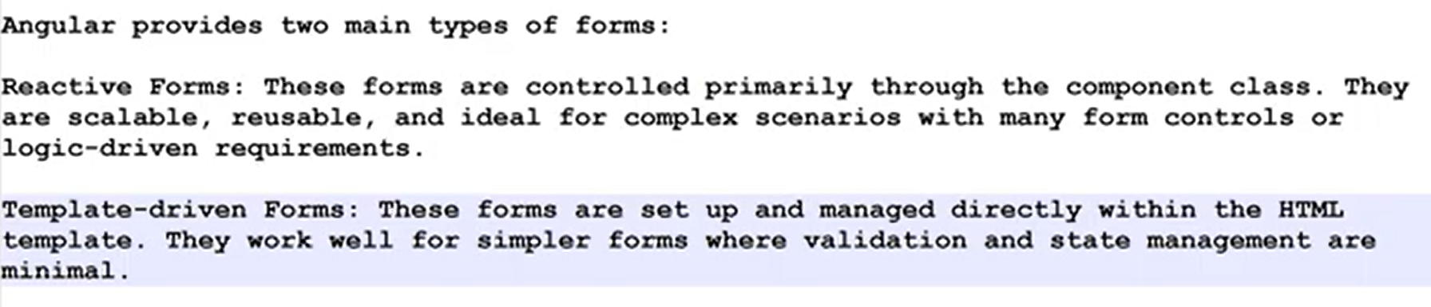**Reactive forms good for —---------------

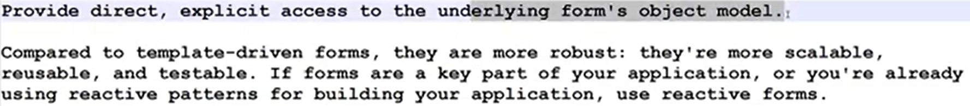

Template forms good for —----

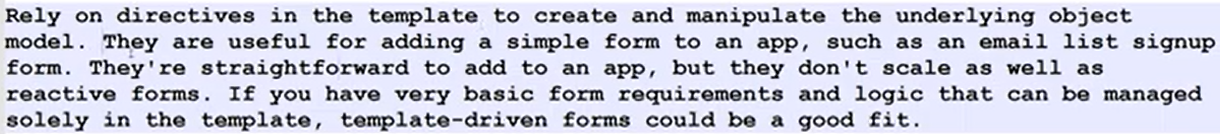  
  
—--------------  
  
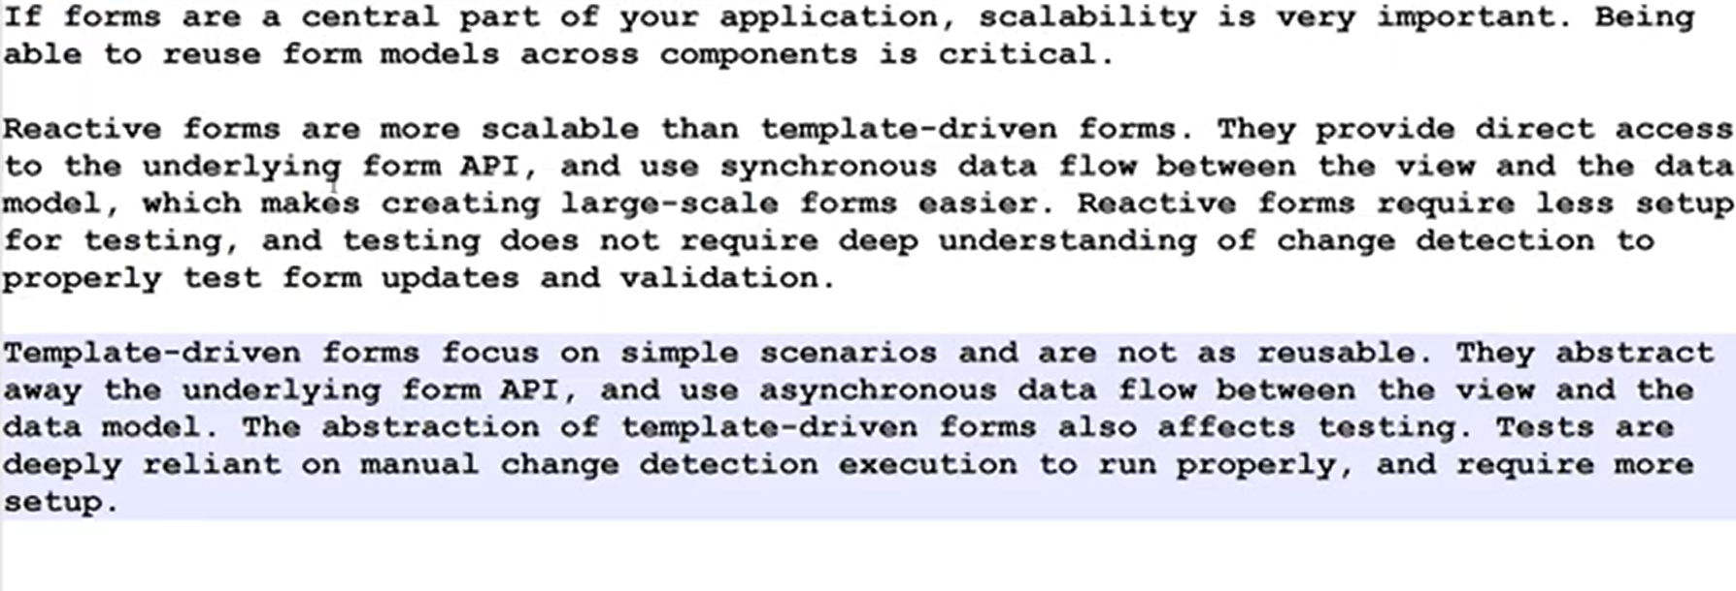  
—----------------------  
  
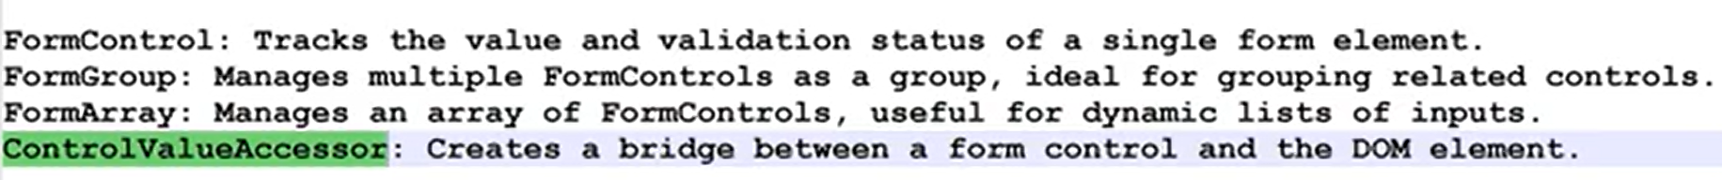

Basic Reactive form

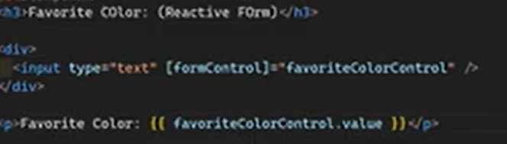  
  
  
  
  
Basic template driven form  
  
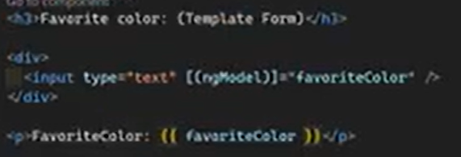  
  
  
  
  
  
  
**Reactive forms —-----------------------------------------------------------------------------------------------------  
  
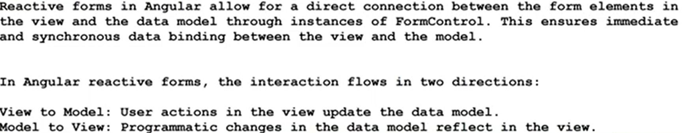**Listen for value changes (View to model) 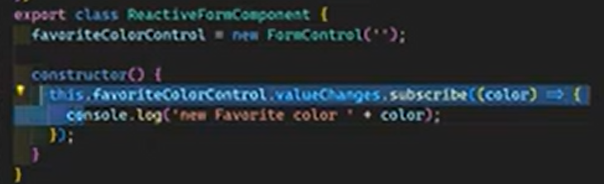Model to view  
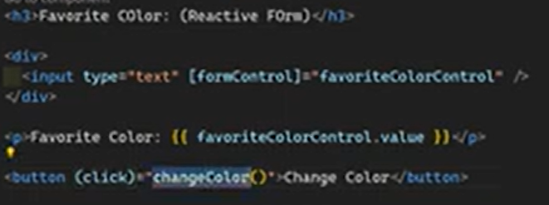  
**Template-Driven Forms —-----------------------------------------------------------------------------------------**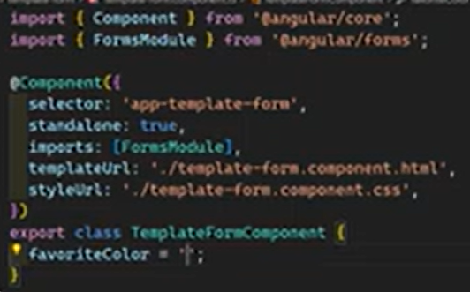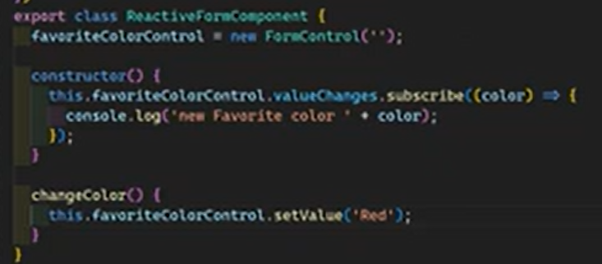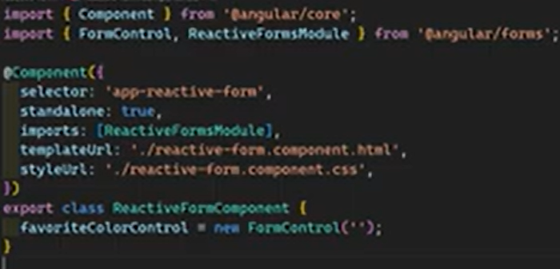

View to model flow  
 **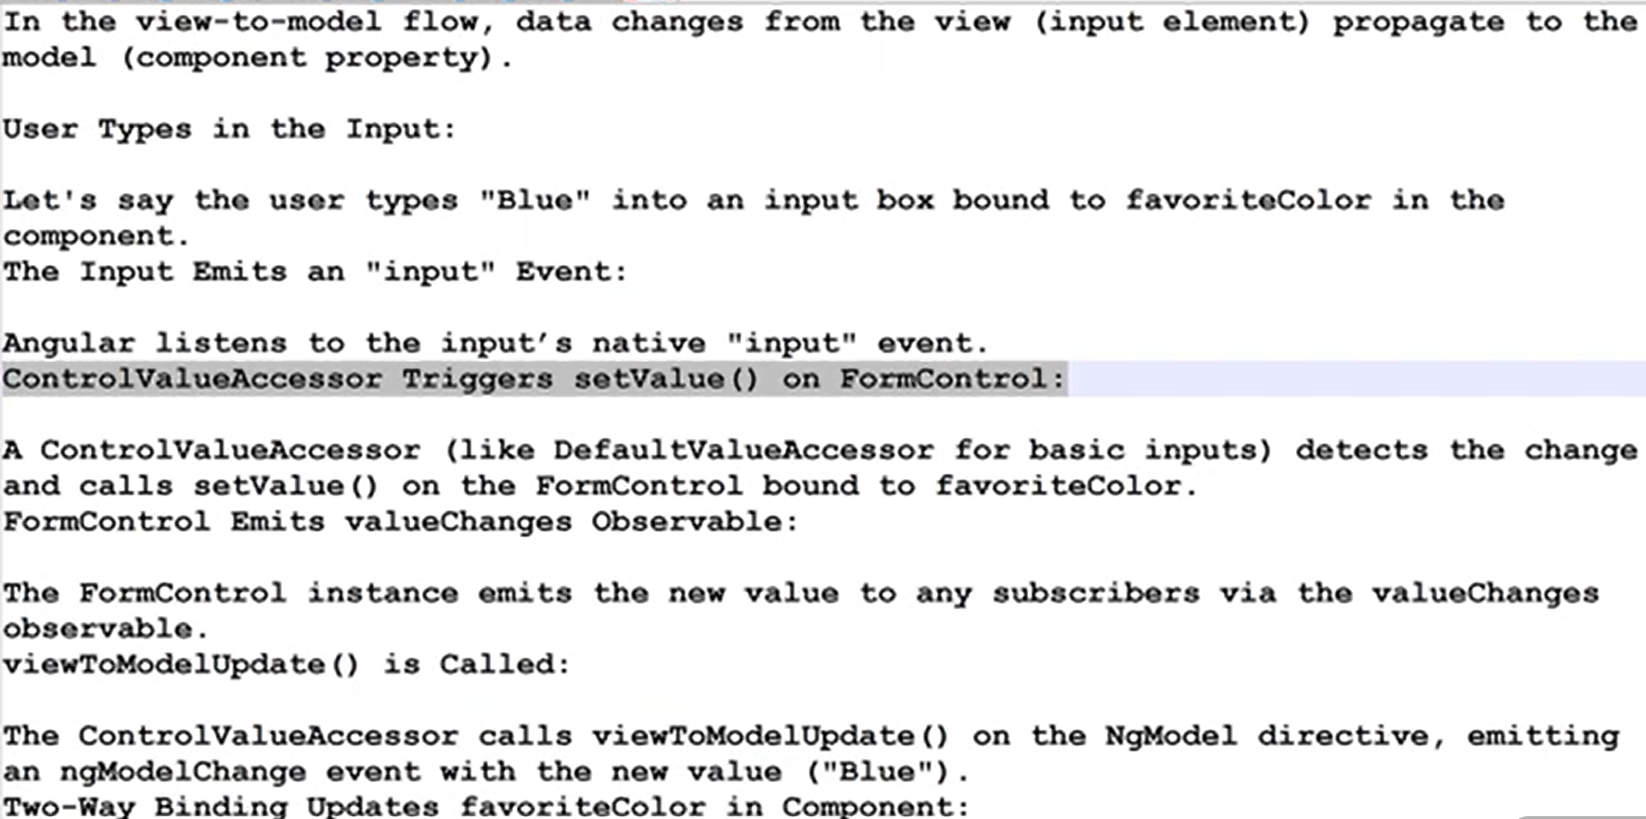  
**

Model to view flow  
 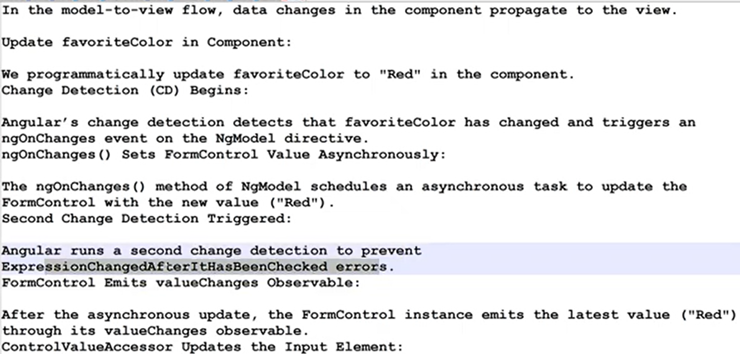

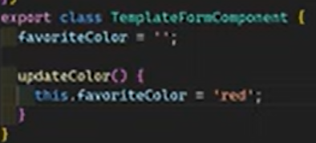  
  
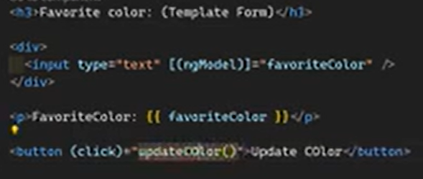

Listen for value changes  
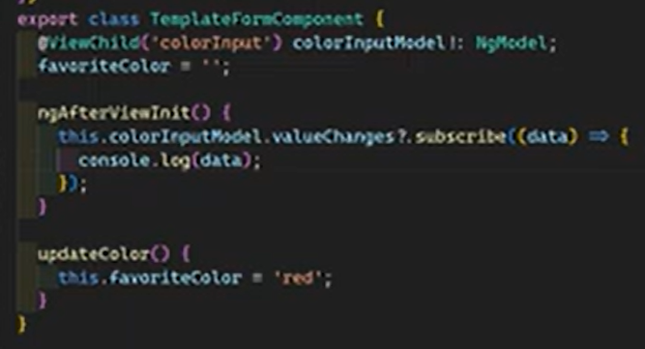

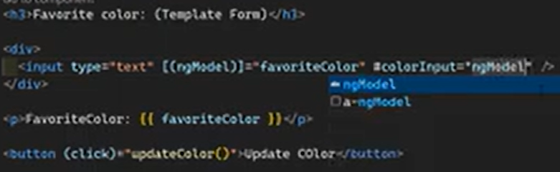  
  
  
  
  
  
  
 **Data Model Mutability —-------------------------------------------------------------------------------------------**In Reactive forms >>  
  
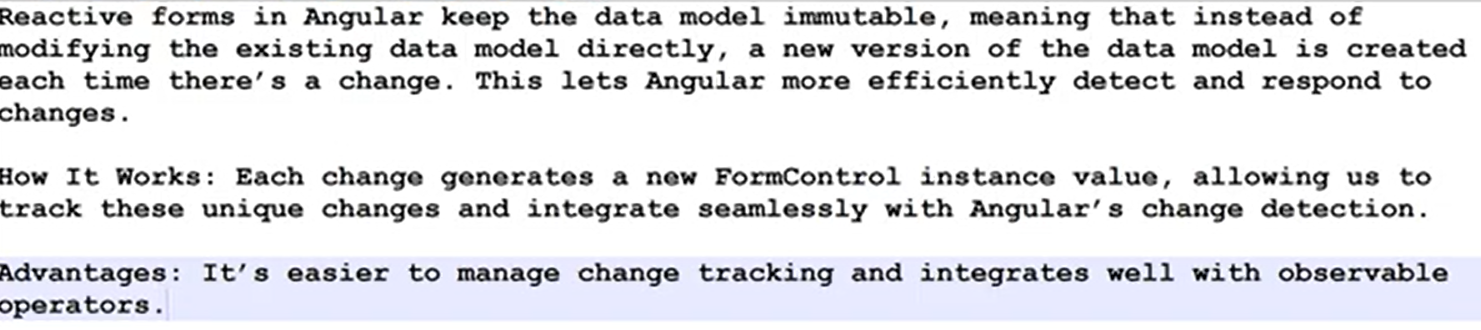  
  
In template driven forms >>  
  
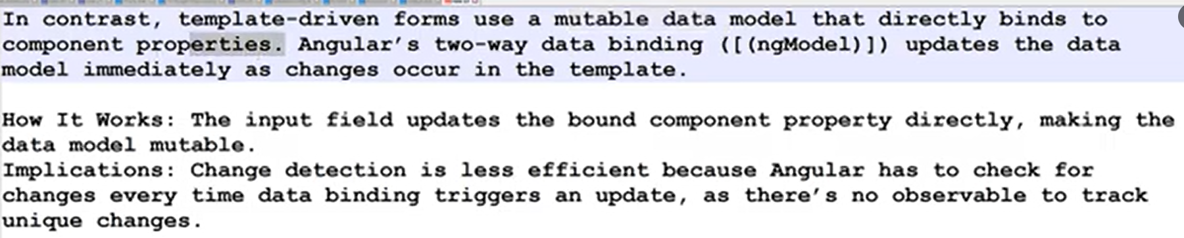  
  
  
  
  
**Reactive Form Controls implementation —------------------------------------------------------------------**Import reactiveFormsControlModule  
  
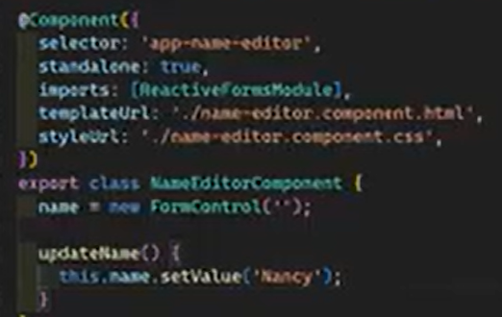  
  
  
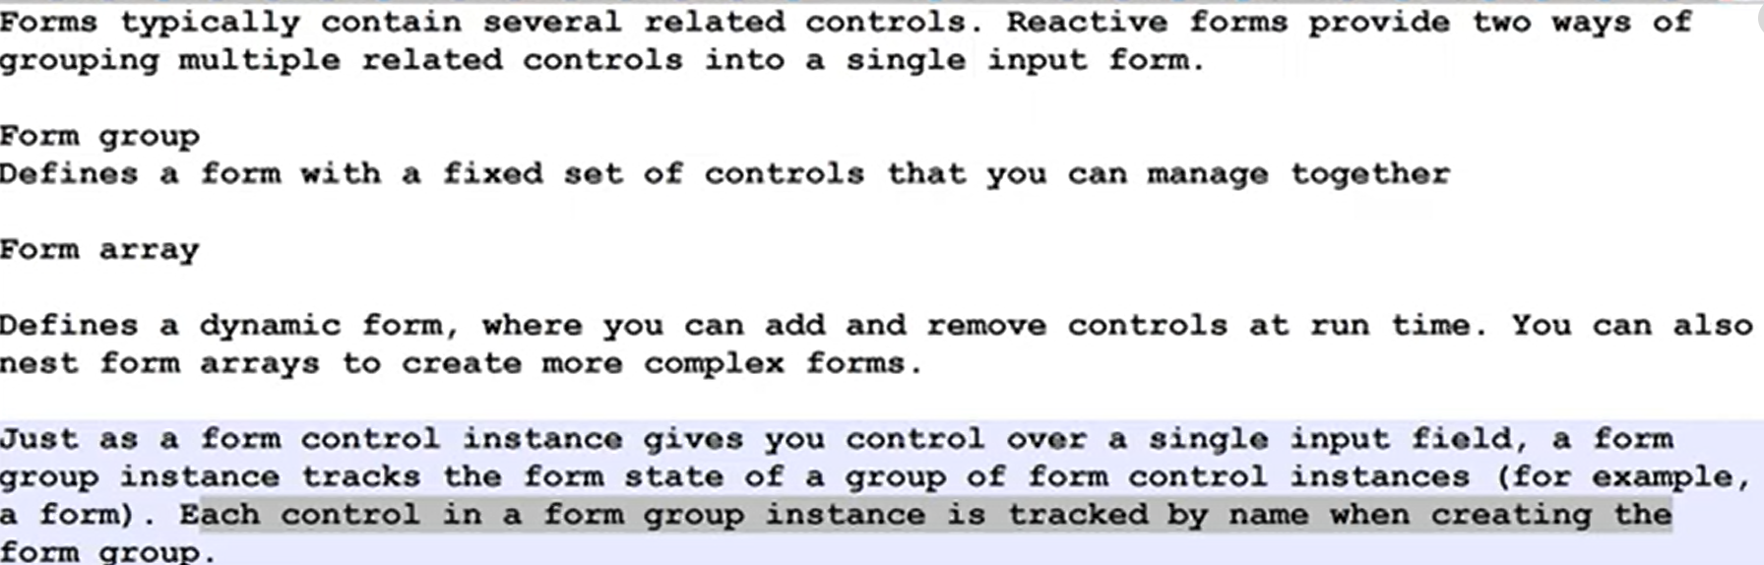  
  
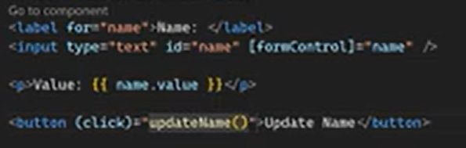

Formgroups >>>  
  
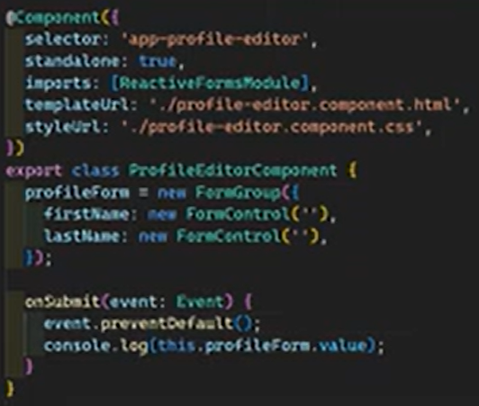  
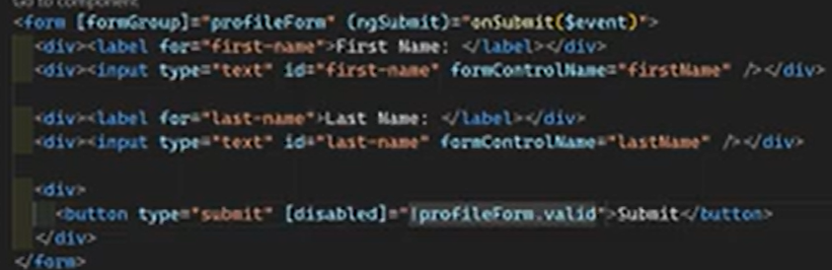  
  
Nested form groups >>>  
  
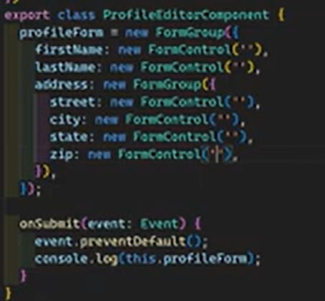  
  
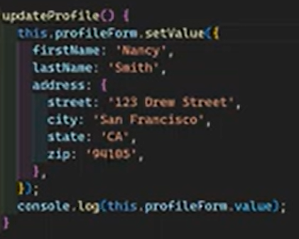  
  
  
FormBuilders and Dynamic forms >>>  
  
  
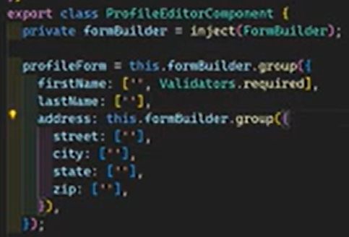  
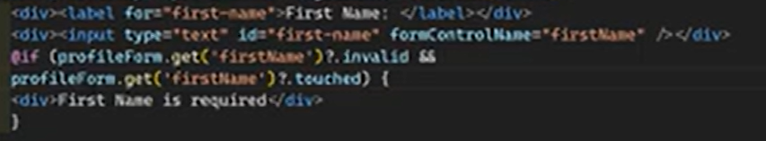 showing error messages  
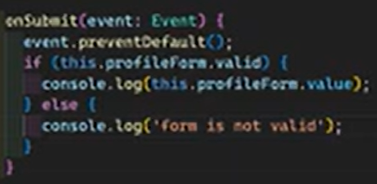  
FormArray >>>  
  
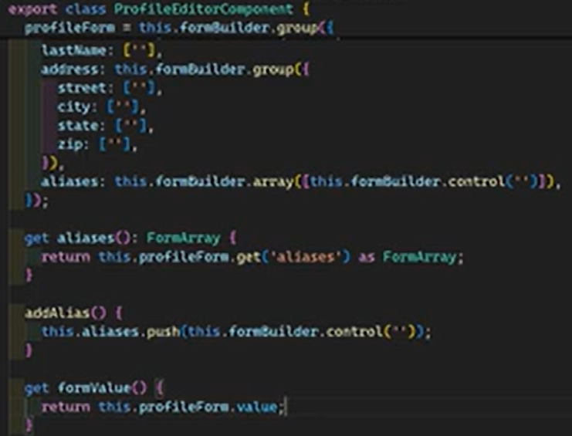  
  
  
  
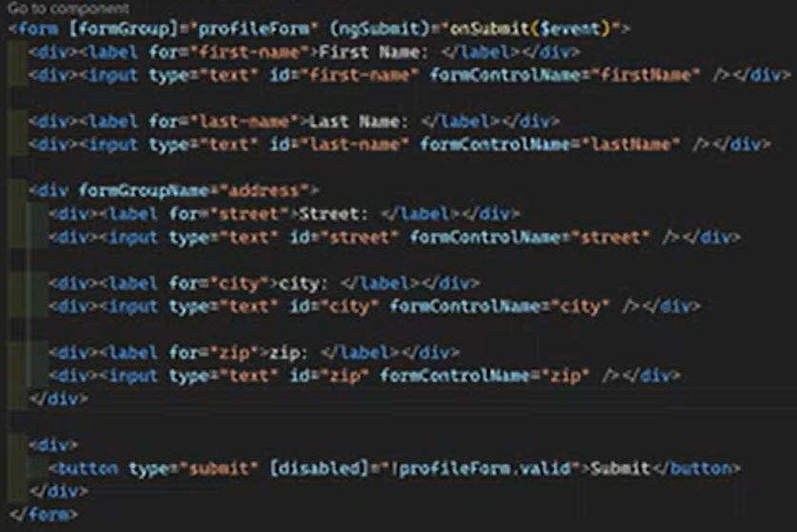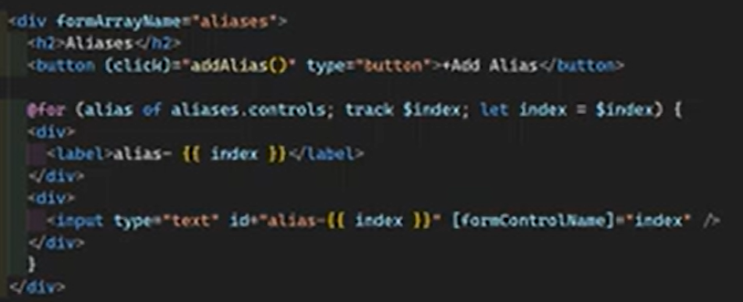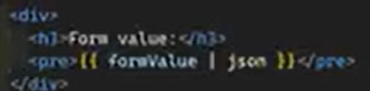

**Strictly Typed Forms —---------------------------------------------------------------------------------------------**  
  
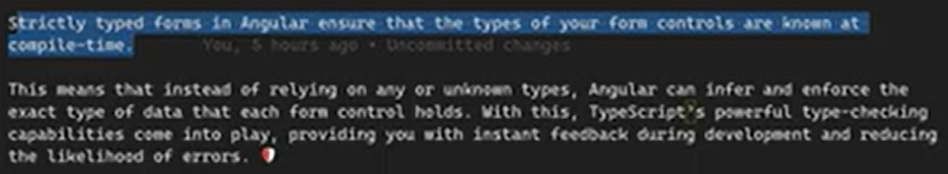  
  
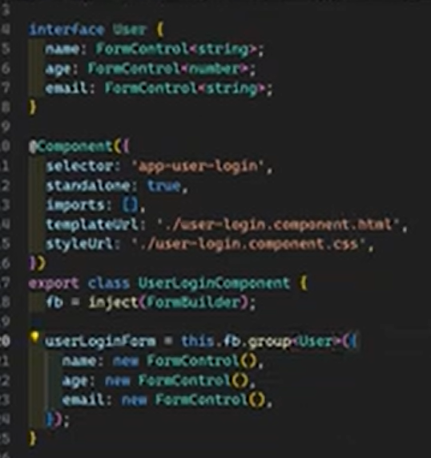  
  
  
  
  
Nullable vs. Non-Nullable Controls >>>  
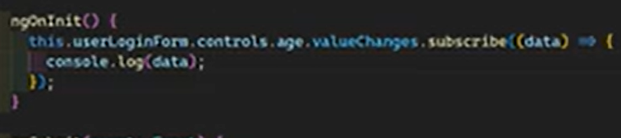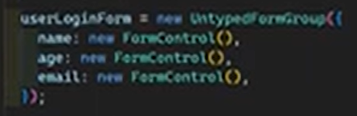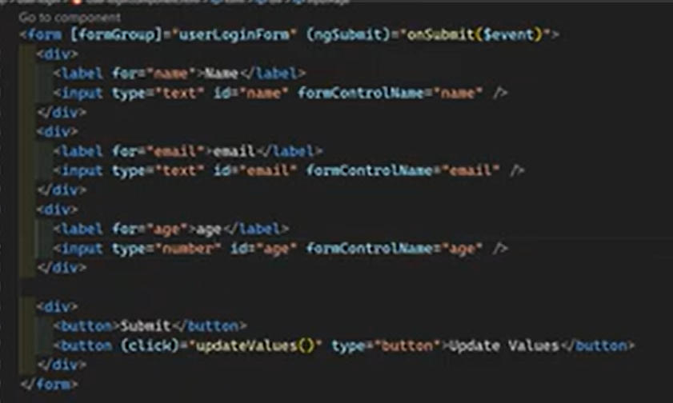

Usually when the form get reset it’s values assigned null. But if we want to enforce not to set null values and set to it’s initial values  
  
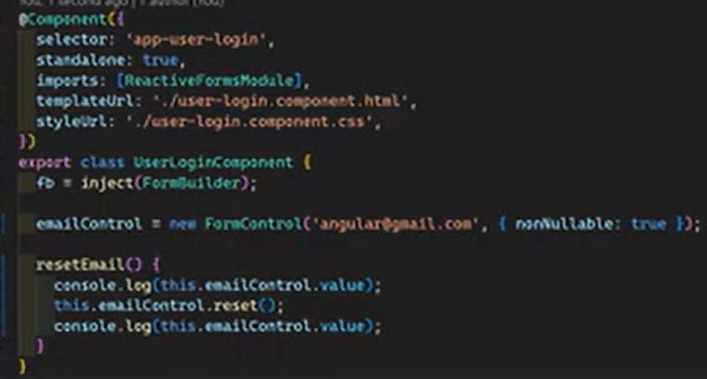  
When this get reset it sets it;s initial values

—  
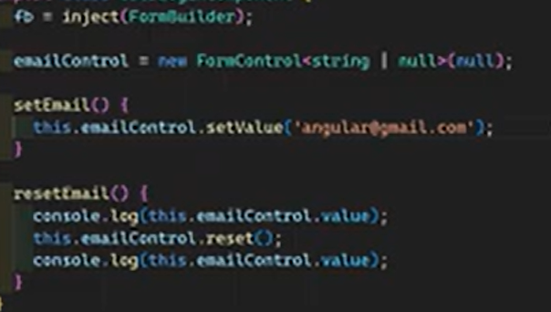.

FormGroup, FormRecord >>>  
  
  
Disabled controls values not present in form.value object, it is present in raw object

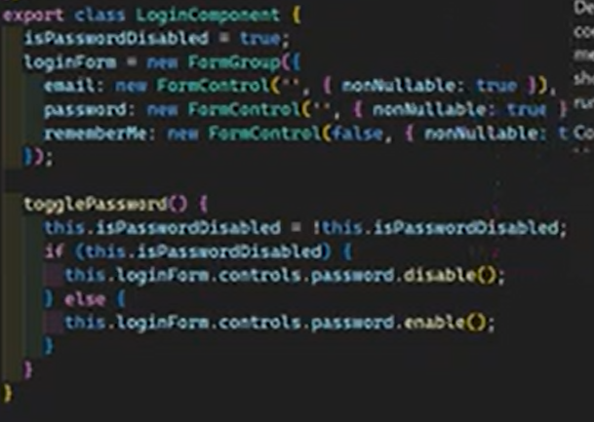

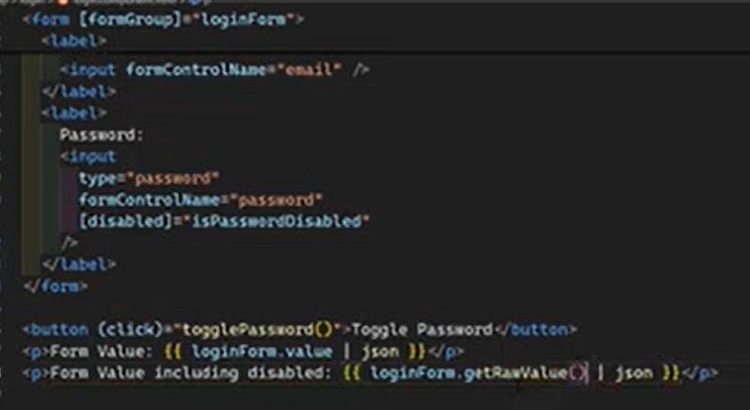

Dynamic include exclude

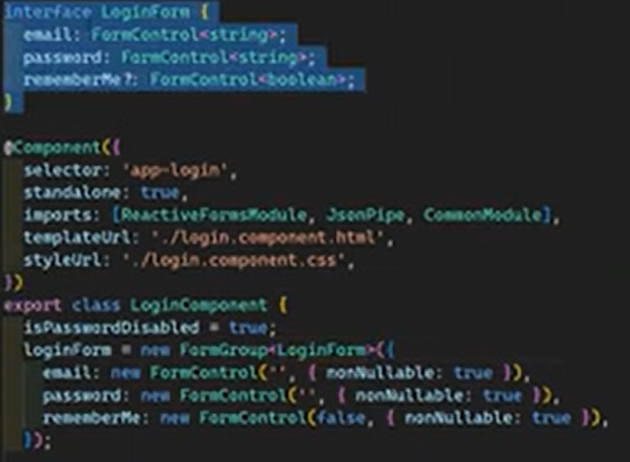  
  
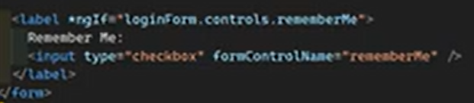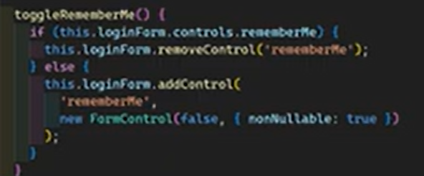

FormRecord Example –  
  
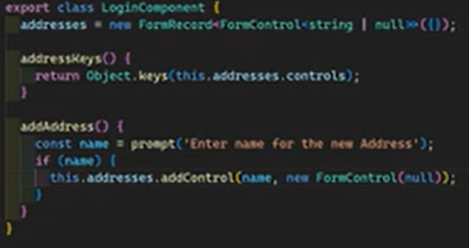  
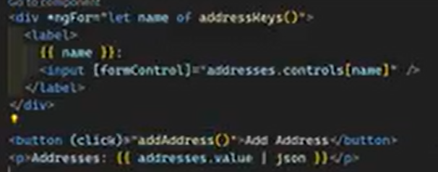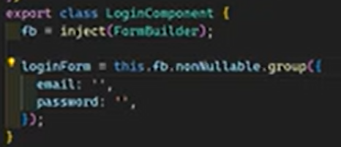

Non nullable form builder >

**Create Template Driven Forms using ngModel two-way data binding —--------------------------  
  
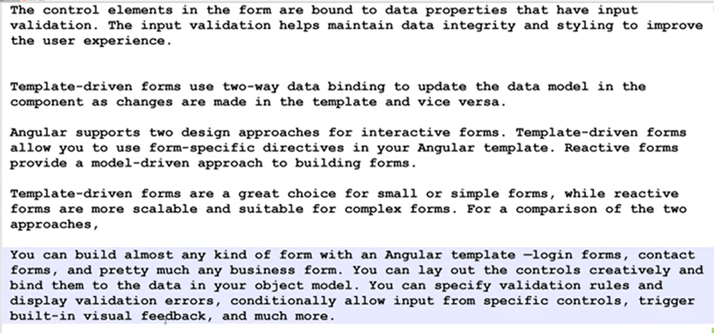  
  
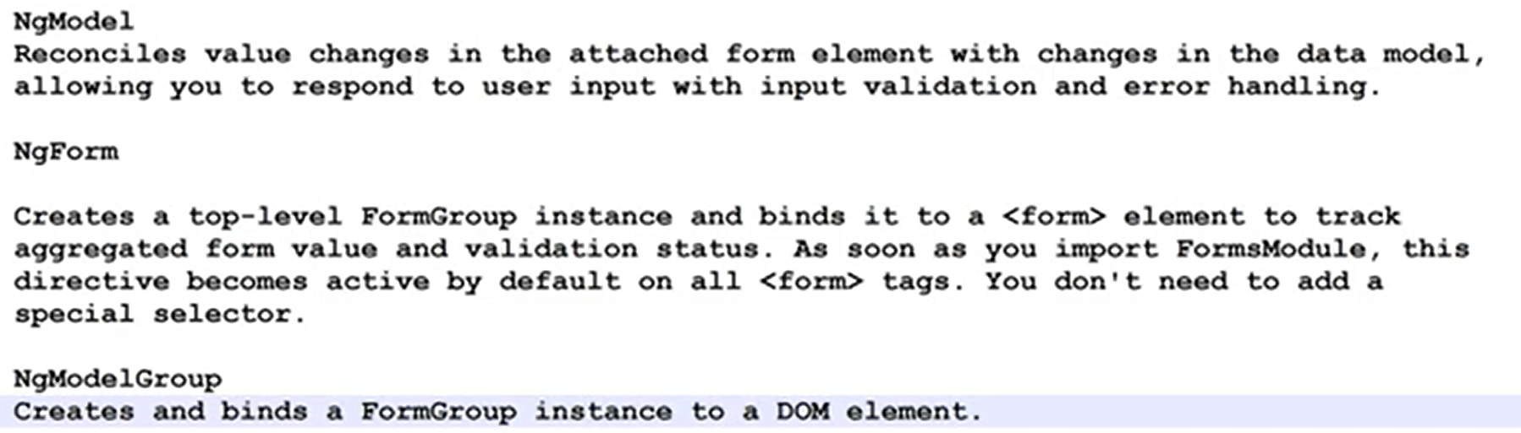**

Implementation example >>>  
  
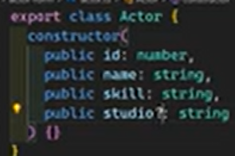  
  
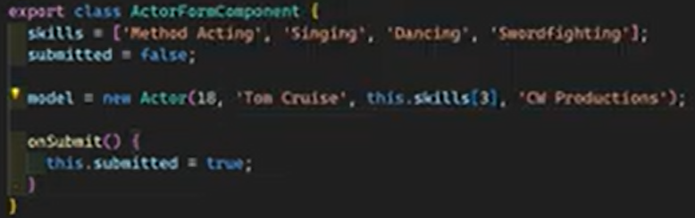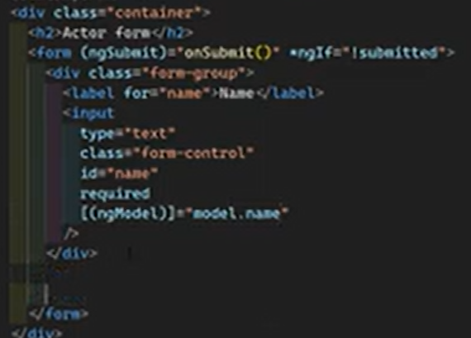

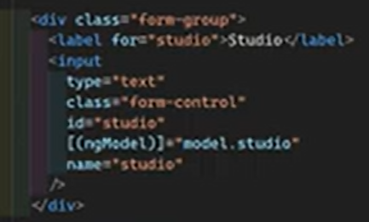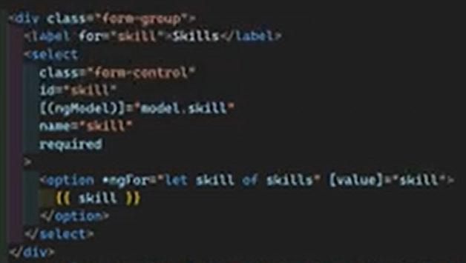

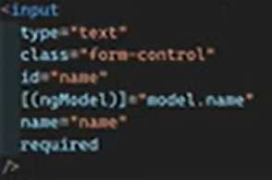

Track Control States & Show Validation Messages >>>

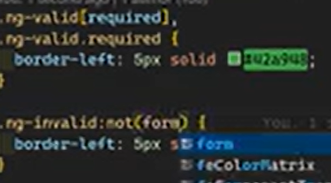

Ng-submitted class appended when the form was submitted and each form control have set of classes for present different events  
  
  
  
Ng-pristine turn into ng-dirty when something typed on input  
  
  
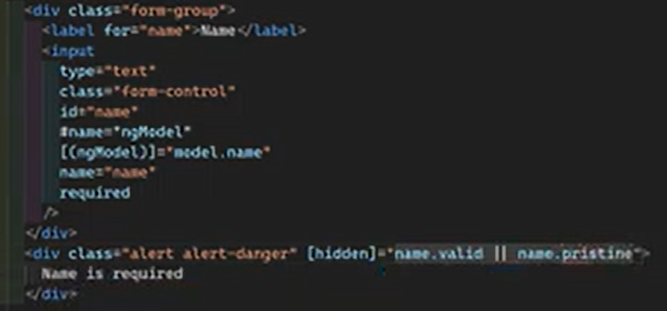

Add the Submitted State in the template >>>

  
  
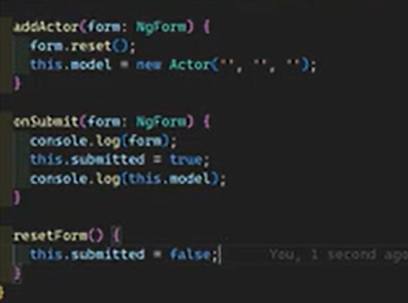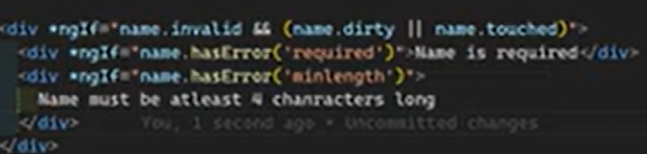

Add Dynamic Rules to Template Forms >>>  
   
  
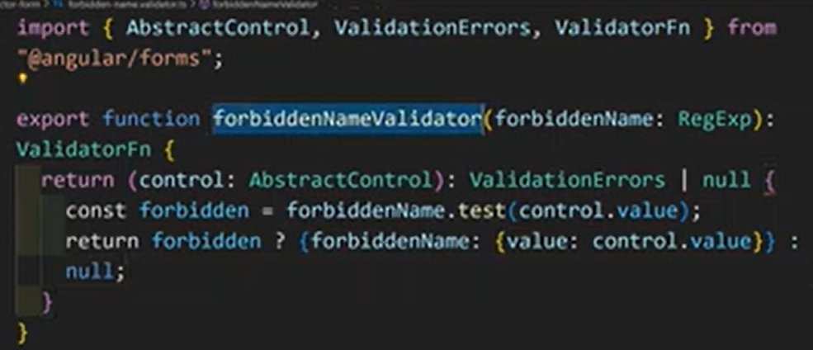  
 This function does not interact directly with the template  
  
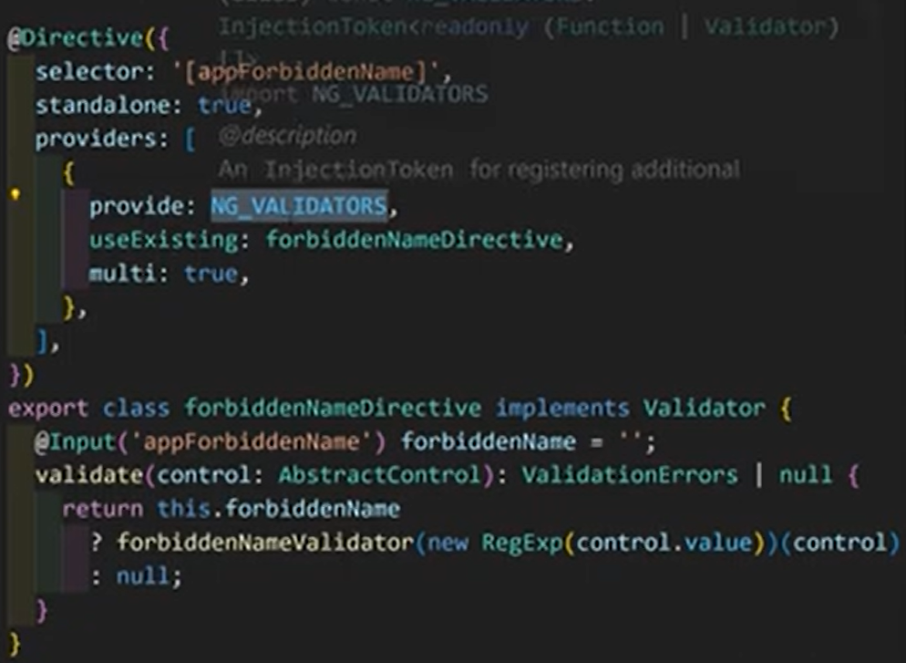  
  
  
  
  
  
  
  
  
  
  
  
  
  
  
  
  
  
Validate in the reactive forms >>>  
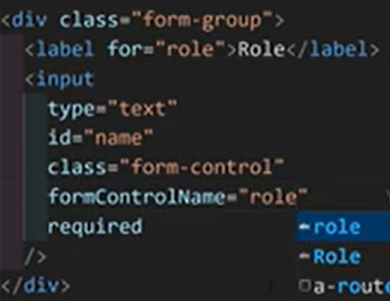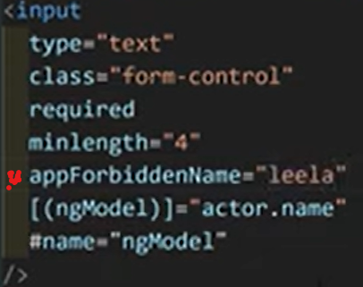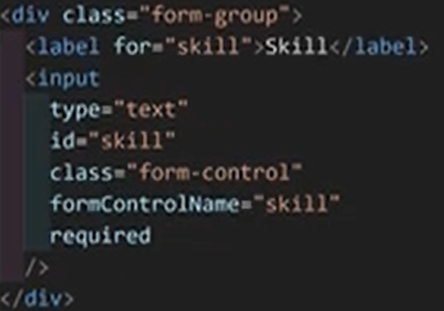

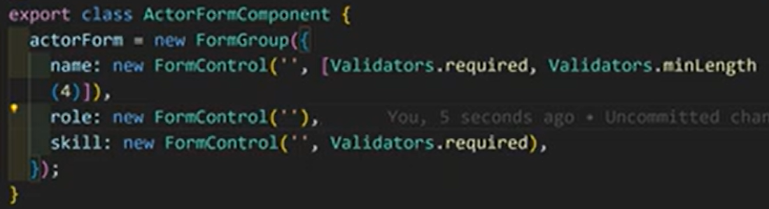  
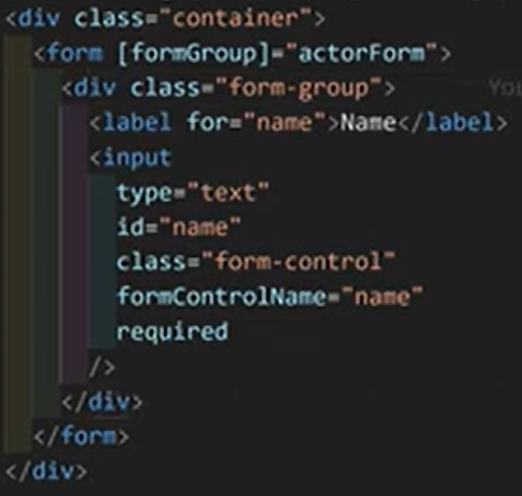  
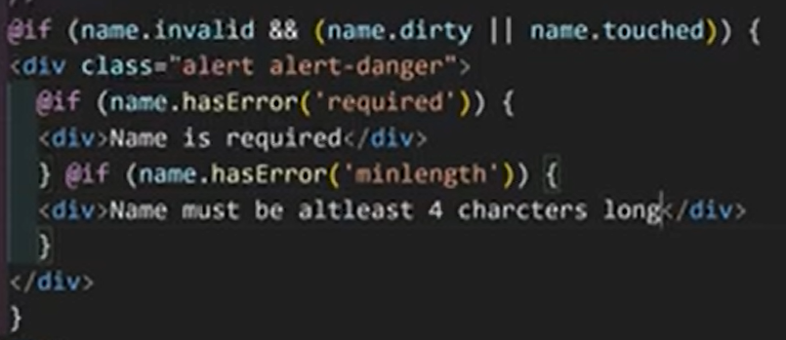

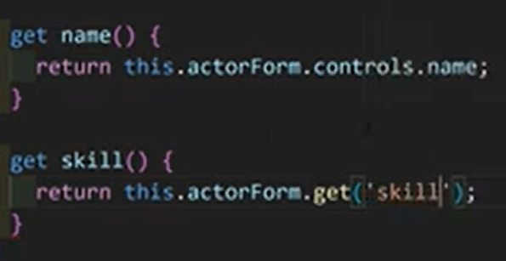

Custom Validators >>>  
  
  
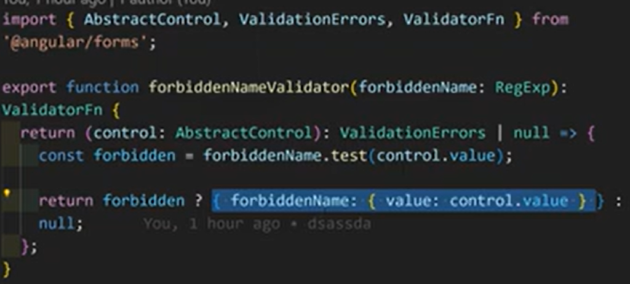  
  
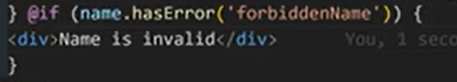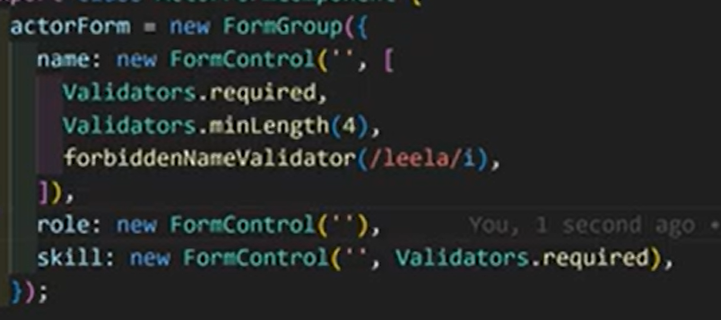

From Pristine to Touched >>>   
  
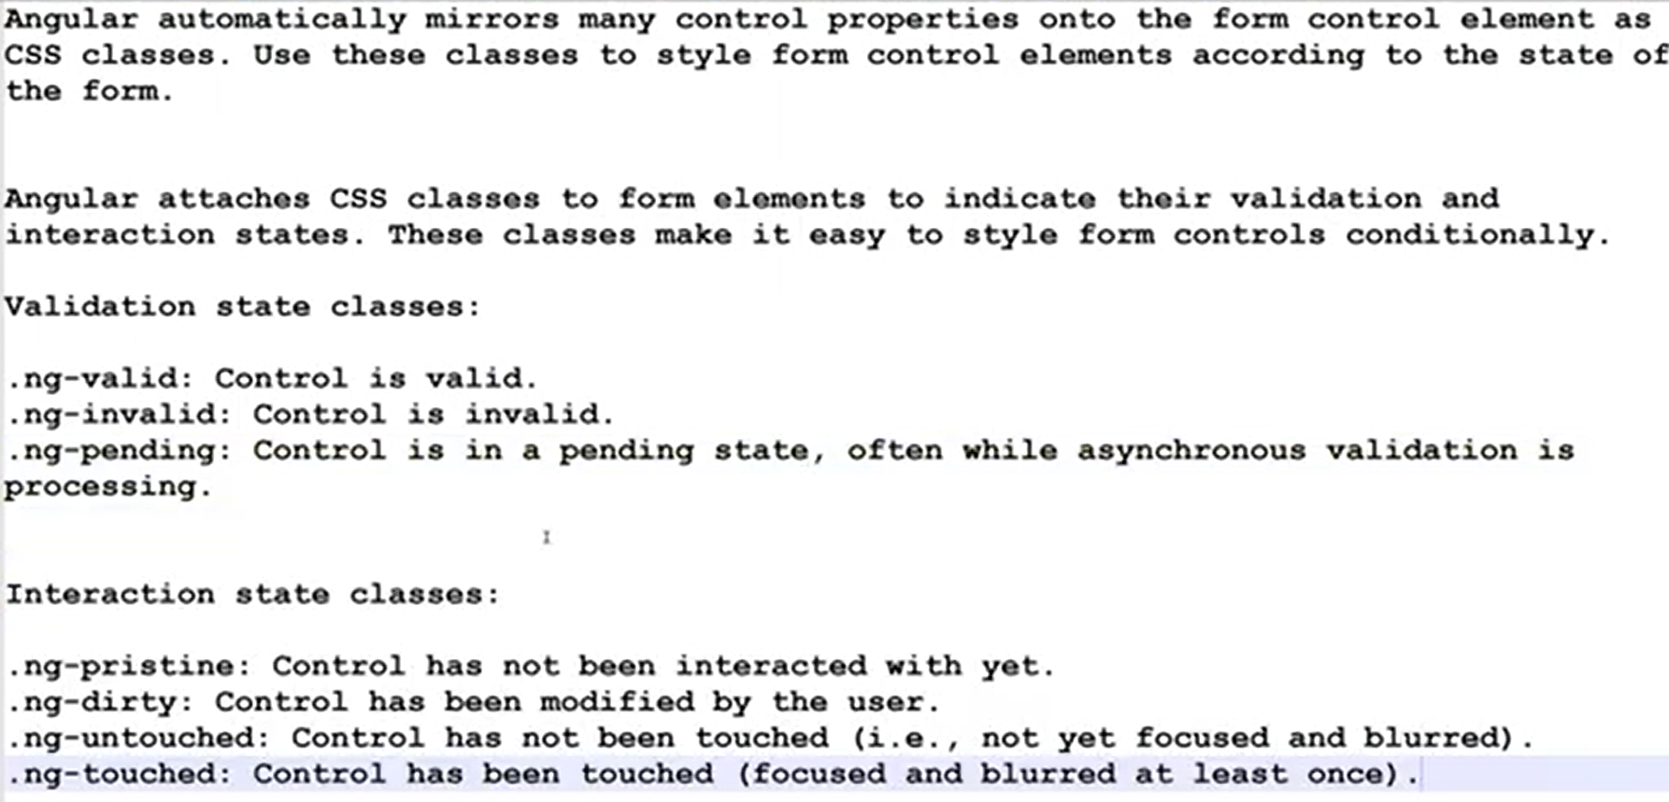  
  
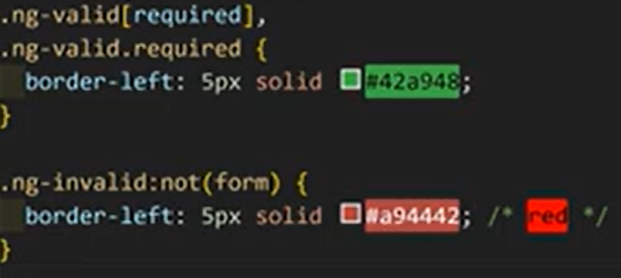

Cross-Field Validation >>>

One form control depend on another control. In here role should not be equal to name attribute  
  
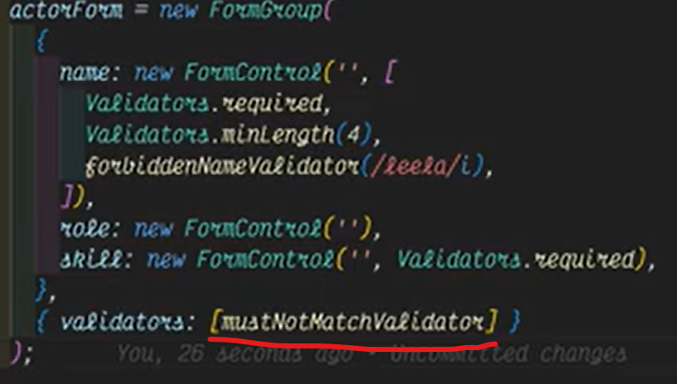  
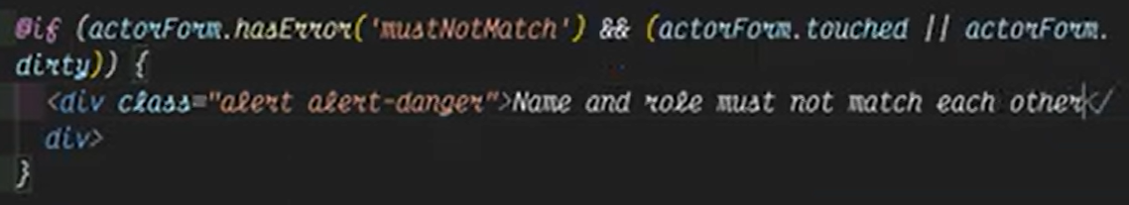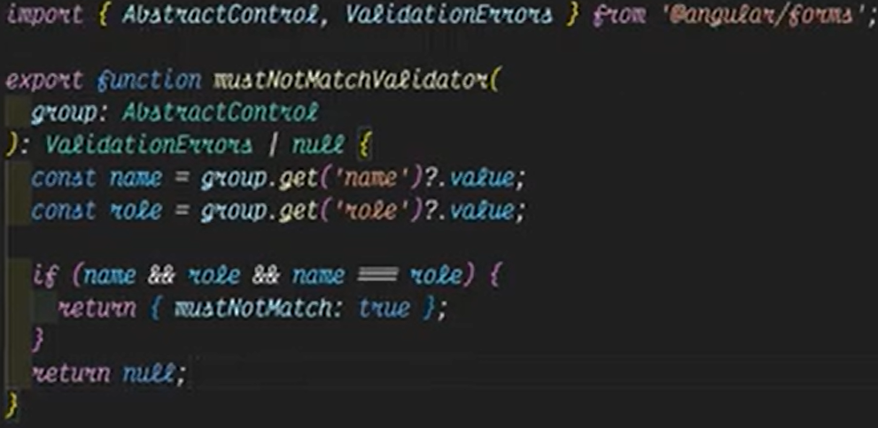

Cross-Field Validation in Template Driven forms >>>

Create directive using previous validator  
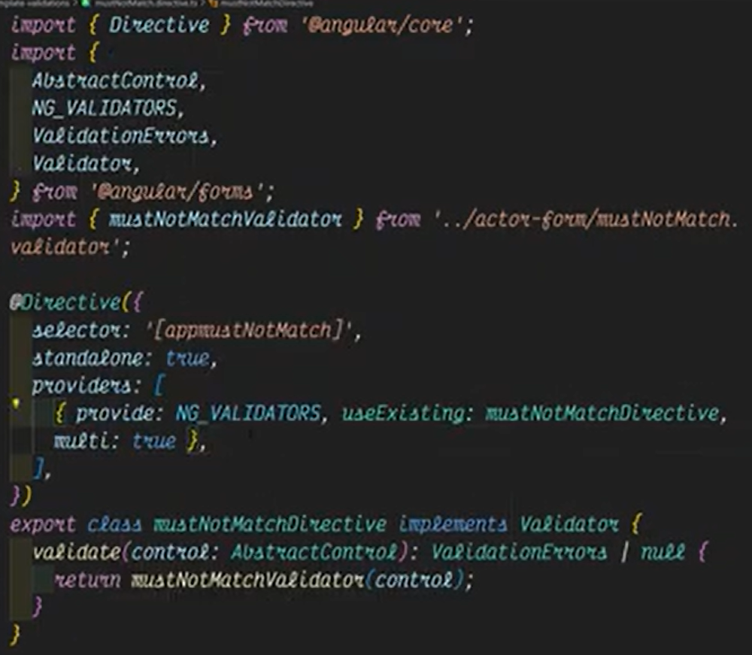   
  
  
  
Asynchronous Validations in reactive forms >>>  
  
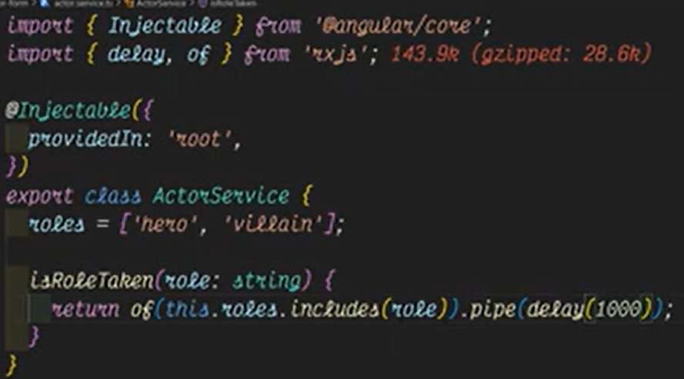  
  
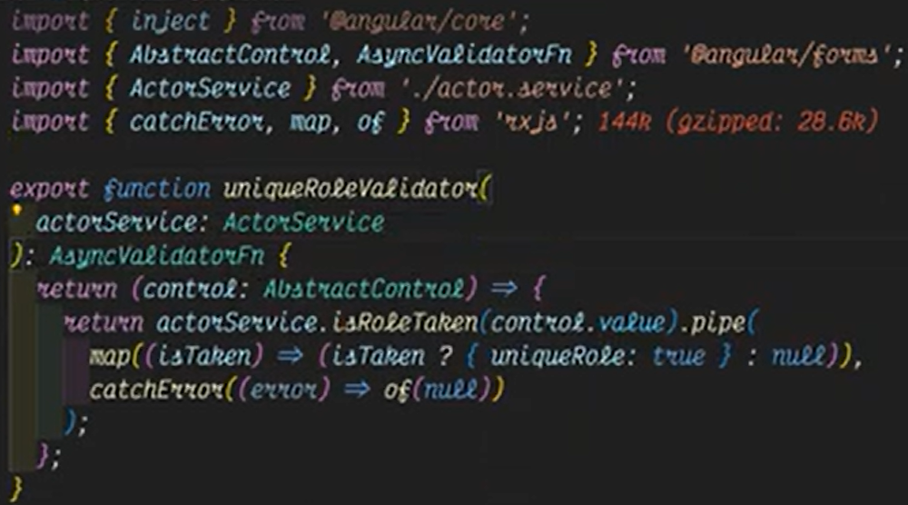  
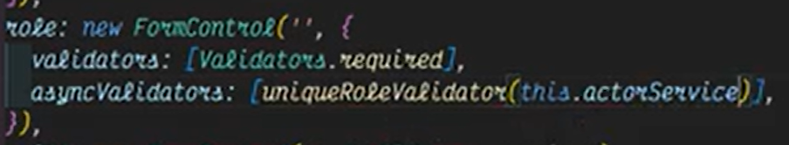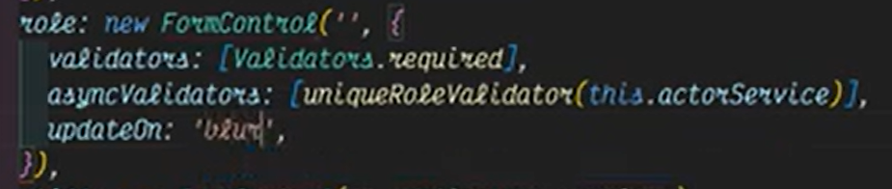  
  
  
  
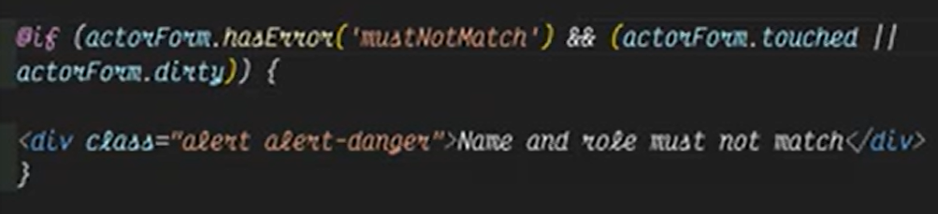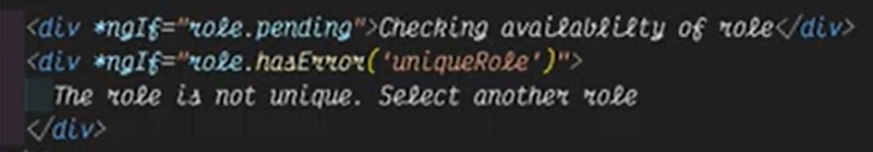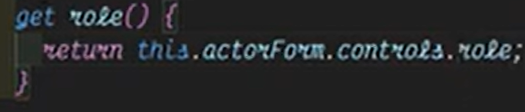

Asynchronous Validations in Template Driven forms >>>

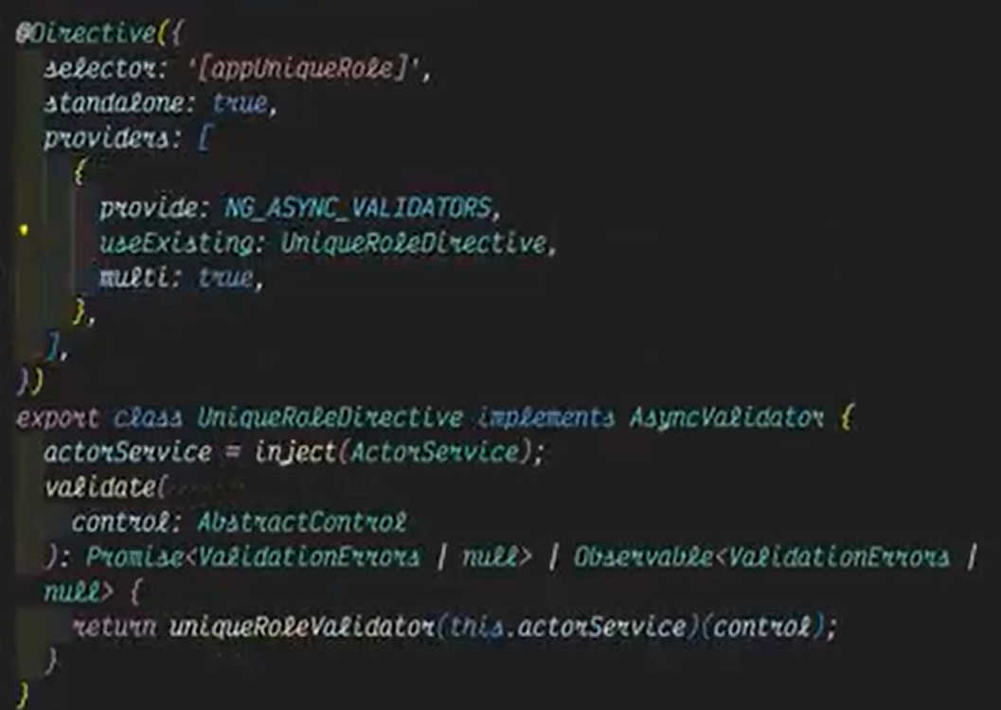  
  
  
  
  
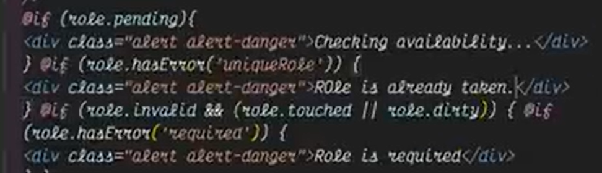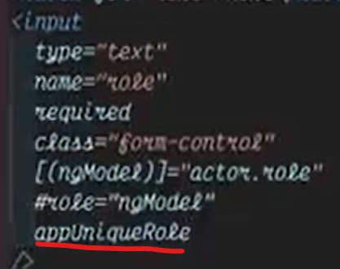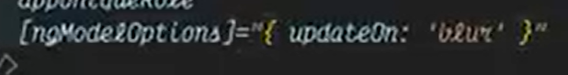

**Building Dynamic Reactive Forms —--------------------------------------------------------------------------**

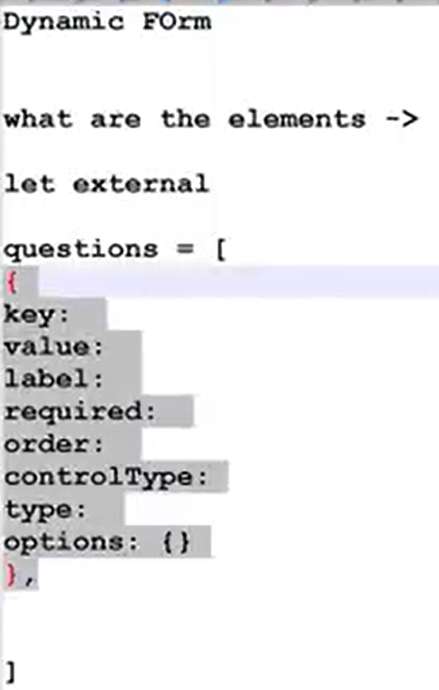  
  
Service class  
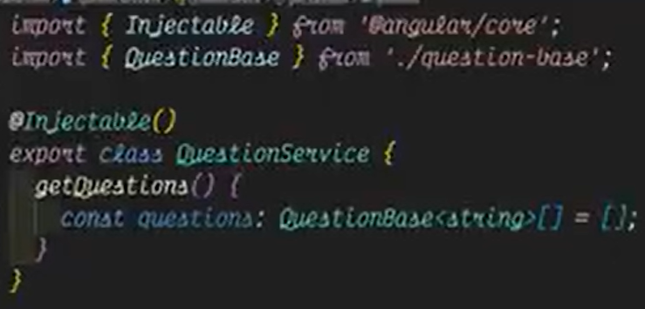  
  
Textbox class Drop down class  
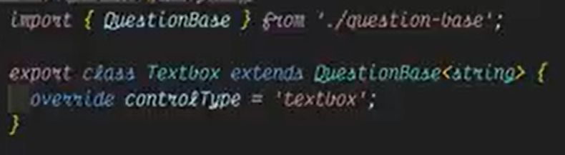  
  
Initializing service  
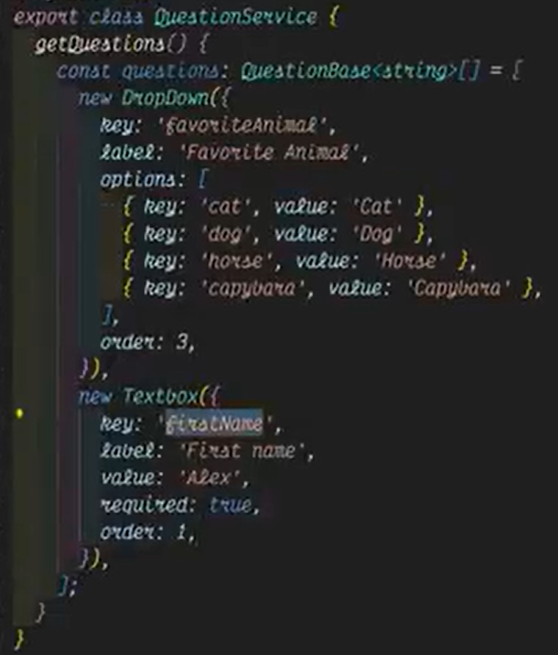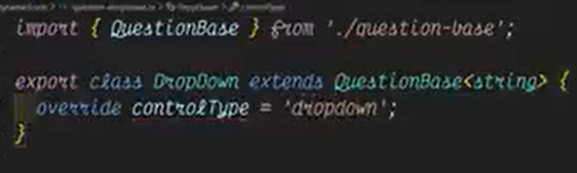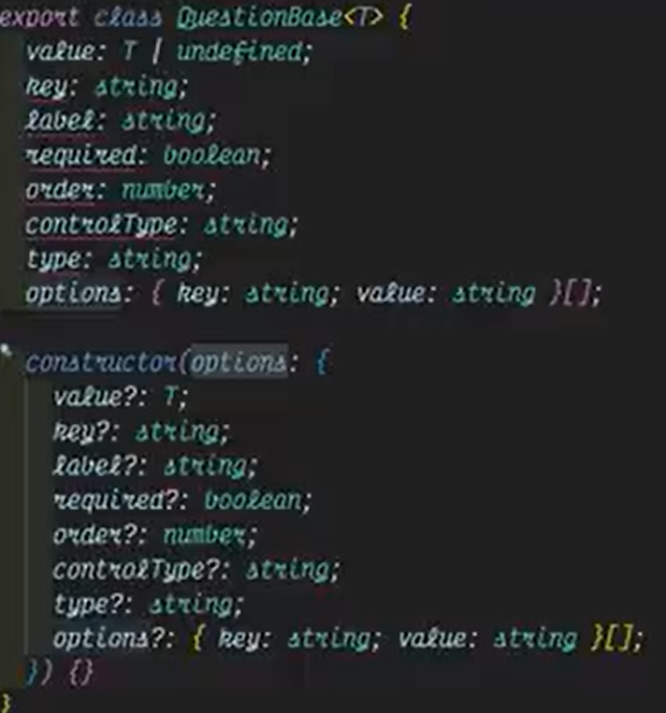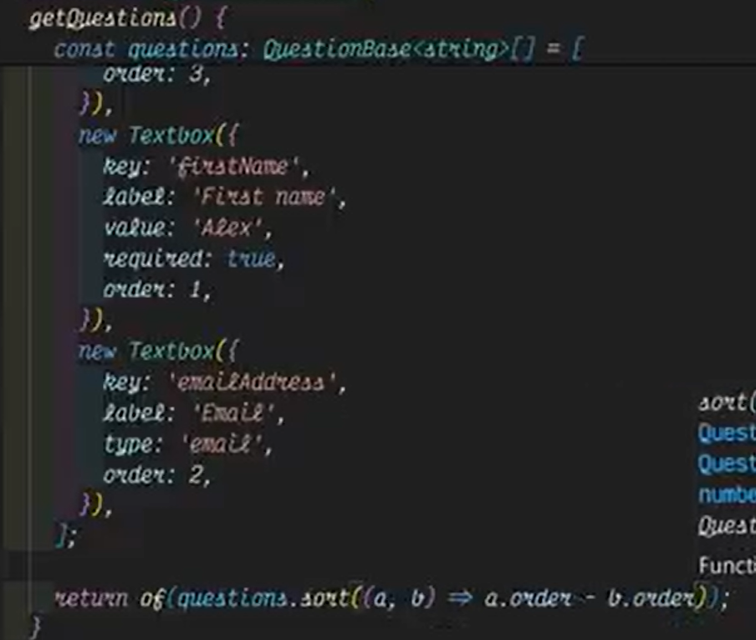

App Component  
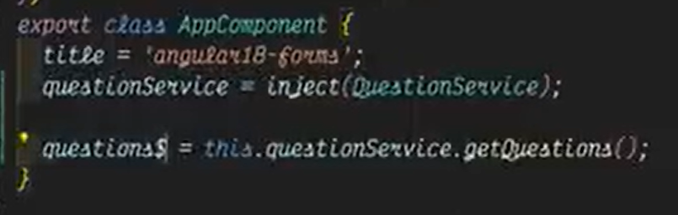  
Dynamic Form component  
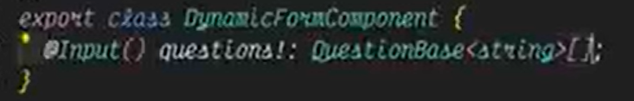  
Invoking Dynamic Form Component within the App Component  
  
  
  
Creating service to build dynamic form group( questionControlls )  
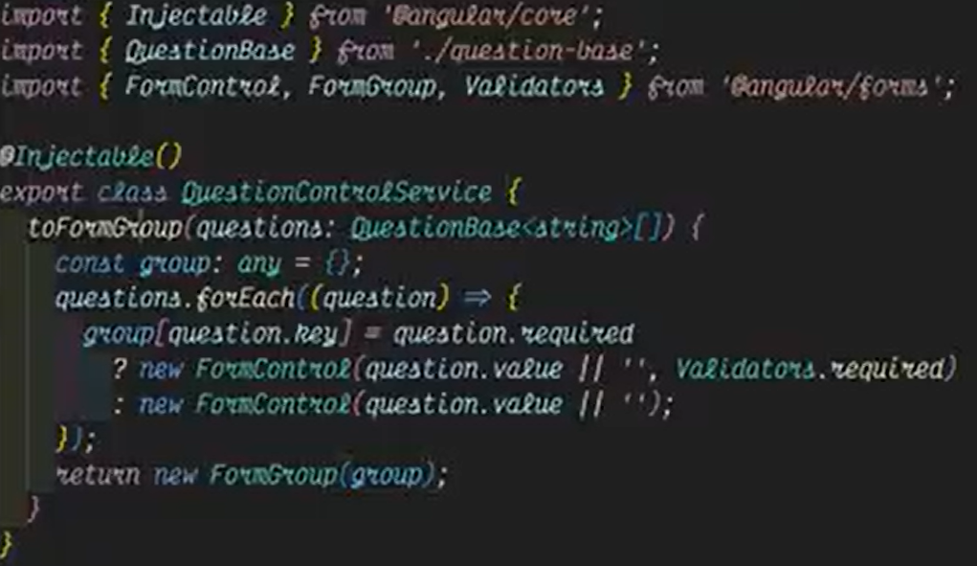  
  
Leverage the service and initialize formgroup within dynamicForm COmponent  
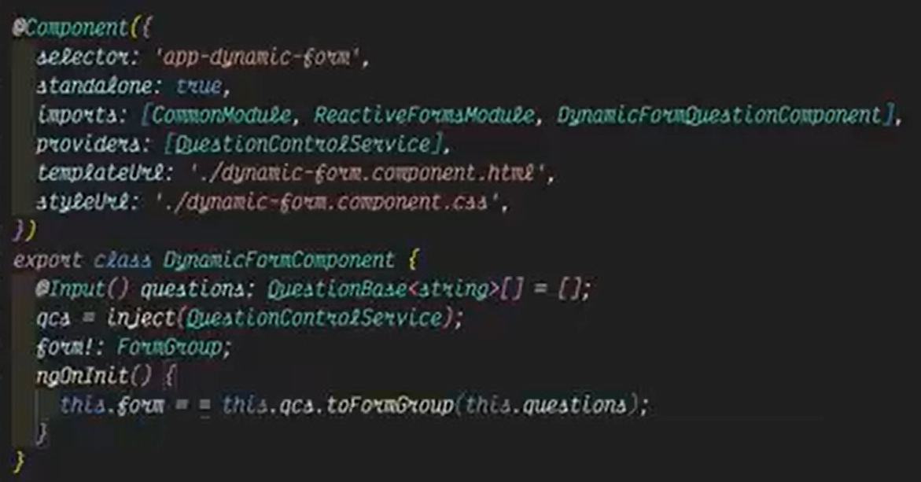

Loop the dynamic formgroup within DynamicForm Component and pass each form control to separate component  
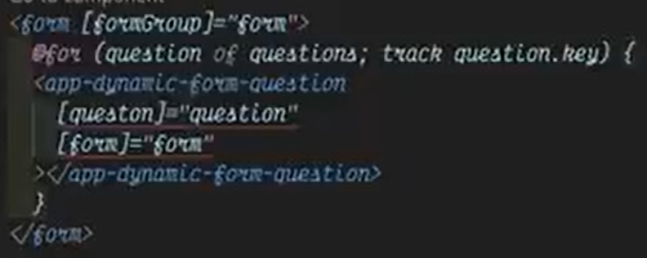  
  
Separate component class file  
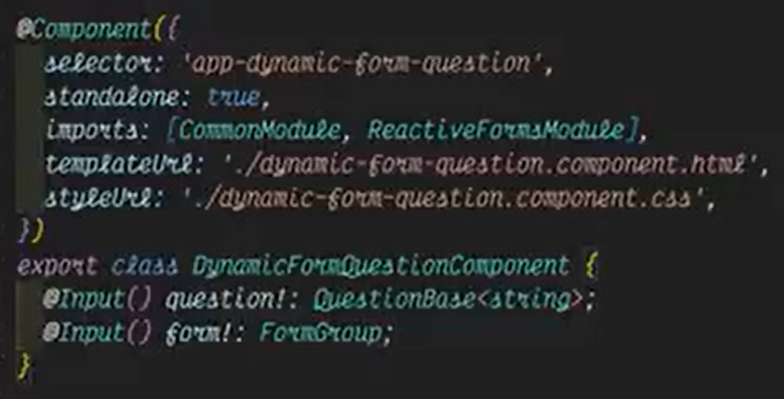  
  
Separate component template  
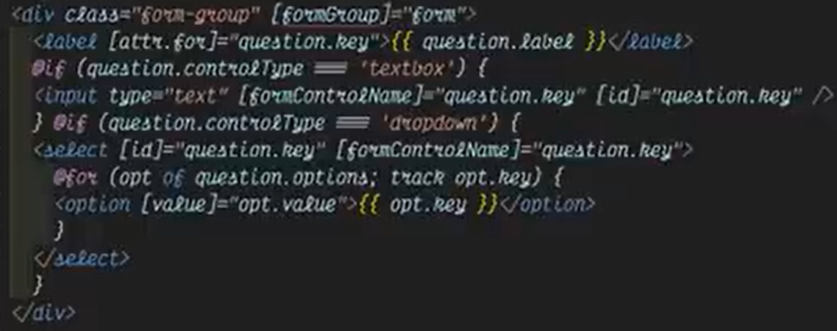  
  
  
  
Track errors in formcontrol separate component  
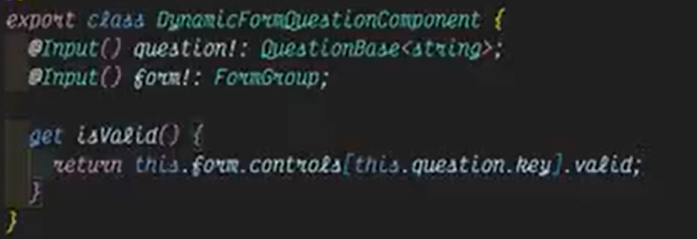  
Display error message in template  
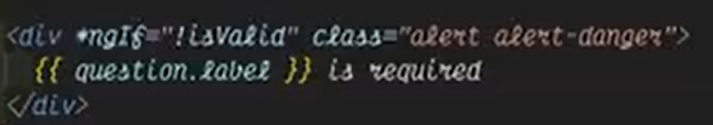

**Http Client in Standalone Components**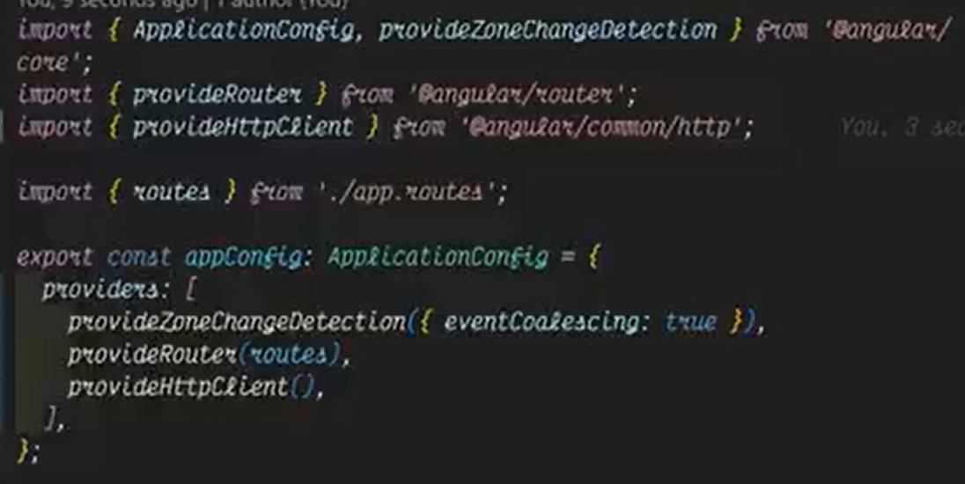  
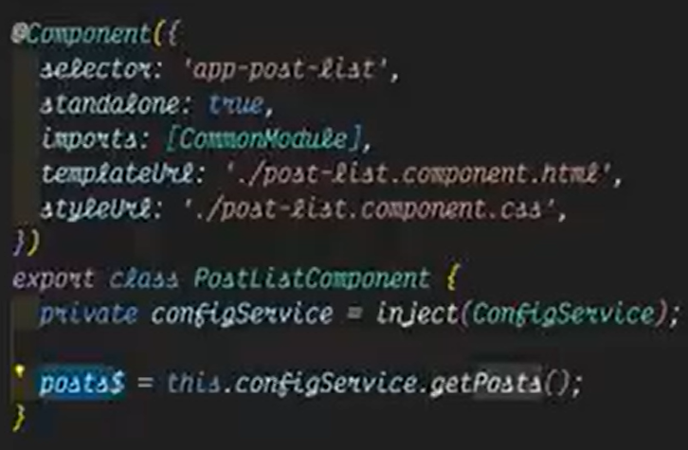  
  
  
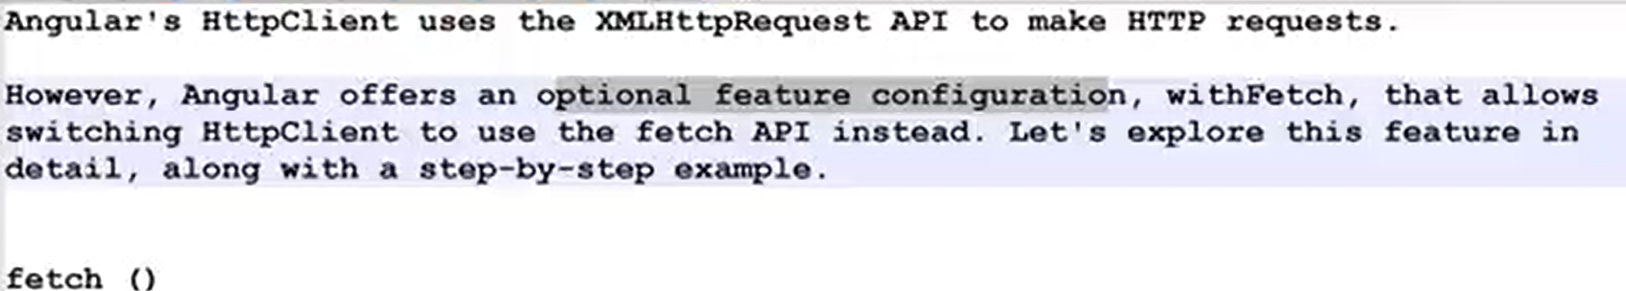  
  
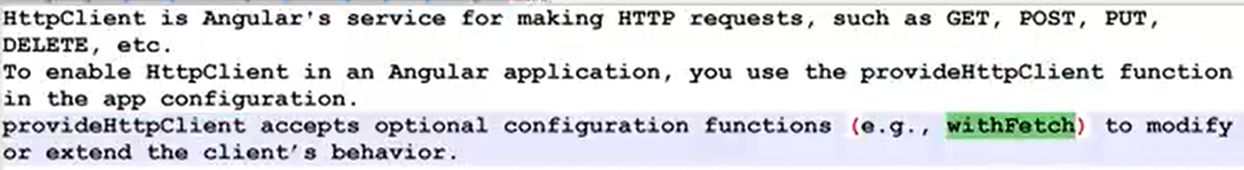  
  
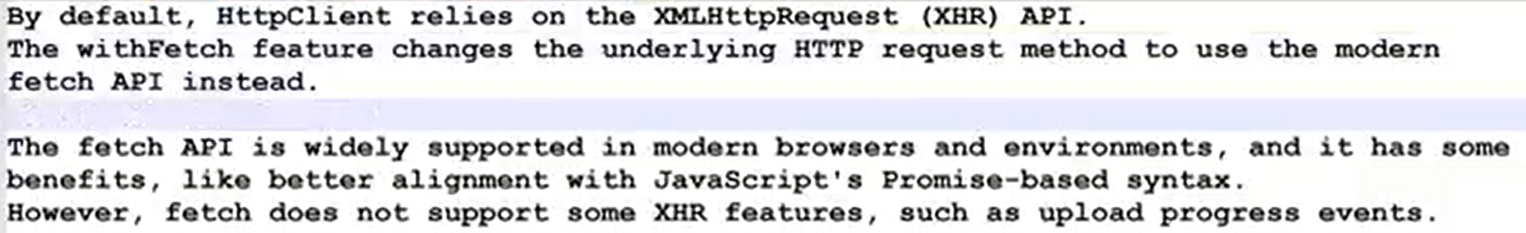  
  
  
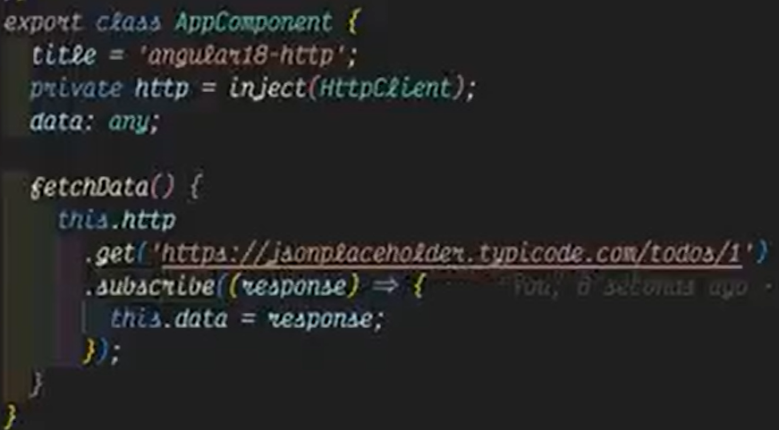  
  
  
**Functional vs DI-Based Interceptors —-----------------------------------------------------------------------**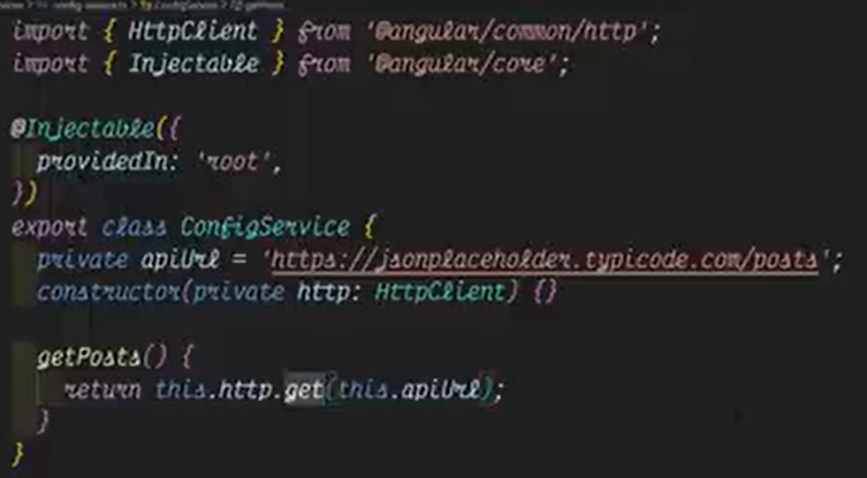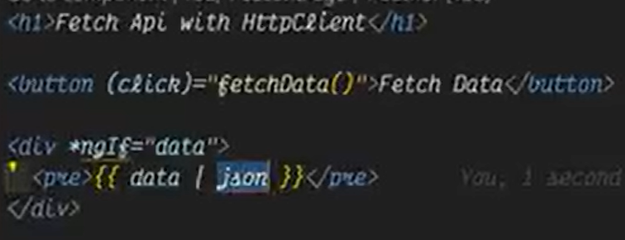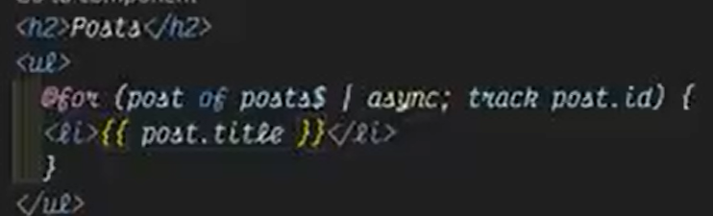

**  
  
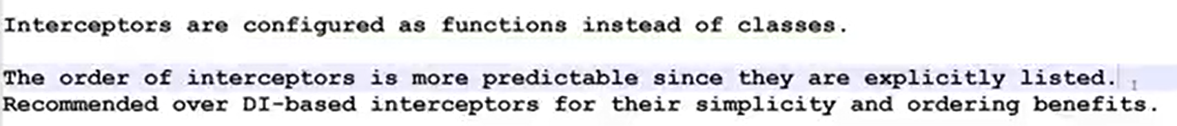**Function based interceptors >>> **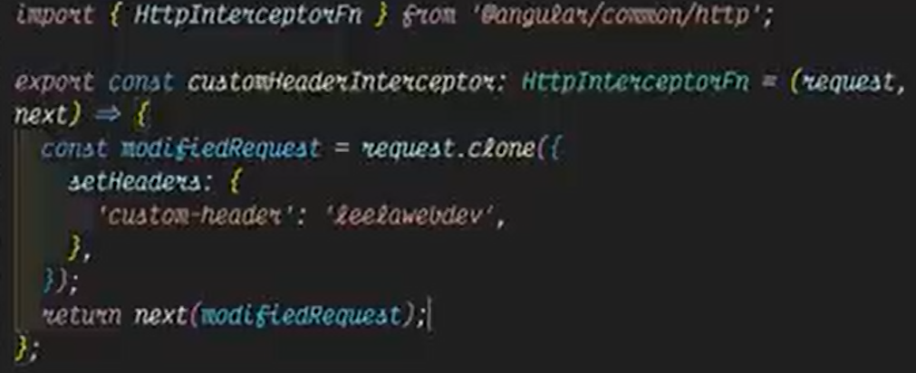  
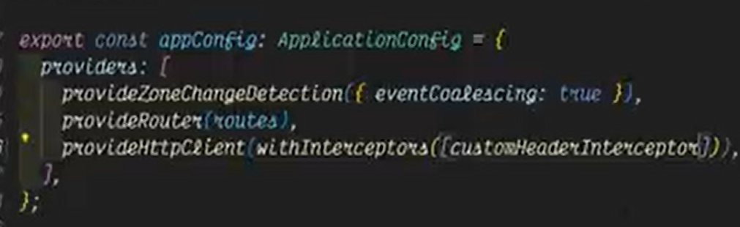  
  
**DI based interceptors >>> **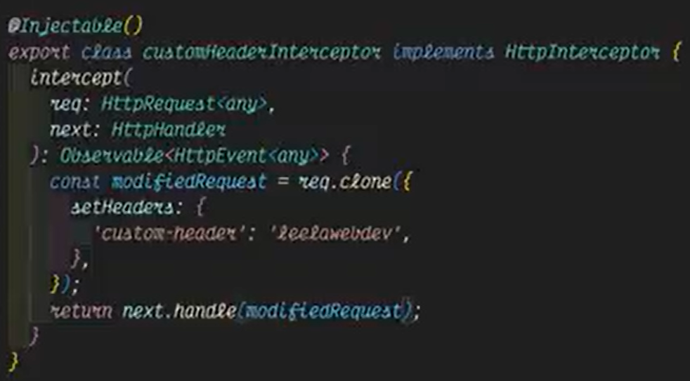  
  
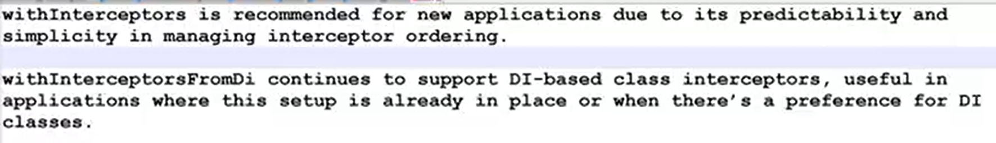**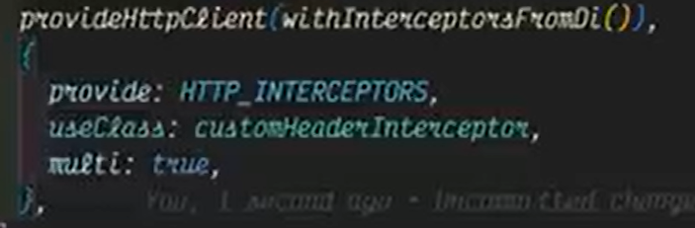

**Call Parent & Child Interceptors —-----------------------------------------------------------------------------**  
  
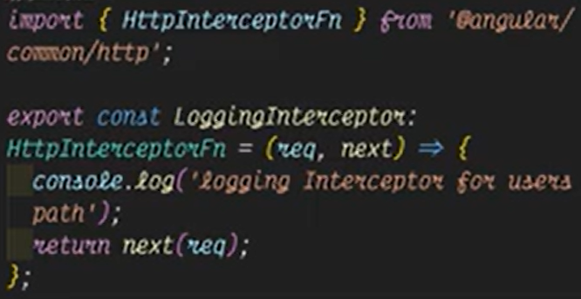 new custom interceptor

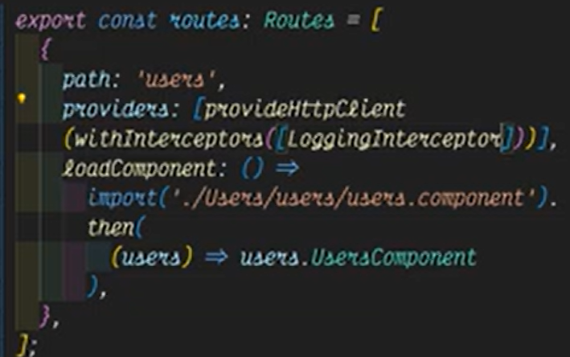 only the logging interceptor will be placed to users path. Not the customInterceptor (in config file) will not be executed. Custom interceptor will be executed within other routes except the users route  
  
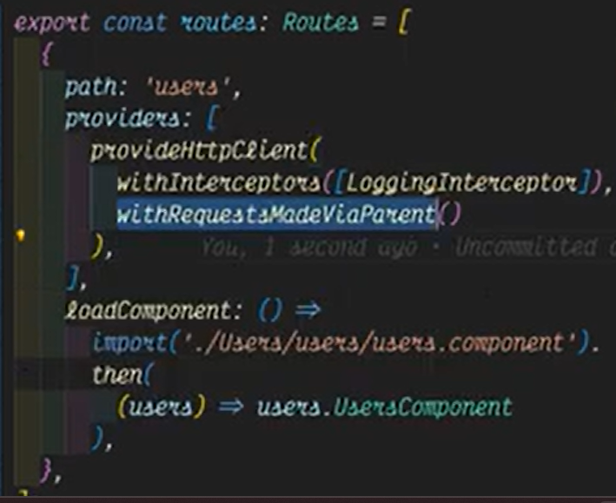  
**Fetch JSON, Images & More with ResponseType —------------------------------------------------------**  


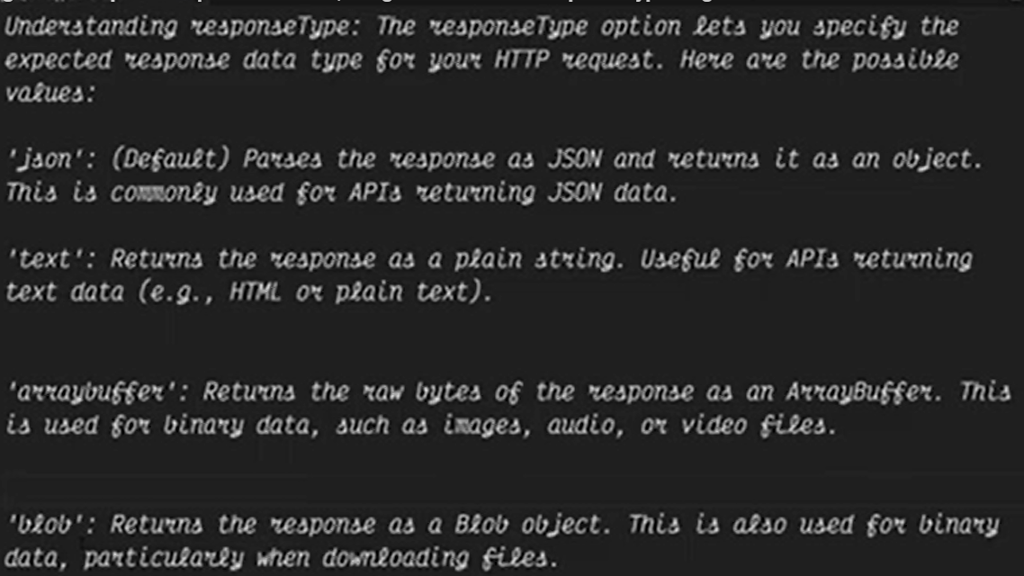  
  
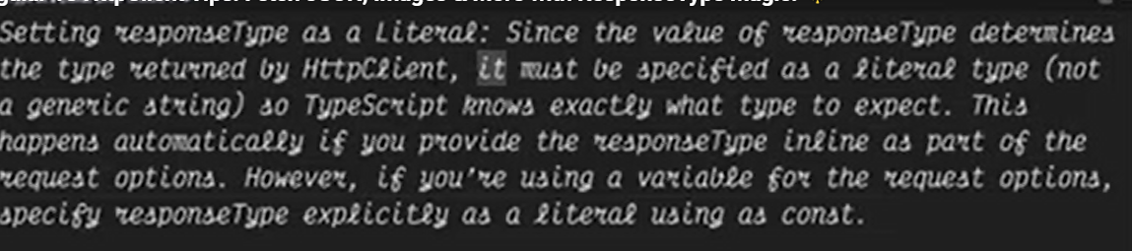  
  
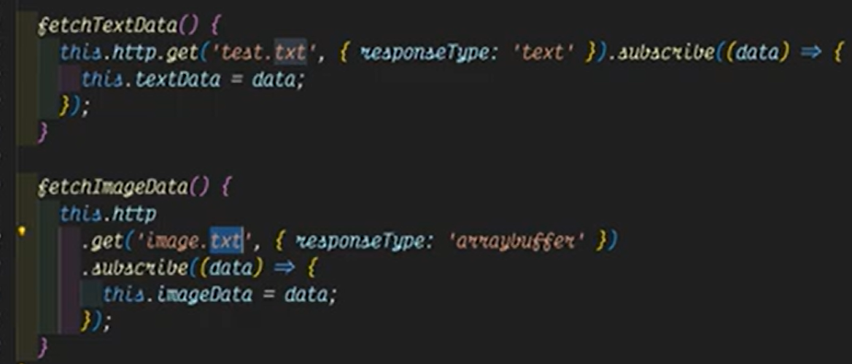

**HttpParams & Object Literals —---------------------------------------------------------------------------------  
  
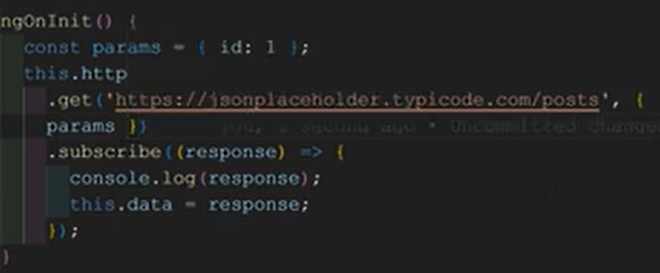  
  
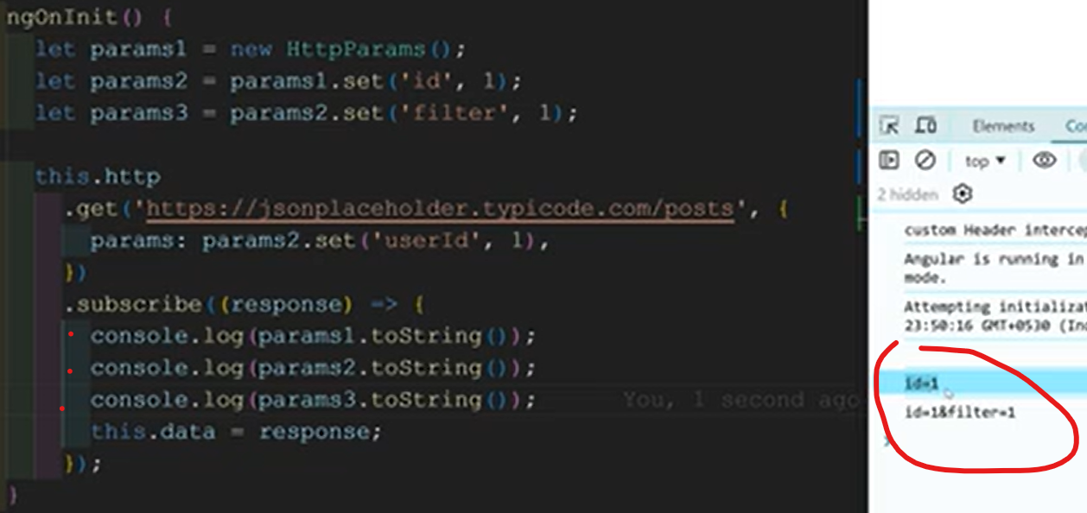**Those are immutables object and creates new objects at each time  
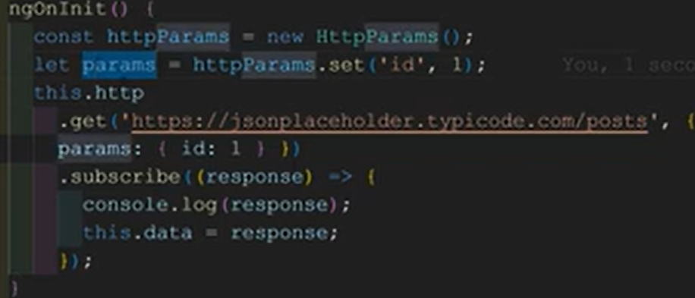

**HTTP Requests with Custom ParamCodec —---------------------------------------------------------------**

Encoding url parameters  
  
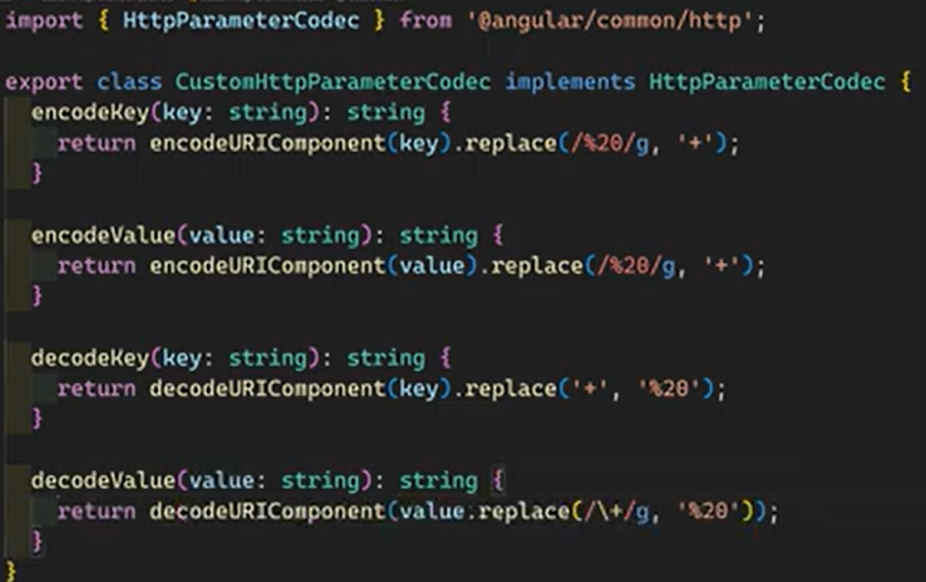  
  
  
  
  
  
  
  
  
  
  
  
  
  
  
**Immutable HttpHeaders —-----------------------------------------------------------------------------------------**  
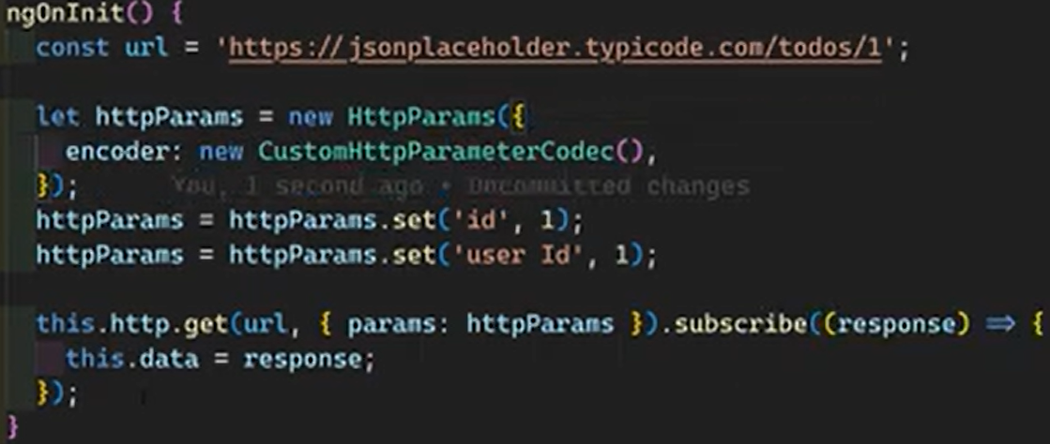

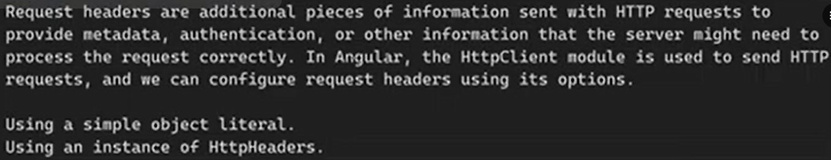  
  
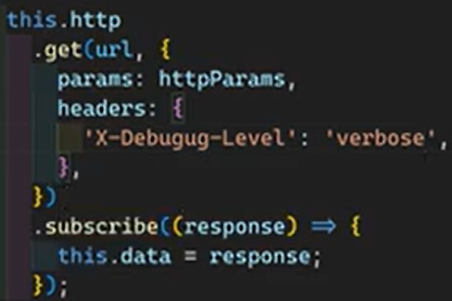  
  
  
  
**Observe Full Response —----------------------------------------------------------------------------------------**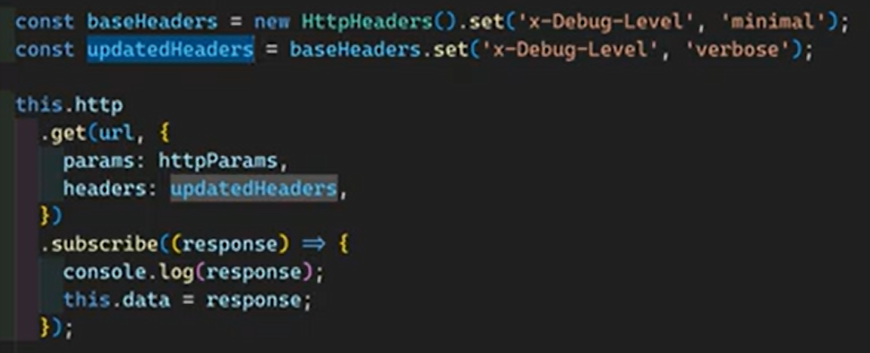

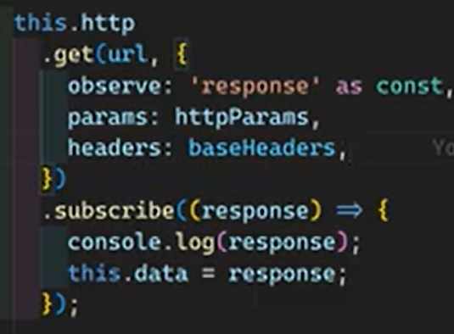  
  
  
**File Upload - Track Progress & Handle Events —--------------------------------------------------------**

Http client can return steam of raw events that represent various stages of http request

Request send  
Upload progress  
Response header received  
Download progress

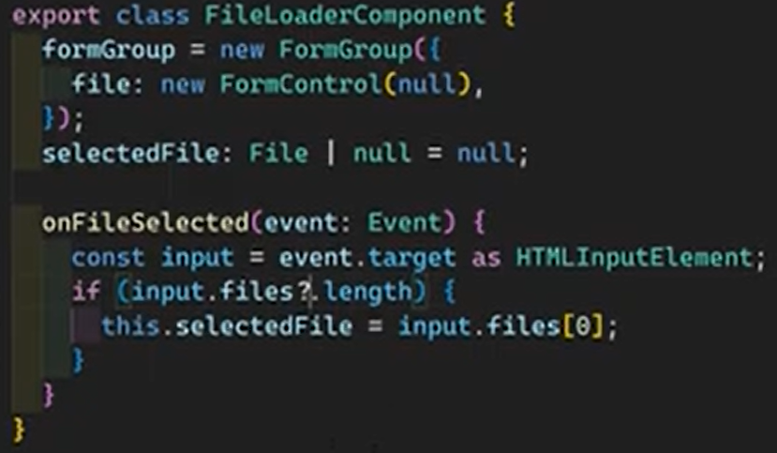  
  
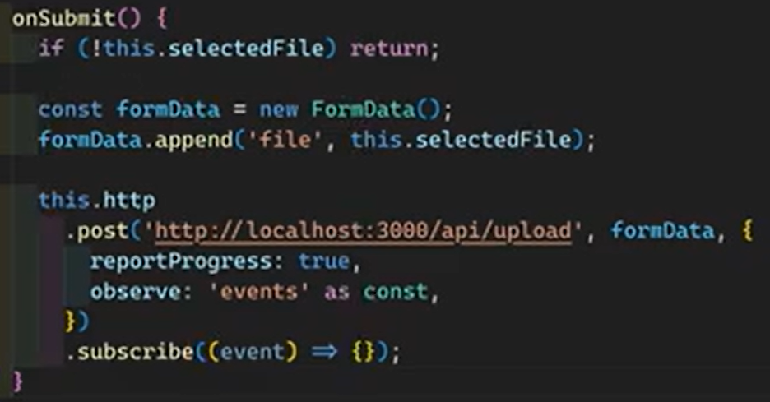  
  
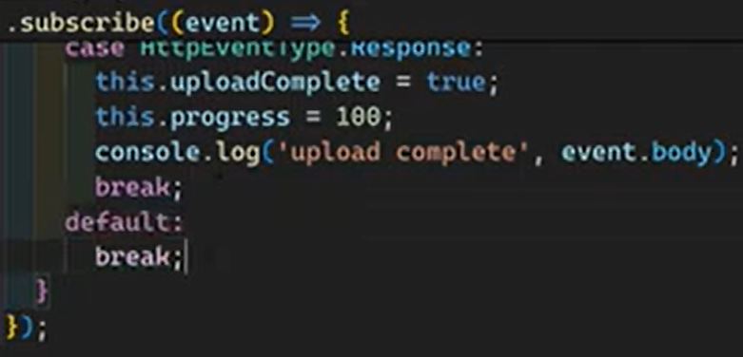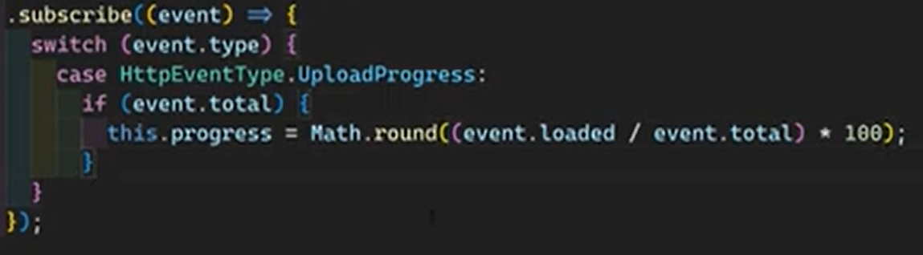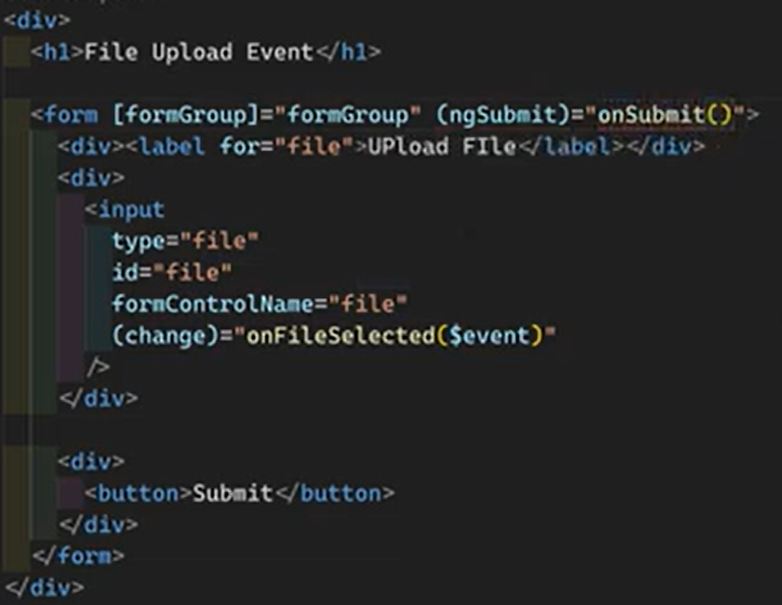

**Fix HTTP Failures in with RxJS Operators —---------------------------------------------------------------**

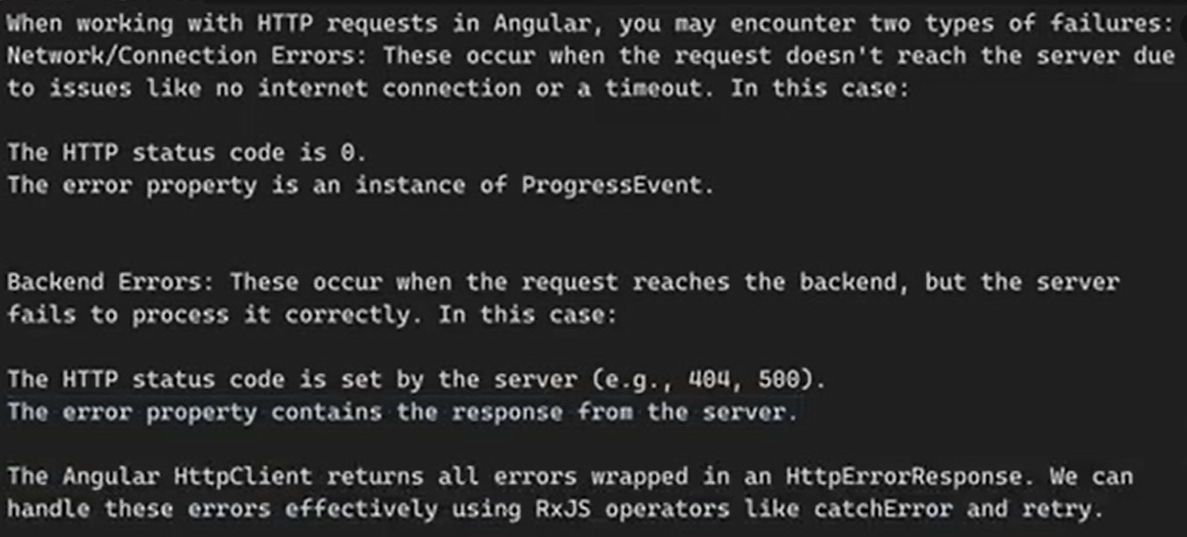  
  
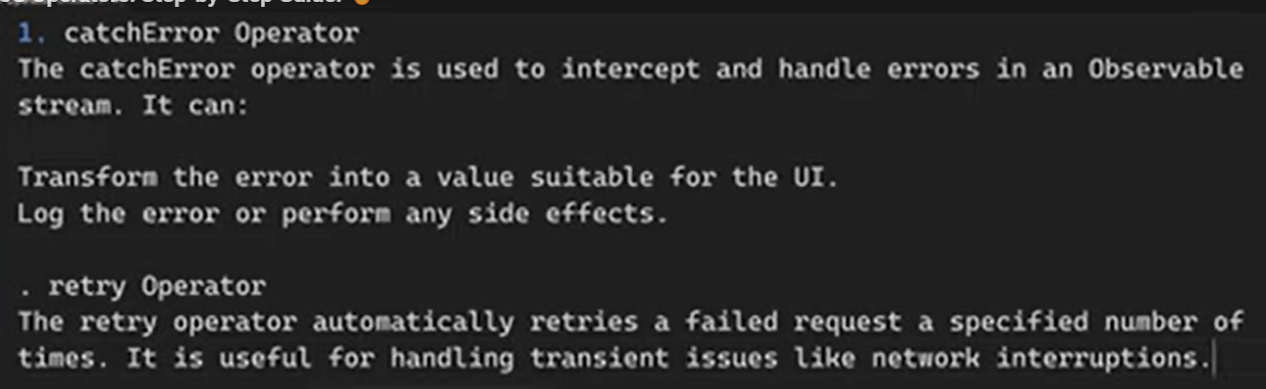  
  
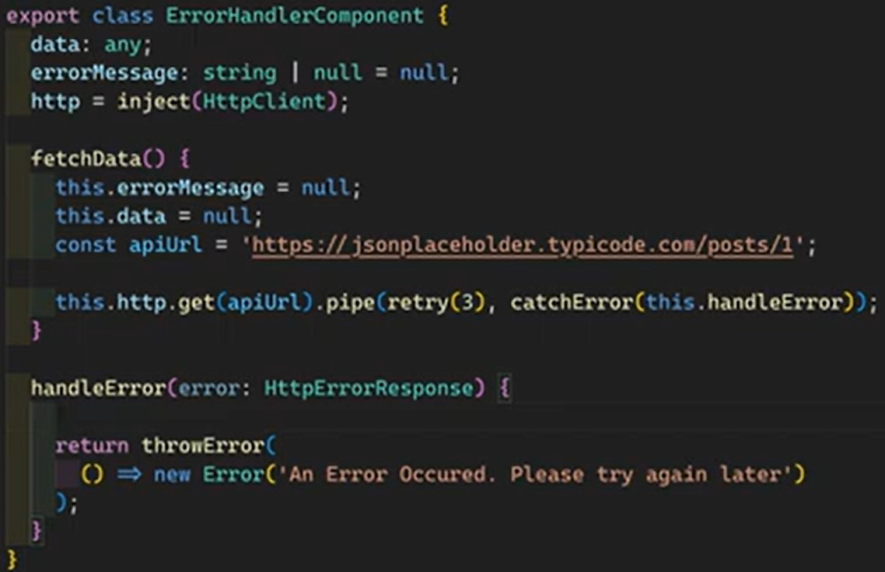  
  
  
  
  
  
  
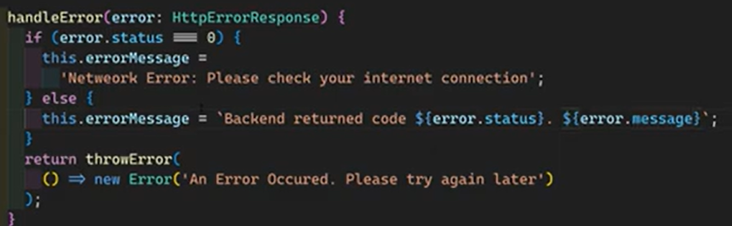  
  
Dynamic retry >>>  
  
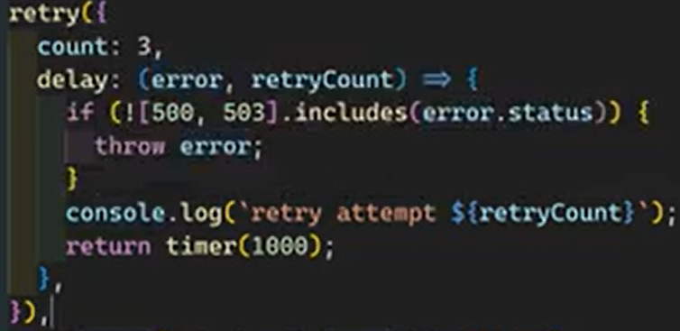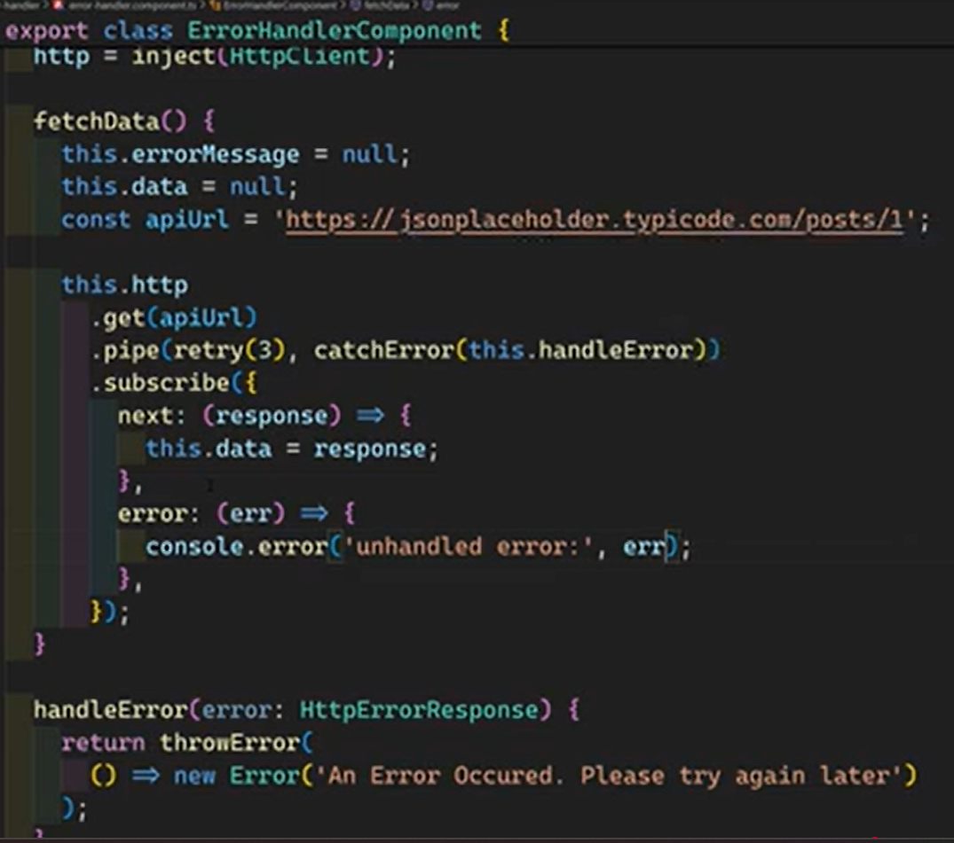

**Angular 19 Server Side Rendering**

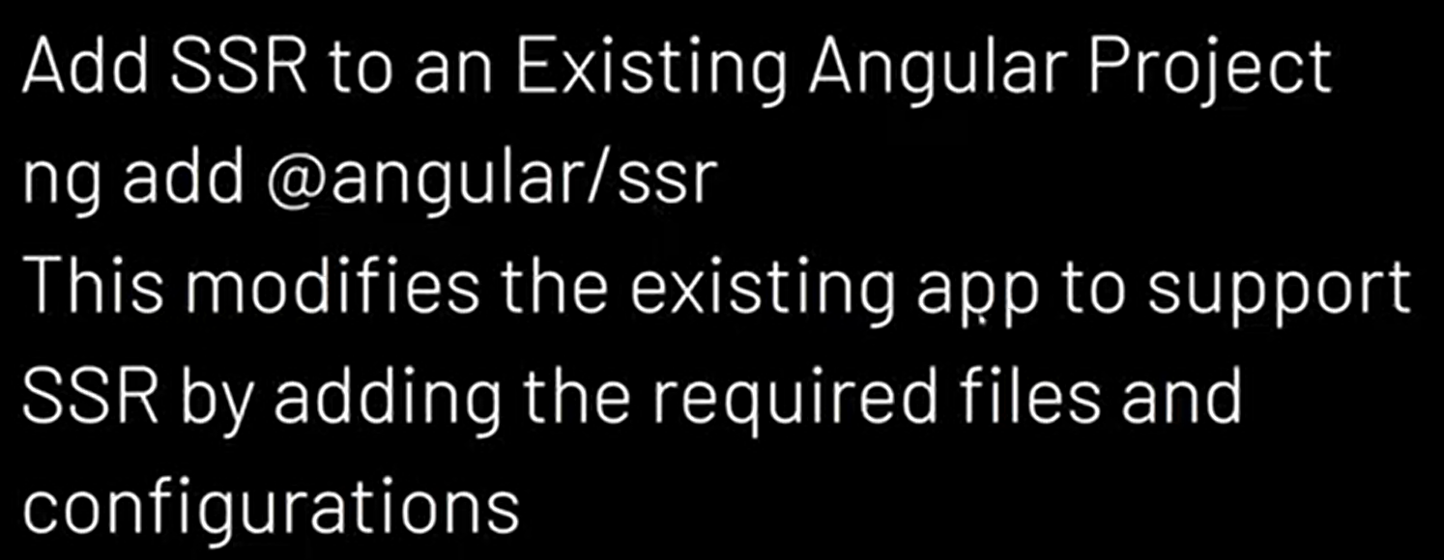

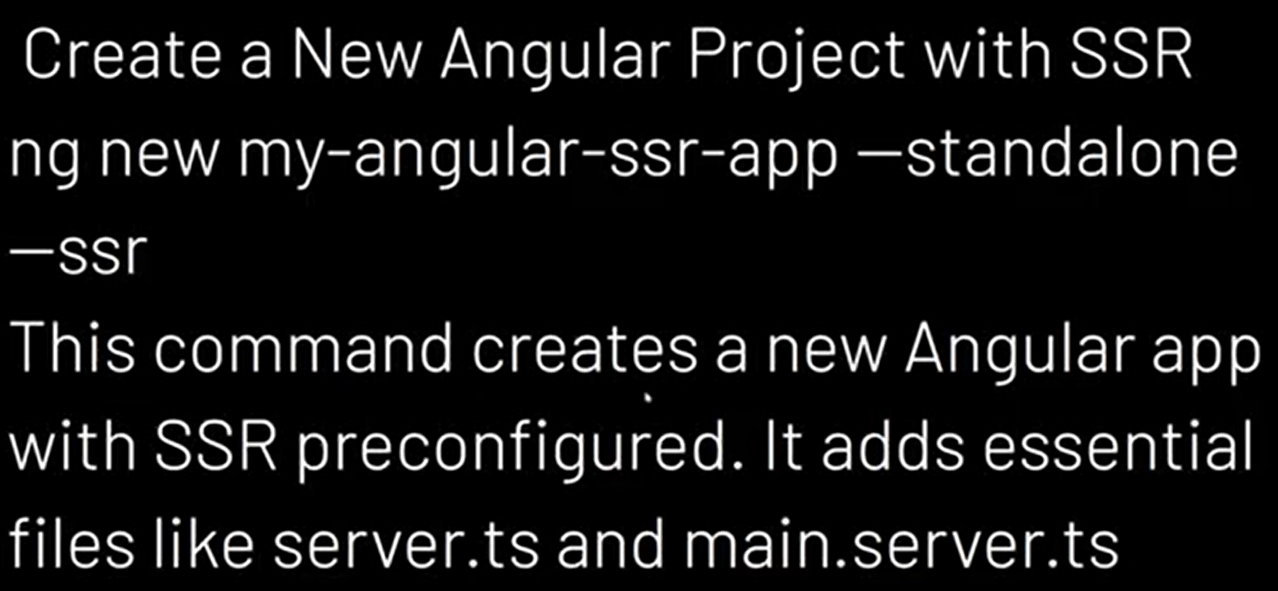 **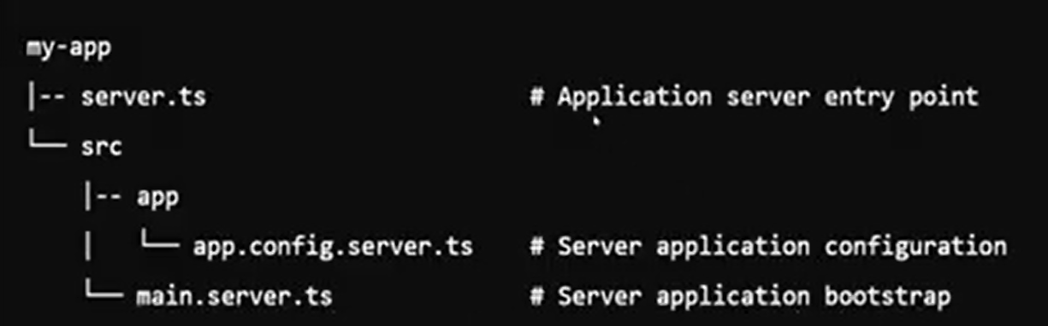  
**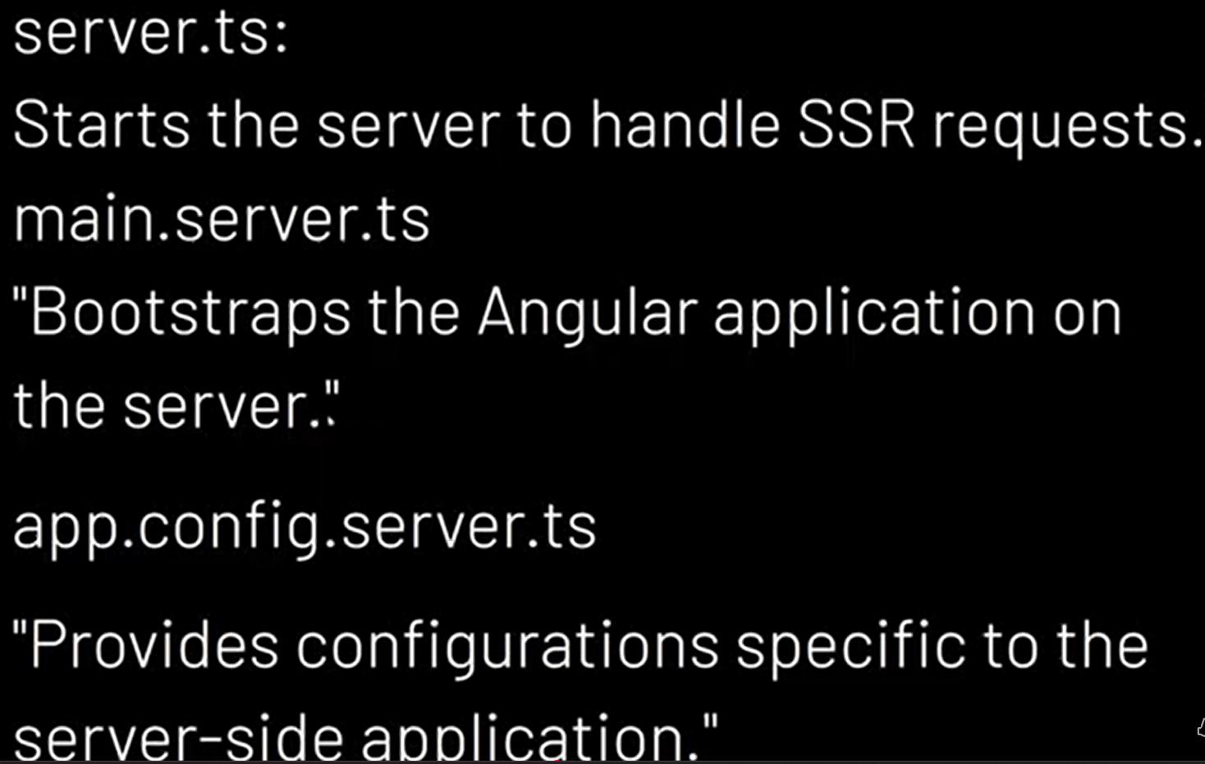

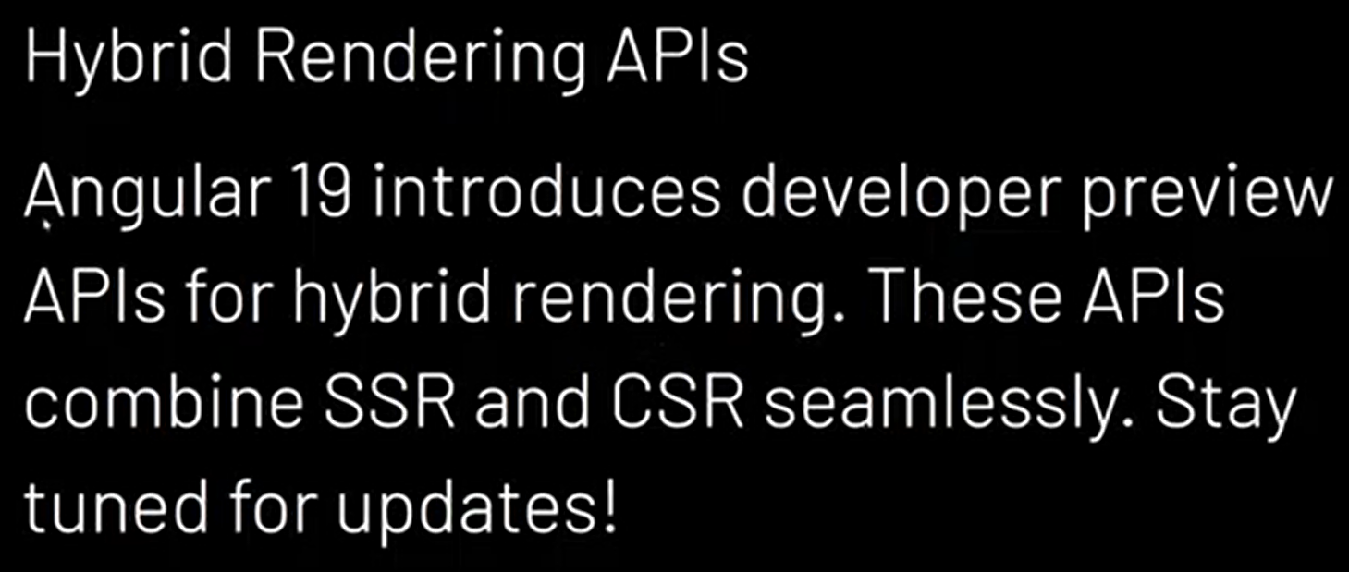



**HttpClient Caching for both Get & Post Requests using includePostRequests —-------------**

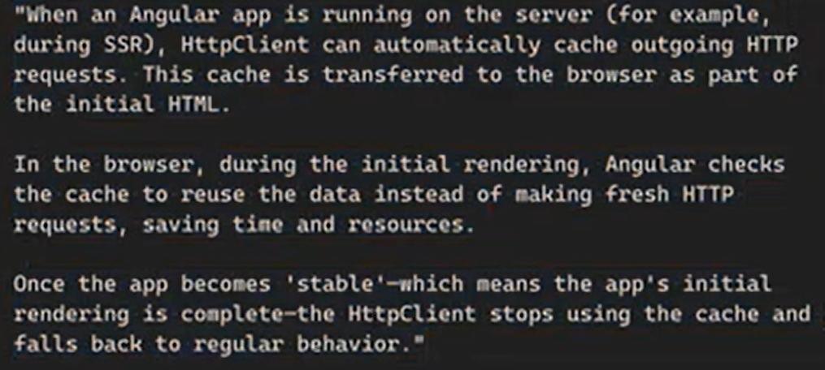  
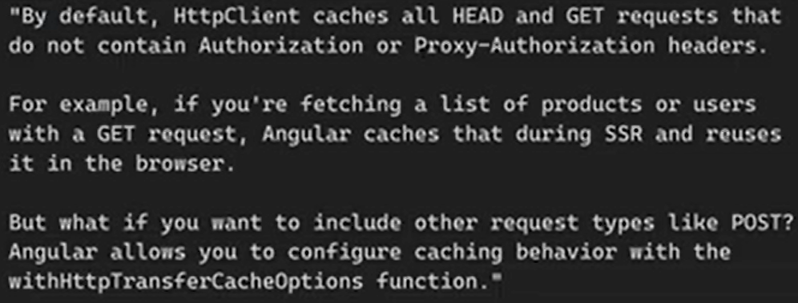  
  
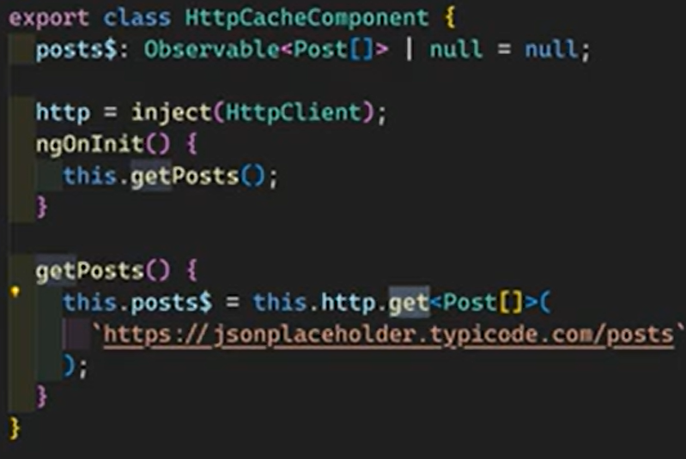  
Initial http request(when the page is loaded) not made since it was cached, After the button click getPosts() will be executed and http request also executed normally. But the Post requests behaves normally without chaching by default

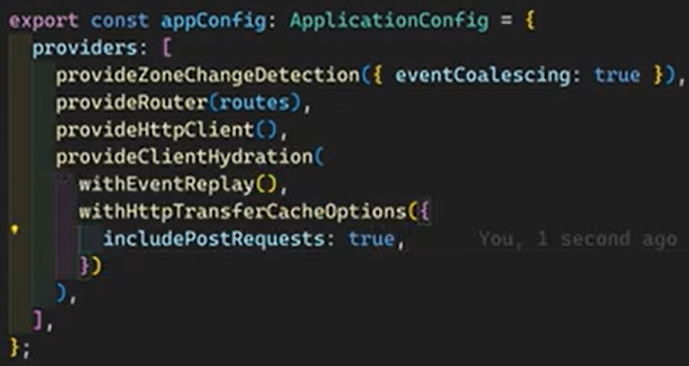  
In order to chase the post requests also

**SSR afterNextRender for implementing Browser-Only Logic —--------------------------------------**

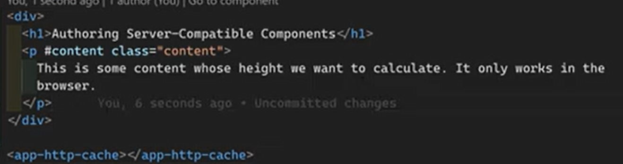  
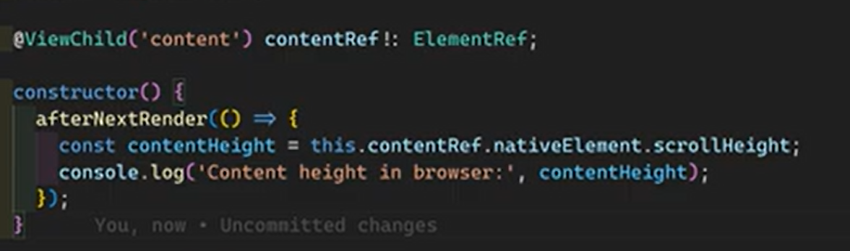

**Prerendering in Angular 19 - Standalone Components for Static Pages —-----------------------**

Angular applications can use Server-Side Rendering (SSR) for dynamic, per-request rendering, and prerendering (Static Site Generation or SSG) for generating static HTML at build time. Both improve performance (Time to First Byte) and SEO, but serve different use cases and can be combined in a hybrid approach

| **Mode** | **Description** | **Best For** | **Requires Server at Runtime?** |
| --- | --- | --- | --- |
| SSR (Server) | Renders HTML on the server for each request at runtime. | Dynamic content that changes frequently or is user-specific. | Yes (e.g., Node.js/Express). |
| Prerender (SSG) | Renders static HTML files at build time for specific routes. | Static content like documentation, blog posts, or landing pages. | No, static files can be served from a CDN/static host. |
| Client (CSR) | Renders entirely in the browser. | User-specific content or highly interactive components where initial SEO isn't critical. | No. |

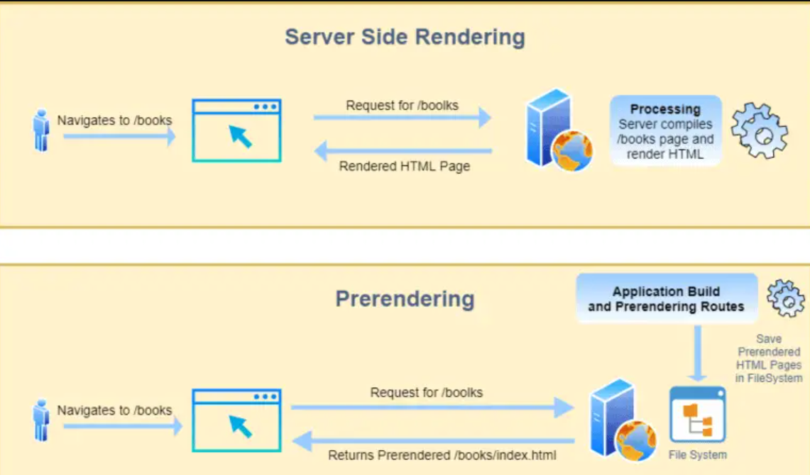  
  
  
  
  
Example :  
  
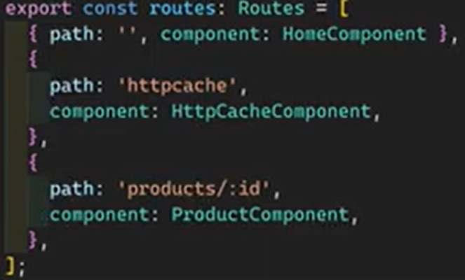 sample routes  
  
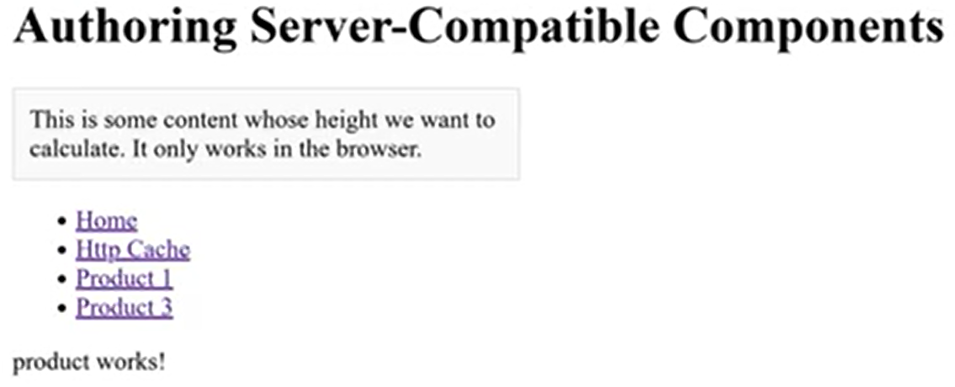trying to access product/:id routes with/without prerendering  
  
  
Building express server inside angular project - creating Server.js at the project root level  
  
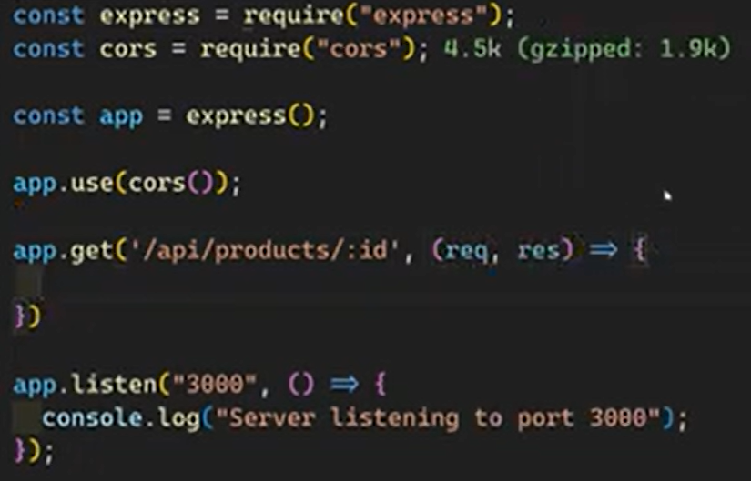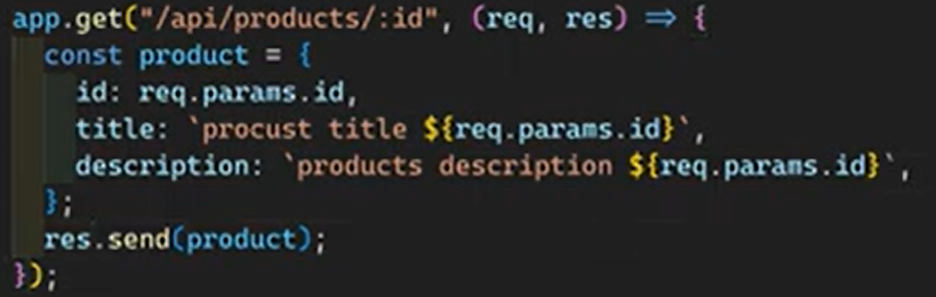  
  
  
  
Inside page or component  
  
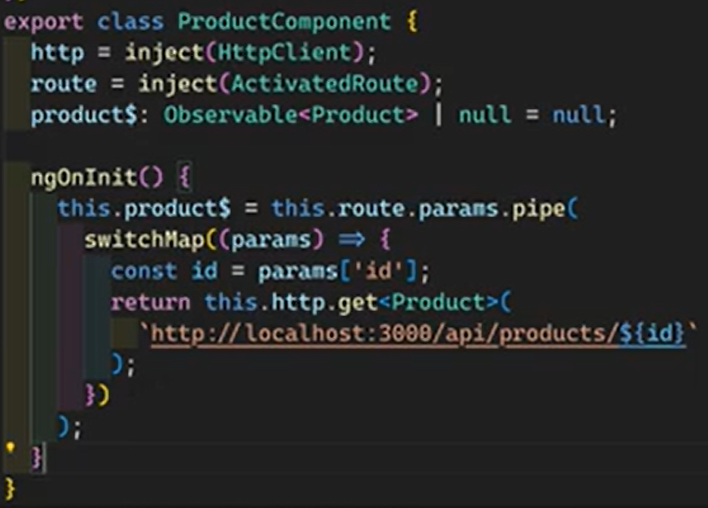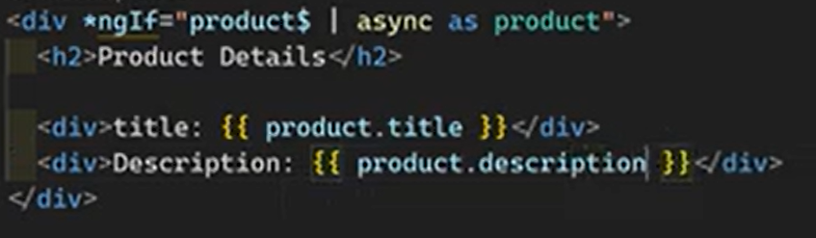  
  
So this implementation without prerendering concept…  
  
  
**Prerender unparameterized static routes in Angular 19 SSR using config object with Routes File —----------------------------------------------------------------------------------------------------------------------------**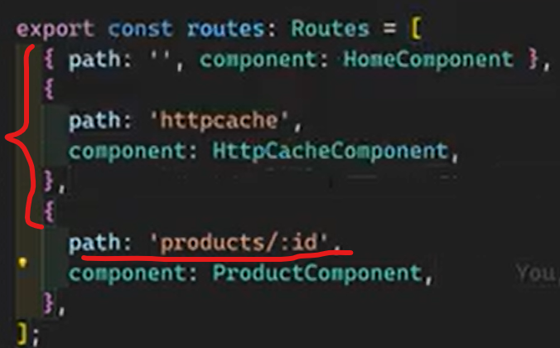

Npm run build - create build output , dist folder  
  
Ng build   
Prerender options by default will be true - all the static routes prerendered (non parameterized routes)  
  
  
Angular.json file  
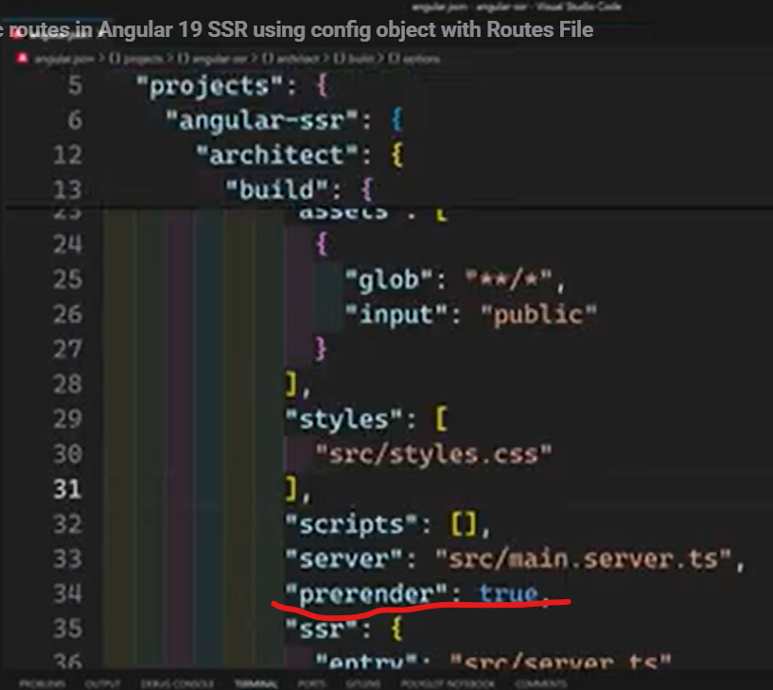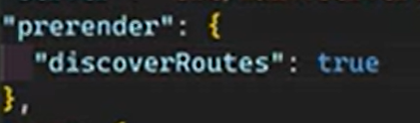  
  
When we build the project with this property true - dist folder will be include the prerender static files  
If we set this property to false and then build the project it will not be create prerender static files  
  
  
If we need to control what are the routes should be prerenderd  
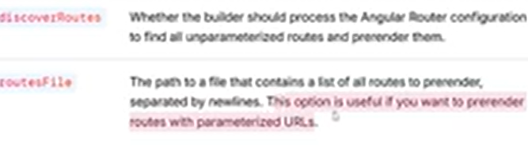

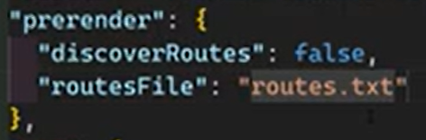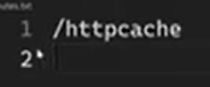 mention the routes in here (/ , /product, /users likewise)  
  
  
  
  
**Prerender the Parametrized dynamic routes in Angular 19 SSR for SEO Load Time Improve**  
—---------------------------------------------------------------------------------------------------------------------------------------

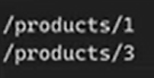only this two prerendered

When the user directly lands on a specifi page, the prerendered page will be rendered. But we navigate normally between the pages then we will get the updated request  
  
  
  
  
  
  
  
  
  
  
  
  
  
  
  
  
  
  
  
  
  
  
  
  
  
  
  
  
  
  
  
  
  
  
  
  
  
 **Hybrid Rendering in Angular, Combine SSR, CSR & SSG**

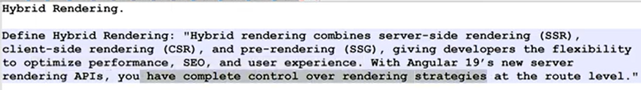  
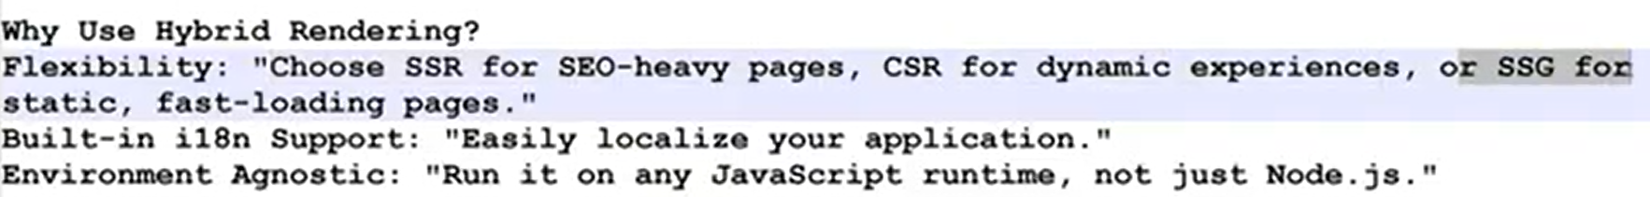  
  
Npm run build  
Npm run server:ssr:Angular-server

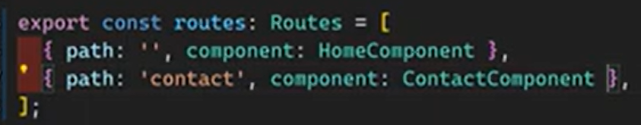  
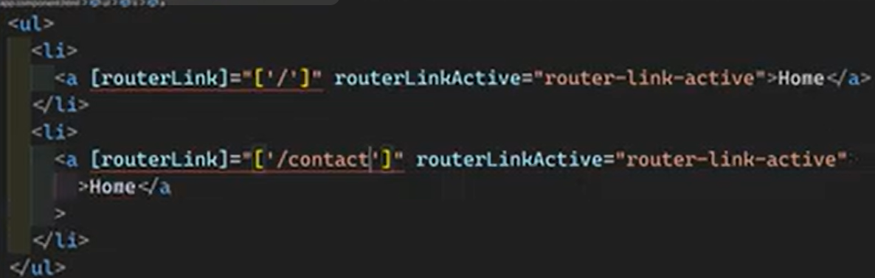  
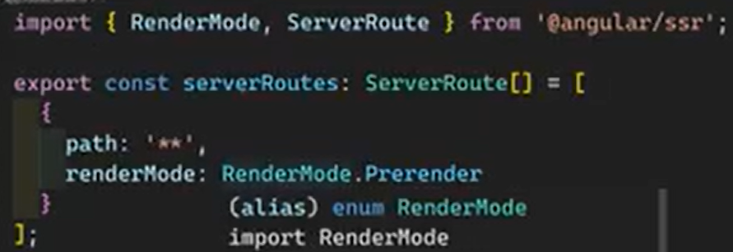  
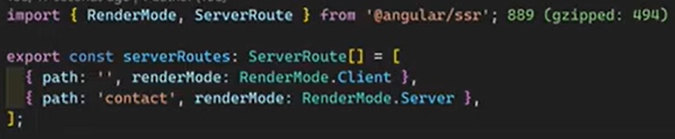  
  
  
  
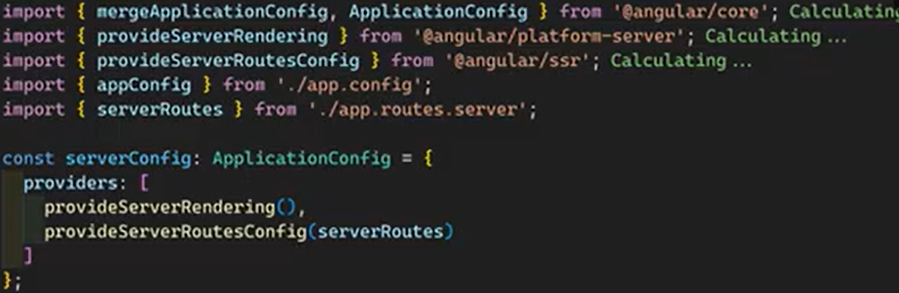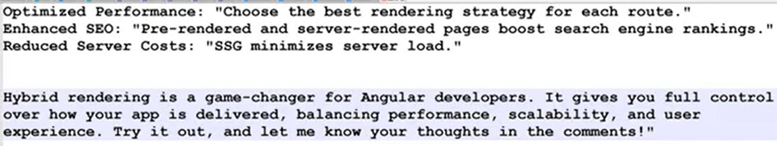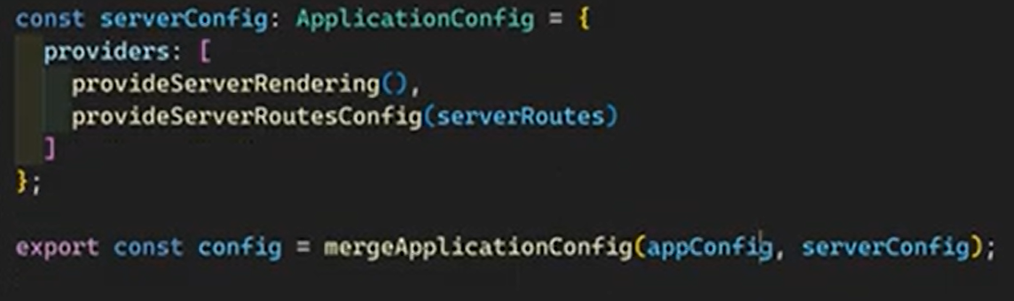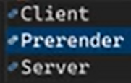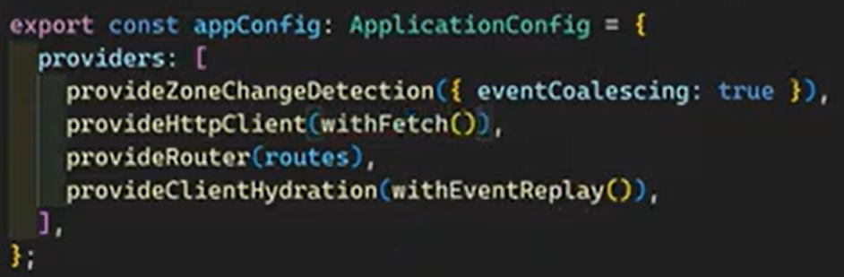

**Customizing build-time prerendering using Parameterized routes & Fallback strategies   
—------------------------------------------------------------------------------------------------------------------------**  
  
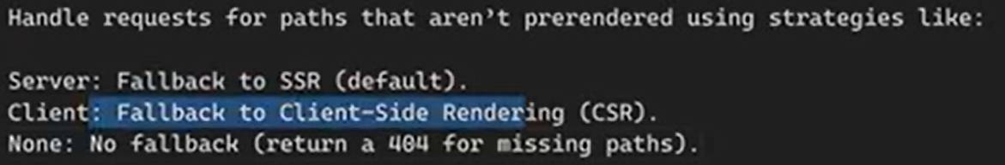  
  
Example:  
  
  
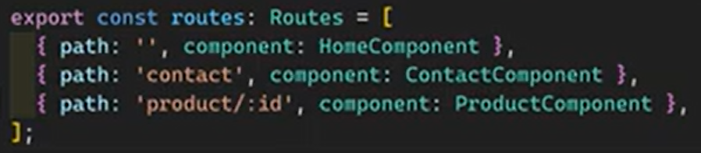  
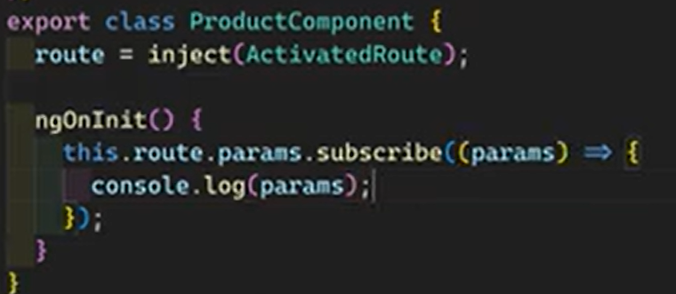  
  
Make only several dynamic routes prerendered  
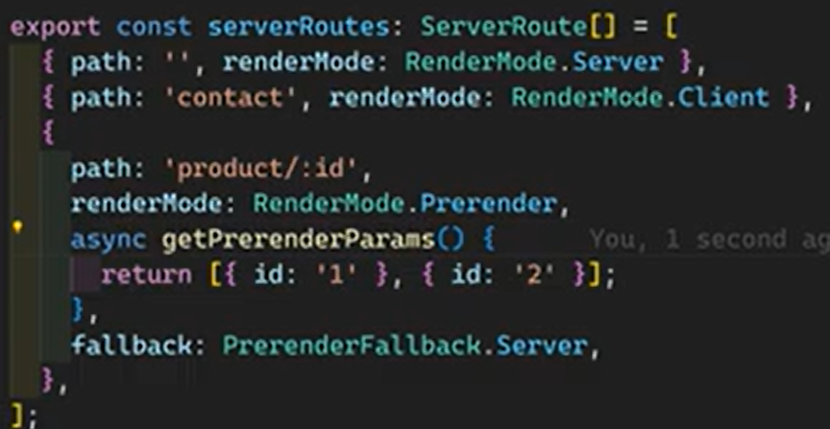  
  
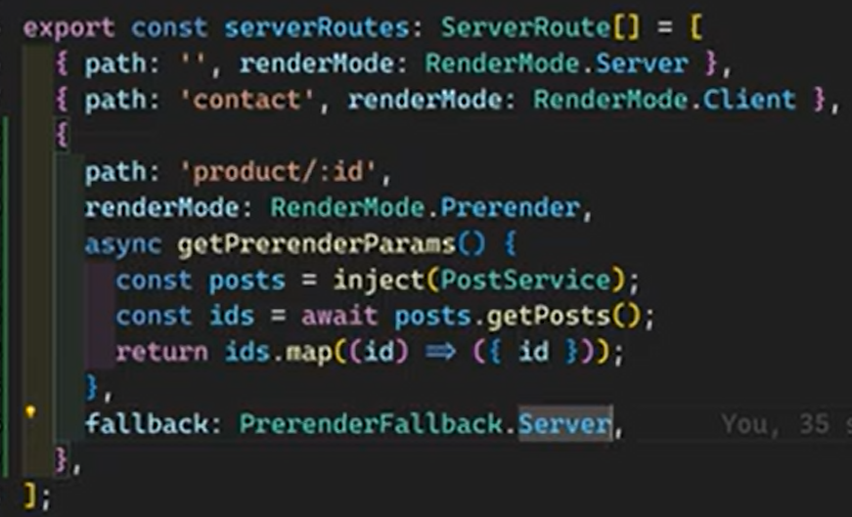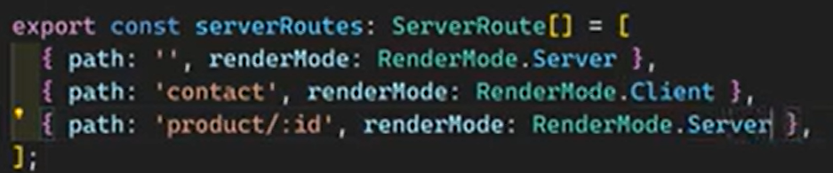

**Angular SSR: REQUEST, RESPONSE_INIT, and REQUEST_CONTEXT —-------------------------**Gives access to critical request and response informations

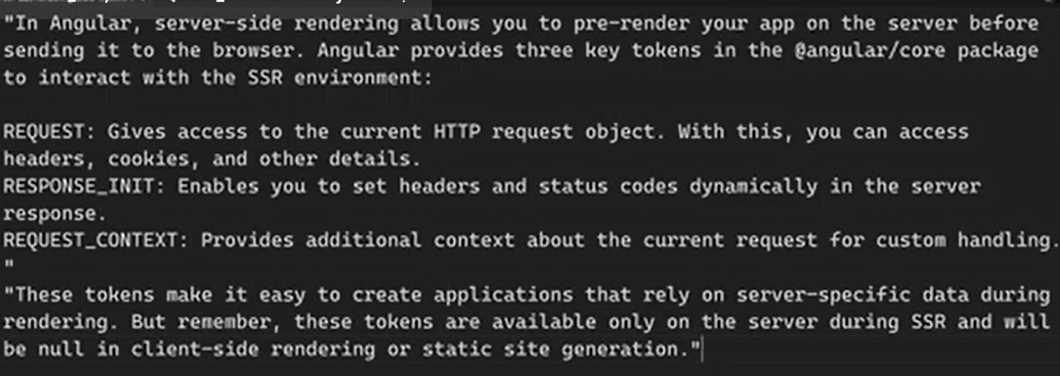

These token only available in server side rendering  
  
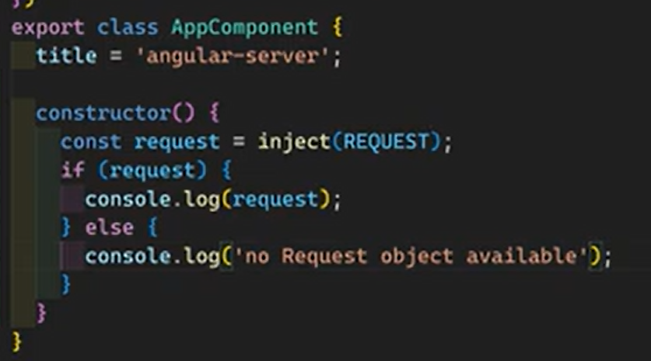server show this information  
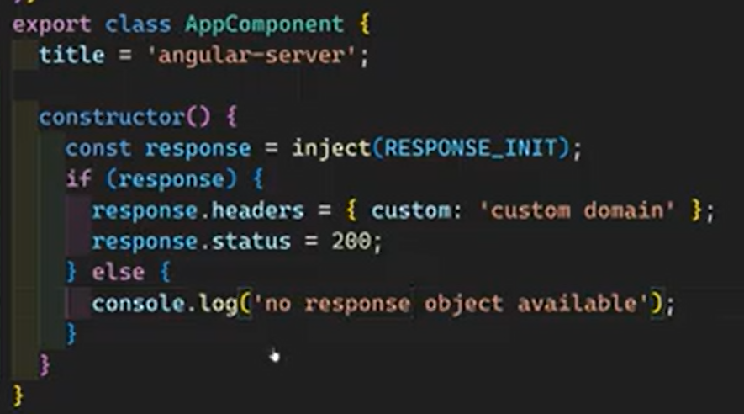  
  
Gives info about requesting device

**Hydration**  
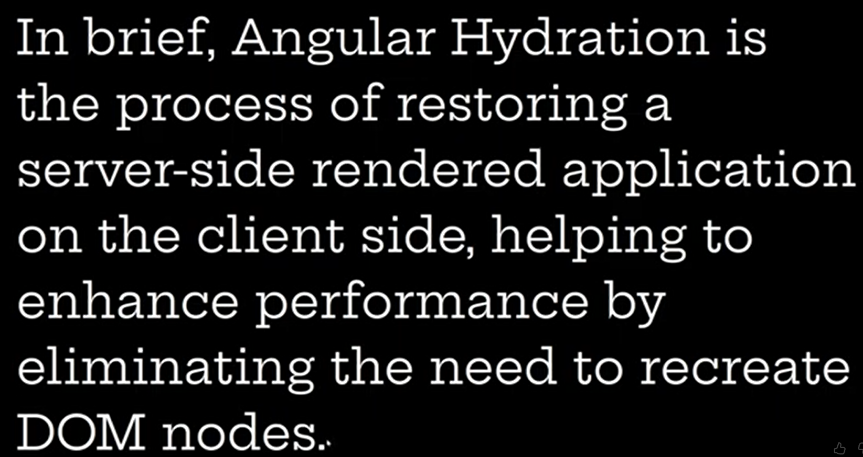  
  
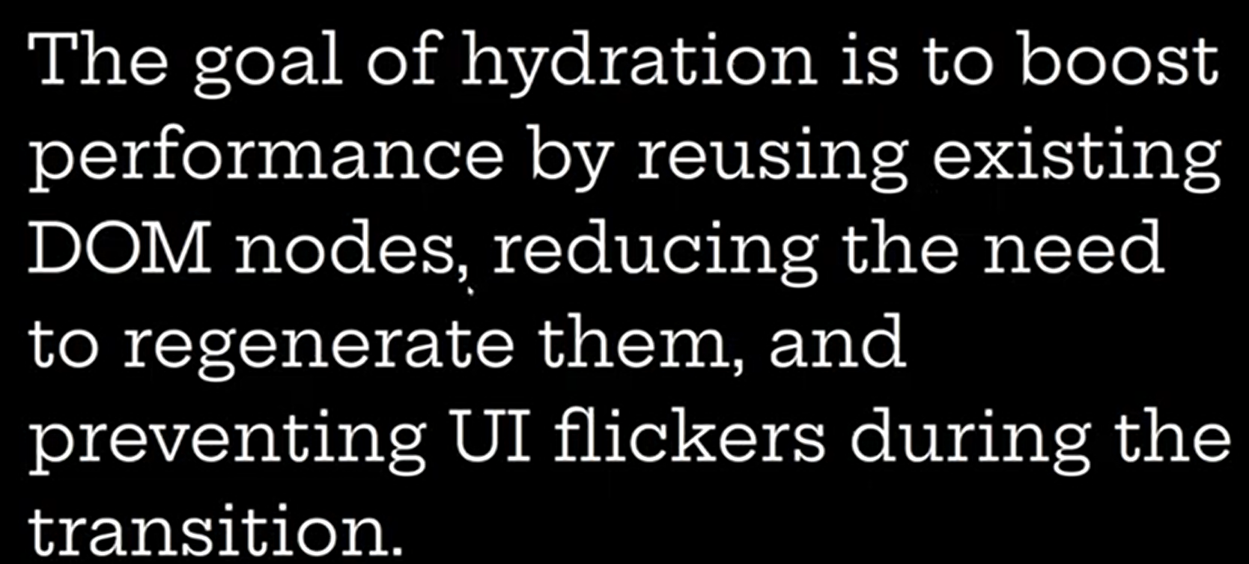  
  
Re creating Dom nodes cause to   
  
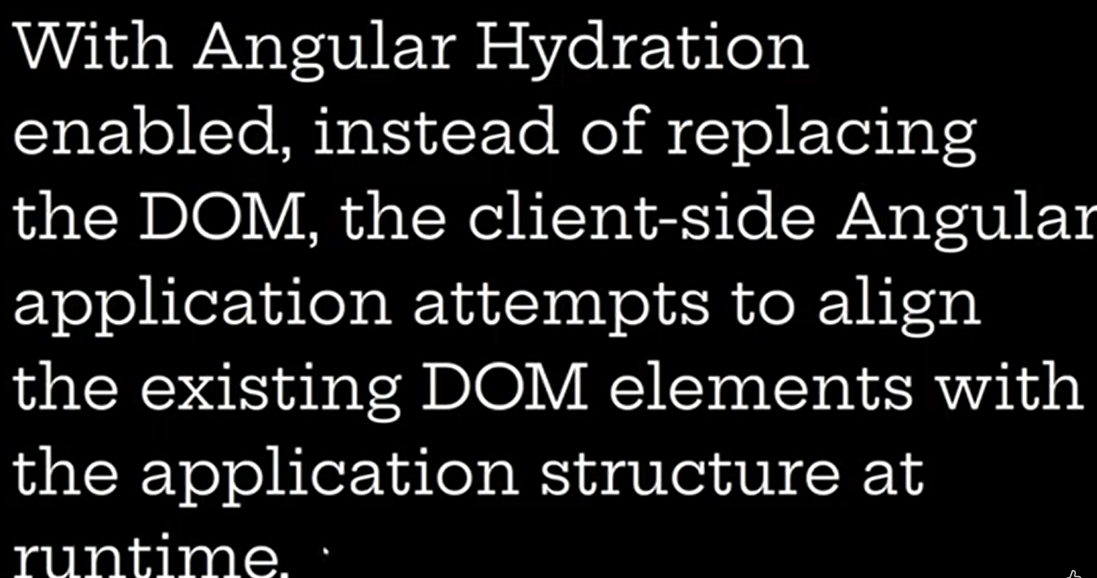  
  
  
  
  
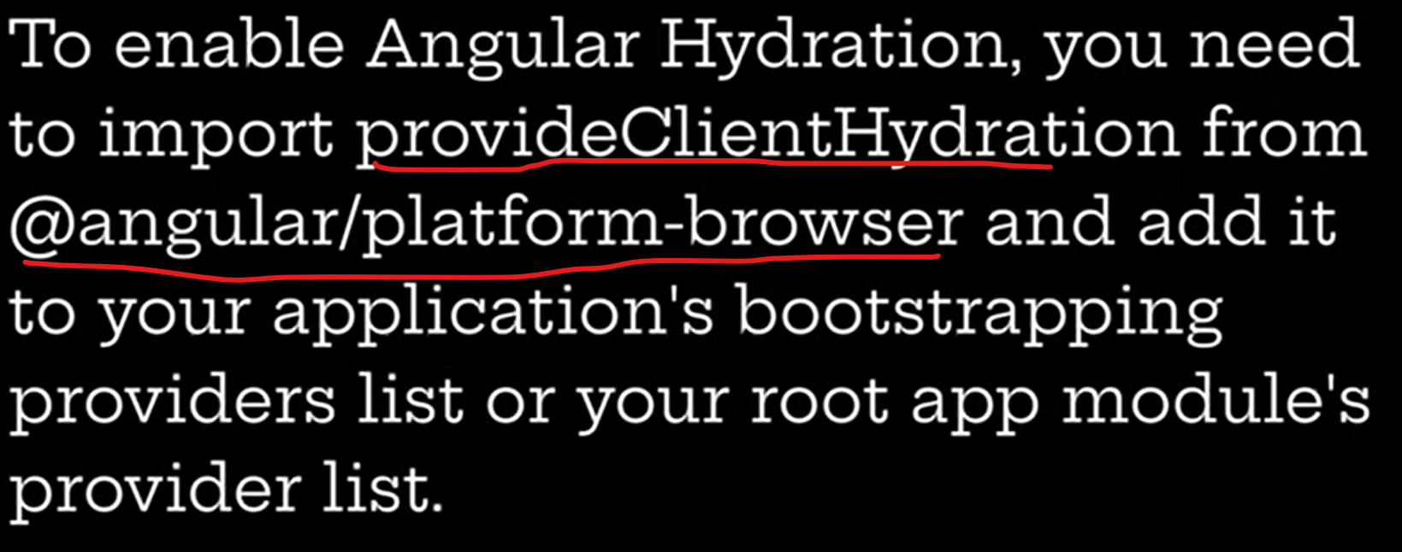

Hydration enables only for the server side applications - can be debugged with angular devtools

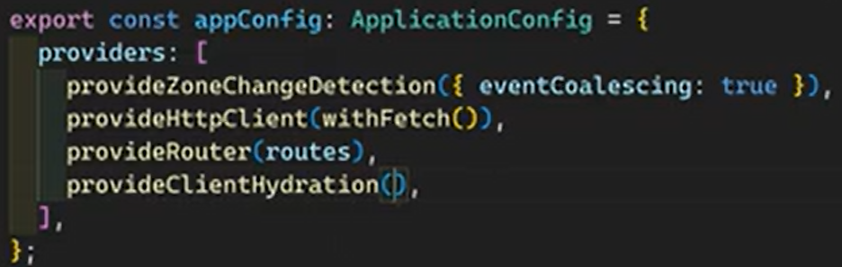  
  
  
withEventReply() will store the all user actions and event during the hydration process ongoing and applies all queued events once the hydration process was done

**Hydration Constraints —-------------------------------------------------------------------------------------------**The client browser dom structure and the html content returned by the server should be exactly same In order to complete the hydration process properly  
  
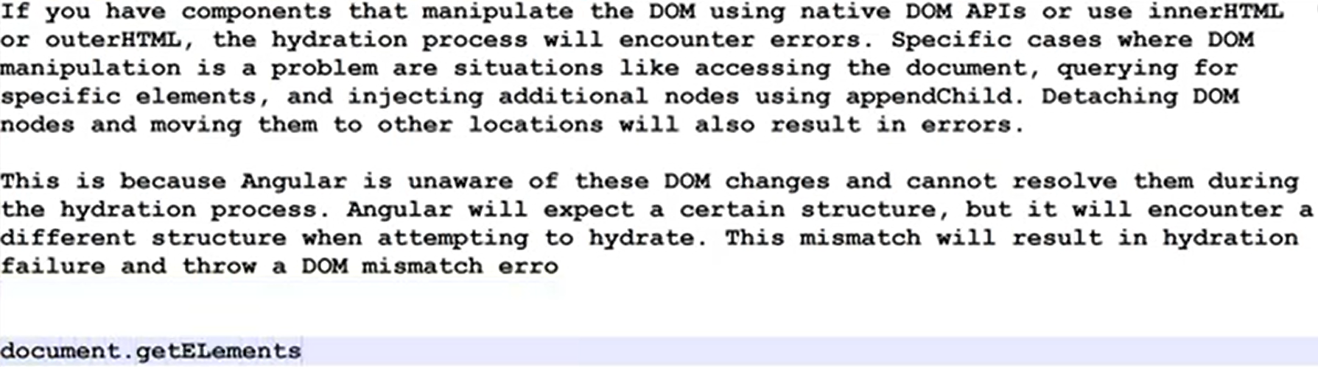  
  
As well as invalid html structures and syntaxes should be avoided  
  
  
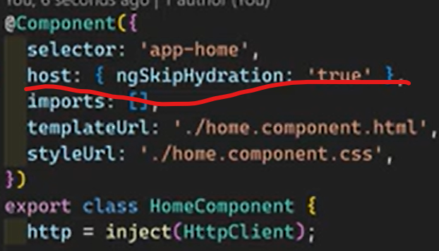  


**Defer Loading —-------------------------------------------------------------------------------------------------------**

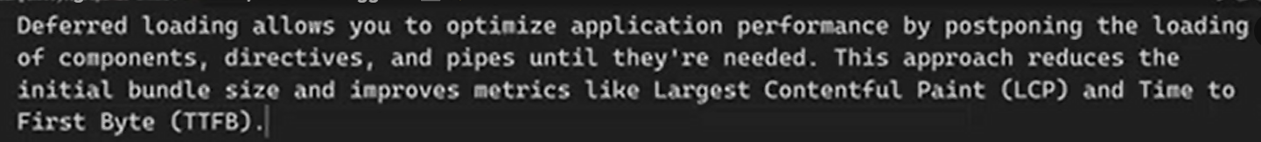  
  
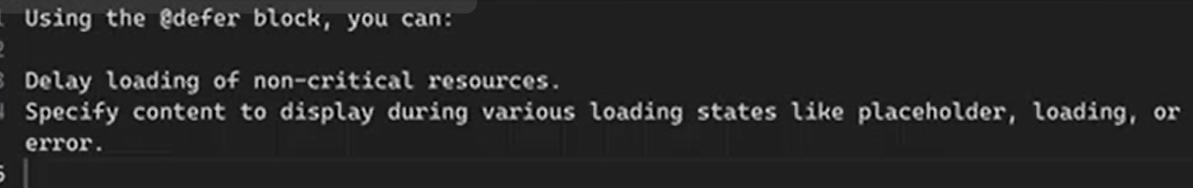  
  
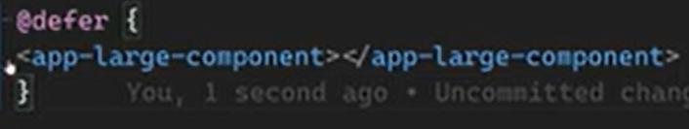  
  
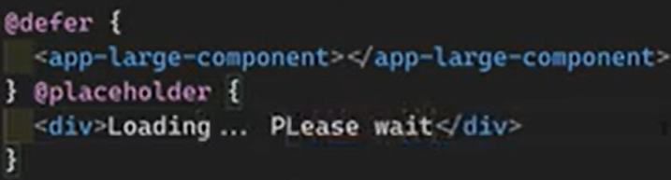  
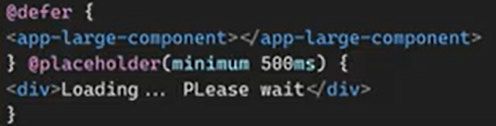  
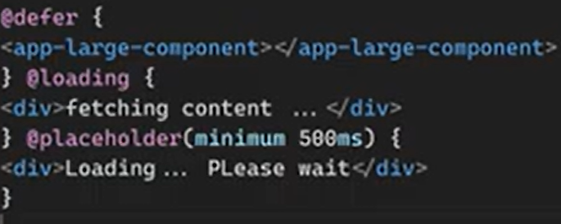  
  
  
  
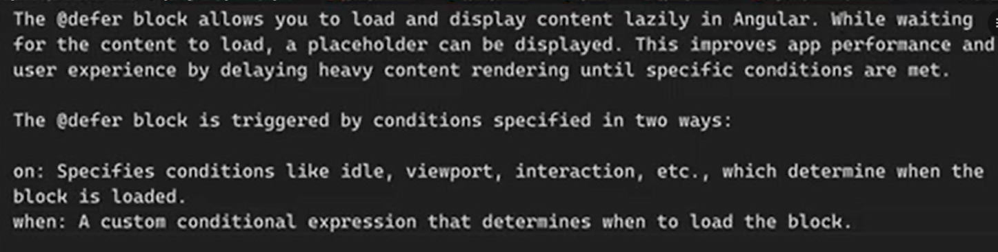  
  
  
  
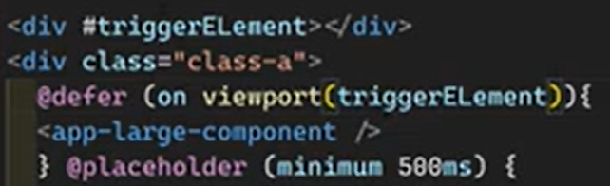  
Try to loads when ever the triggerElement comes to viewport  
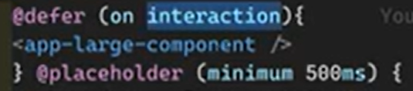  
User interaction need to load the component, click on it  
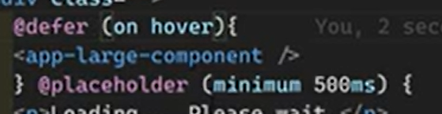  
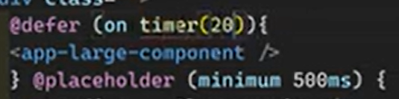  
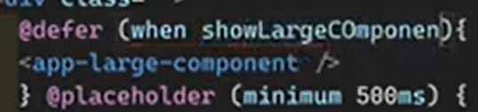  
Showloargecomponent is a variable in class file  
  
  
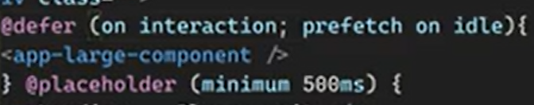  
  
  
  
  
  
  
  
  
  
  
  
  
  
  
  
  
  
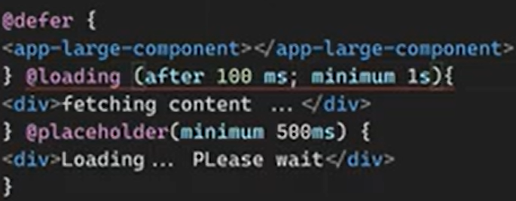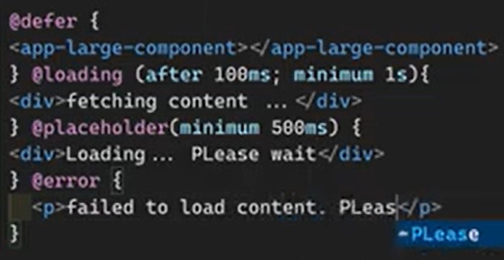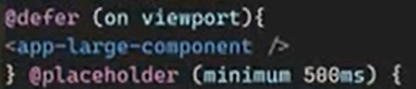

**Incremental Hydration**  
  
  
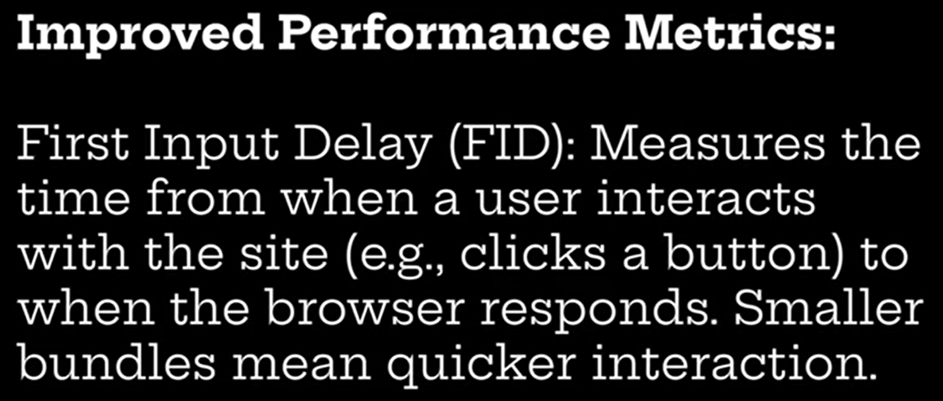  
  
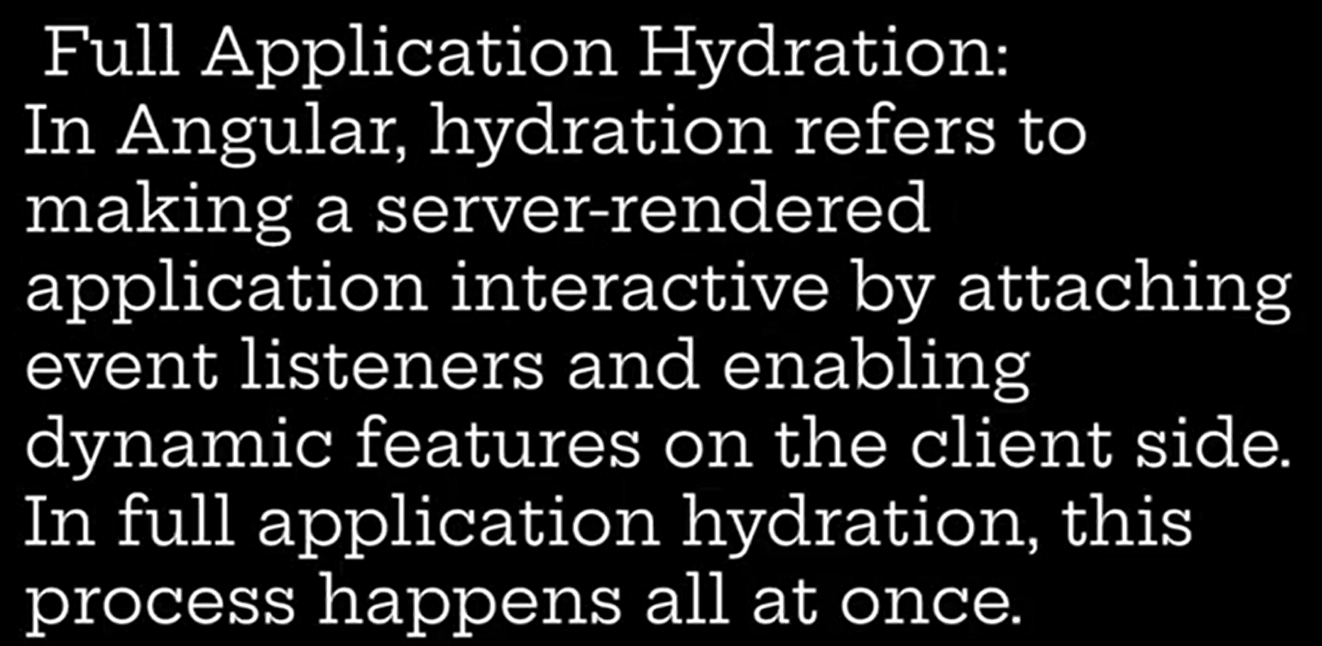  
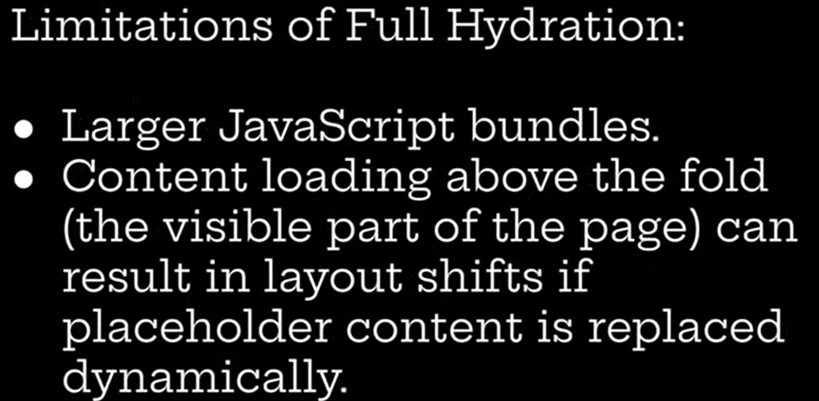  
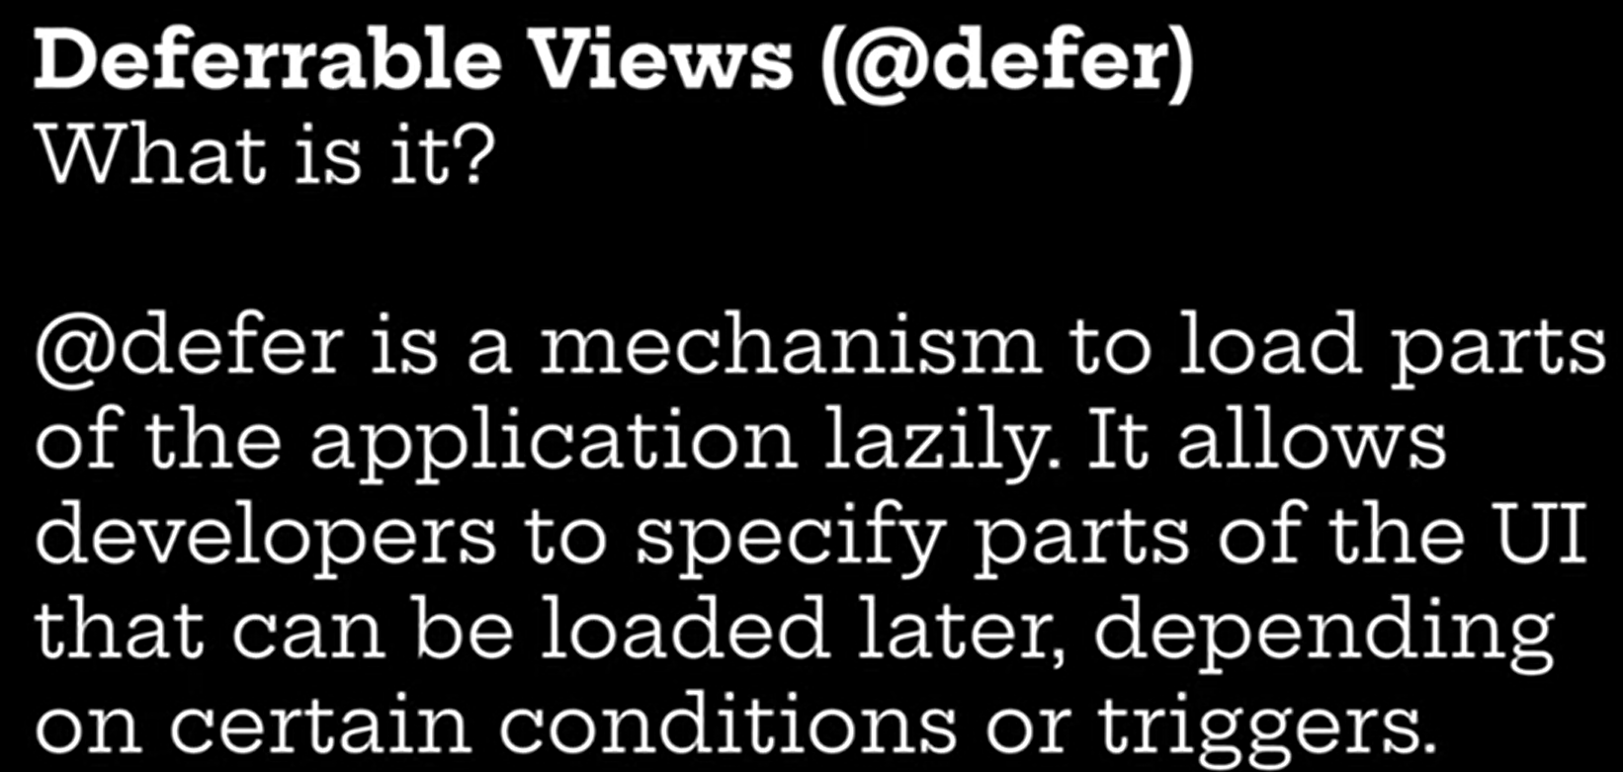  
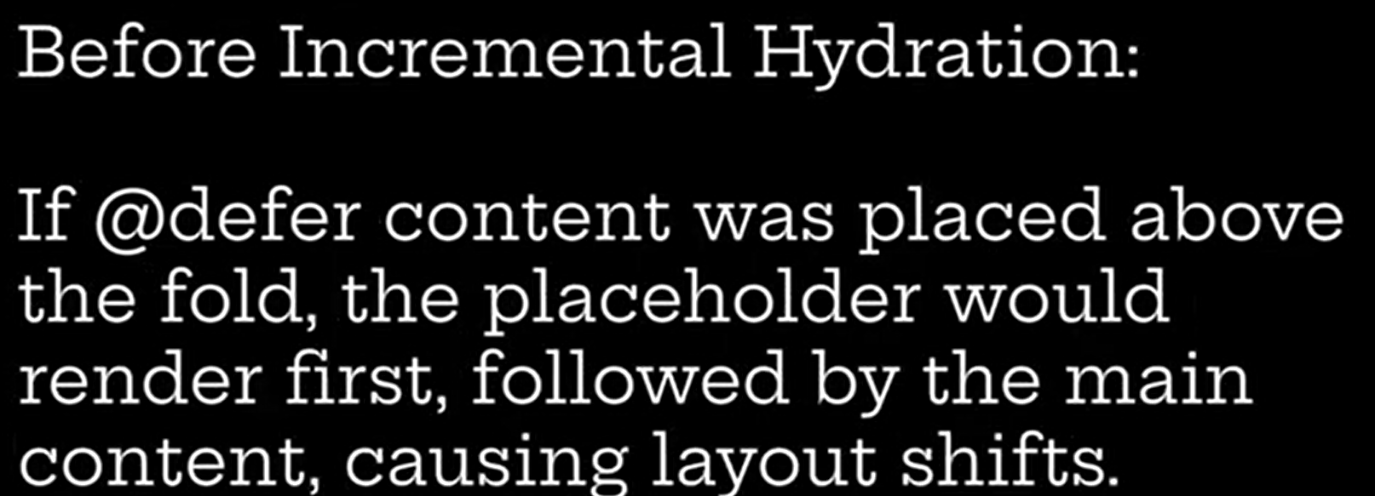  
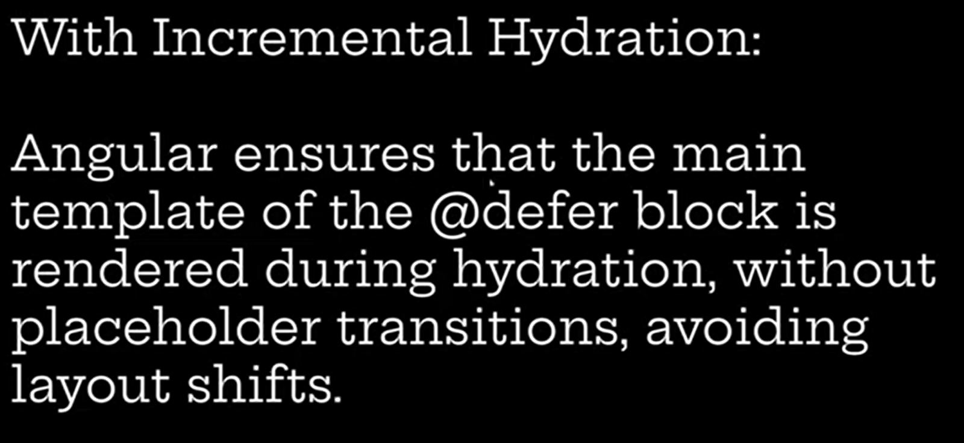  
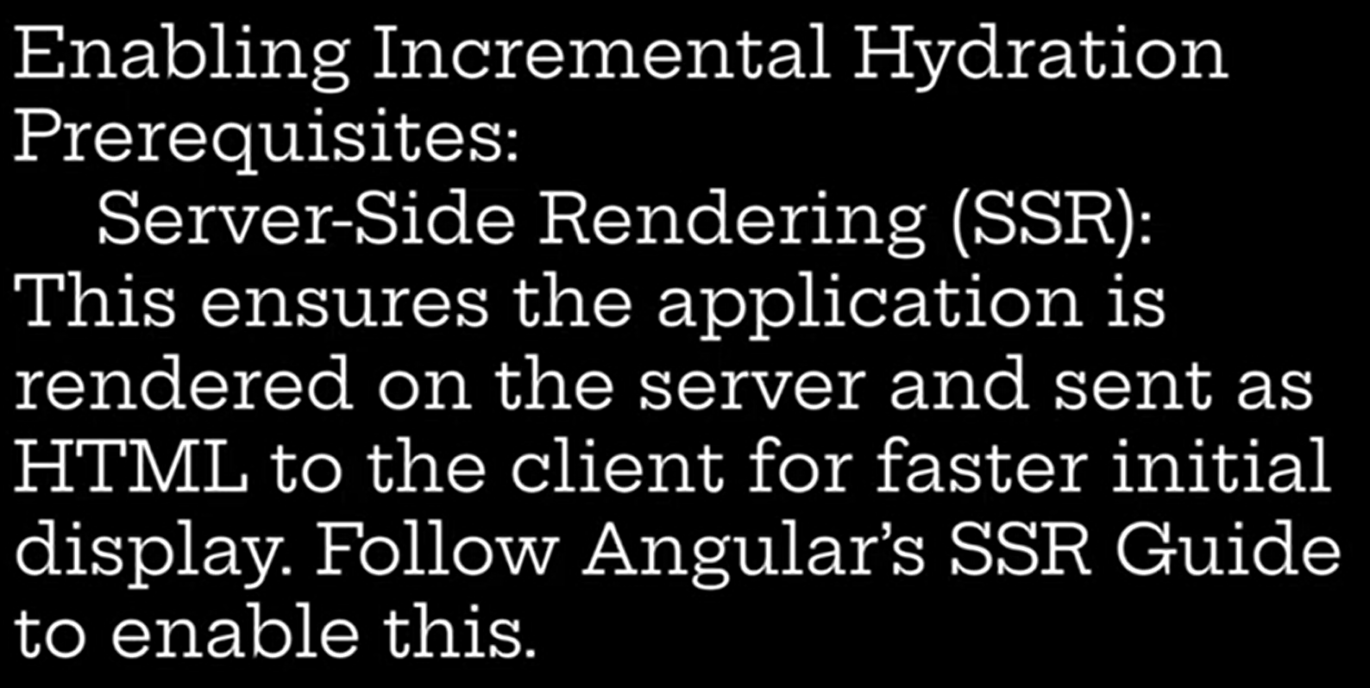  
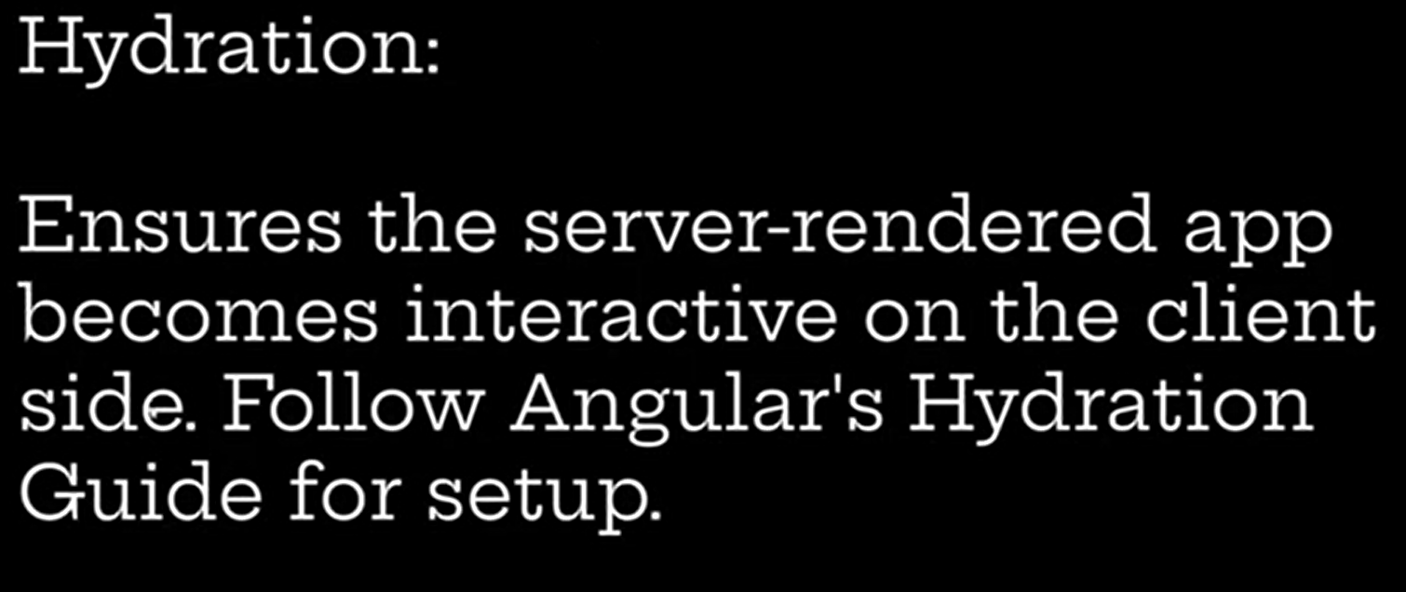  
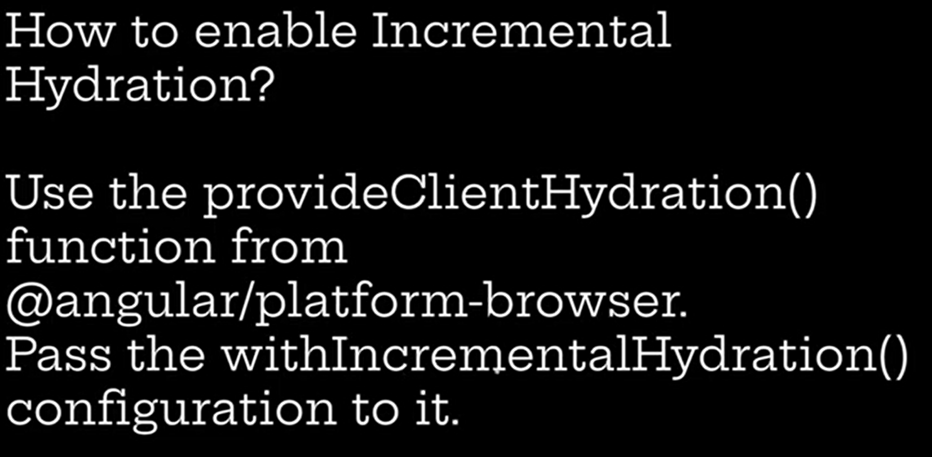  
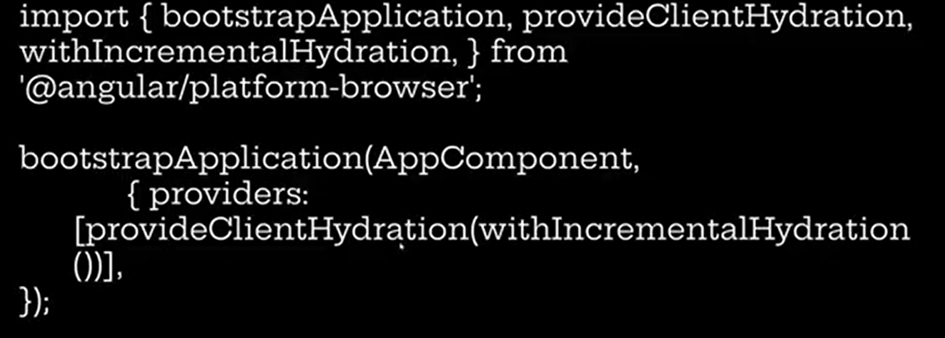  
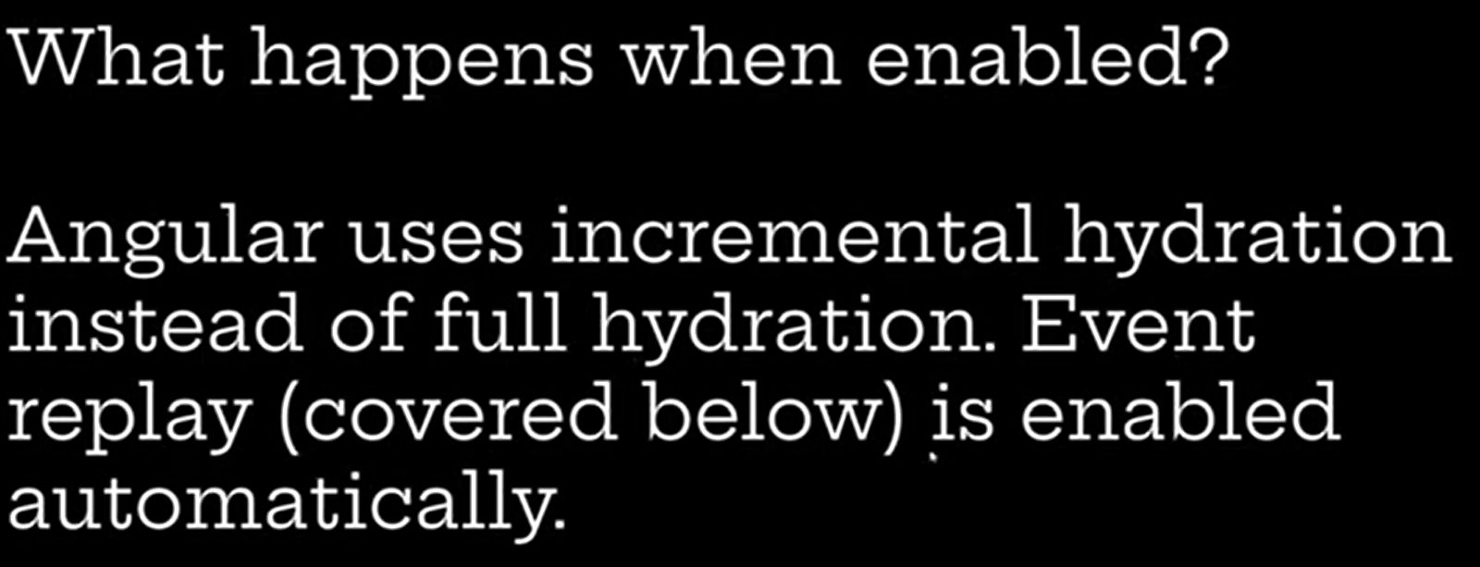  
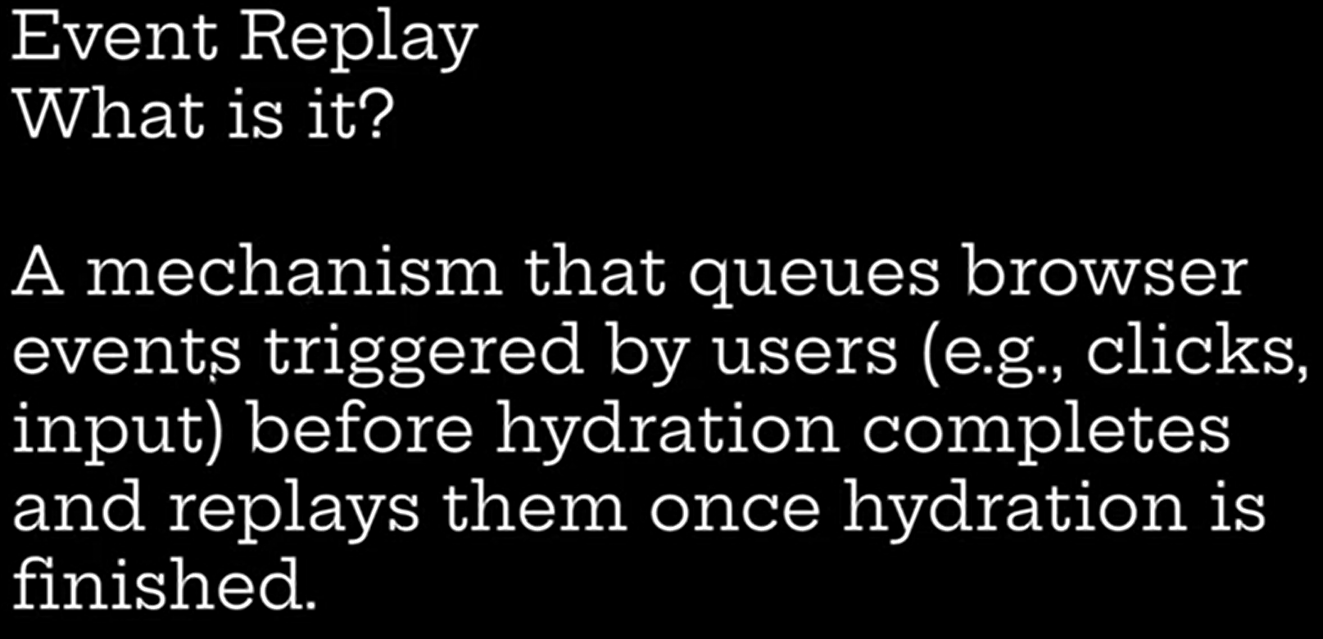  
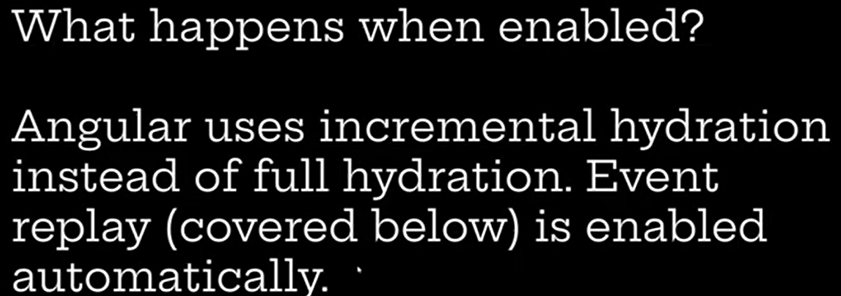  
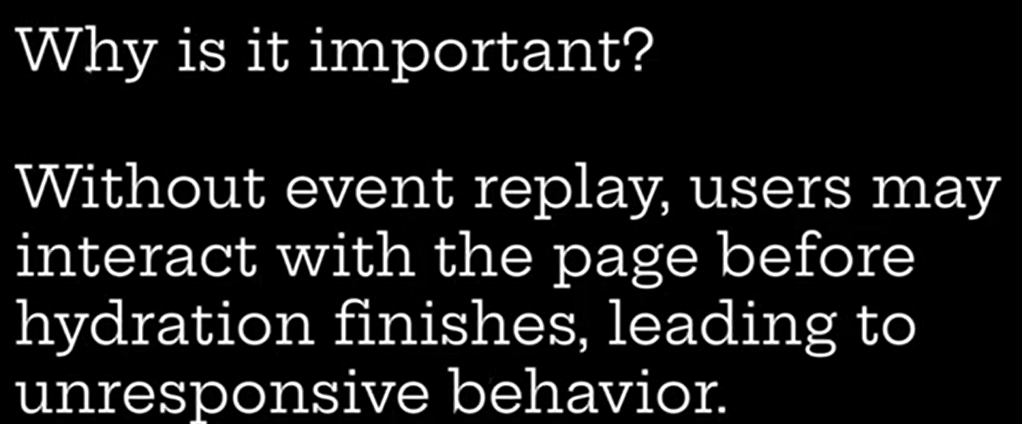  
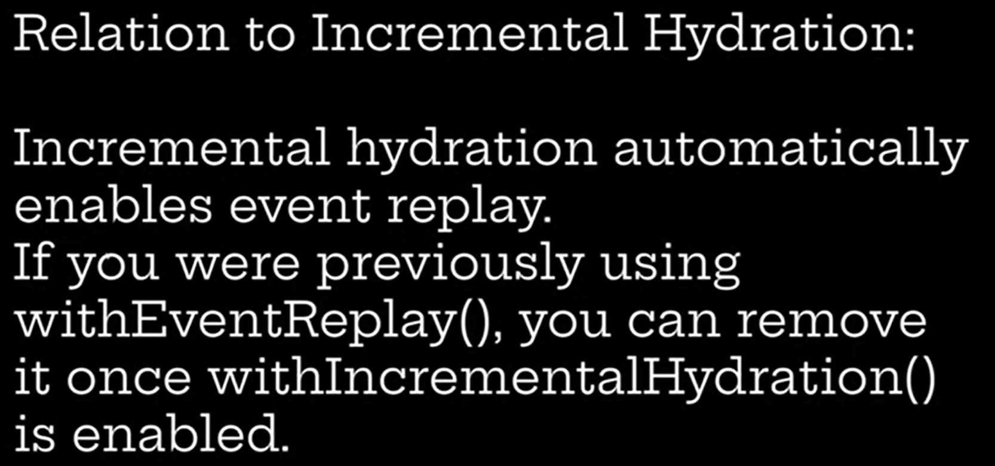  
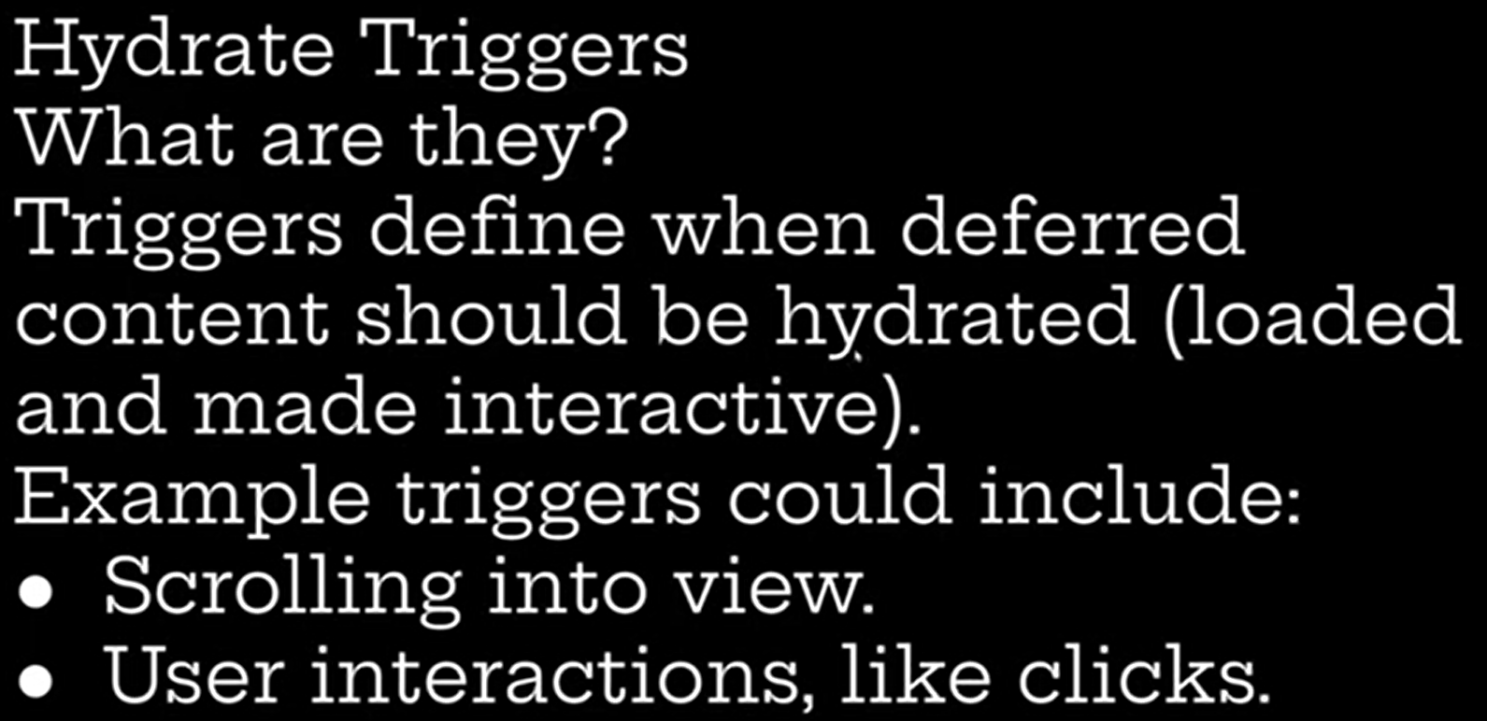  
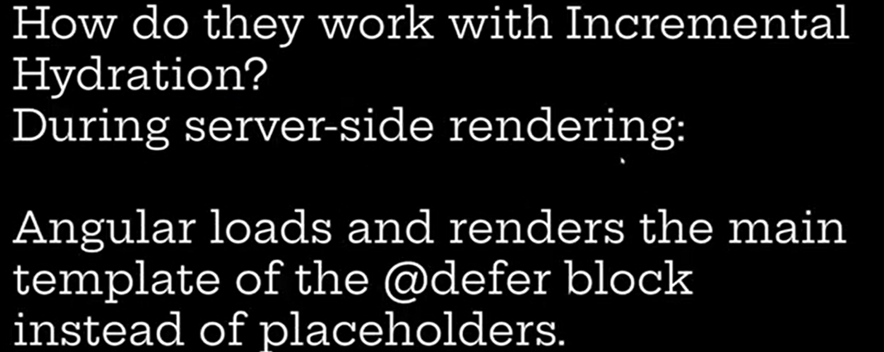  
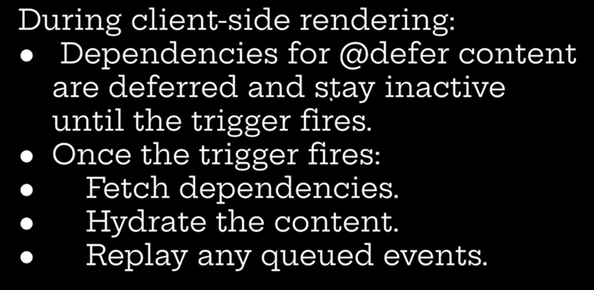  
  
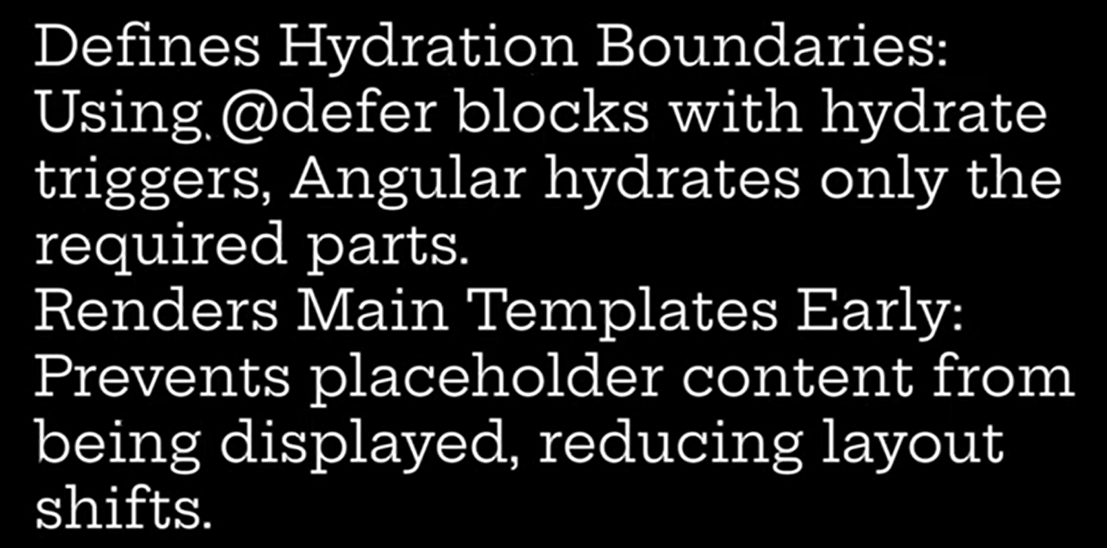  
  
  
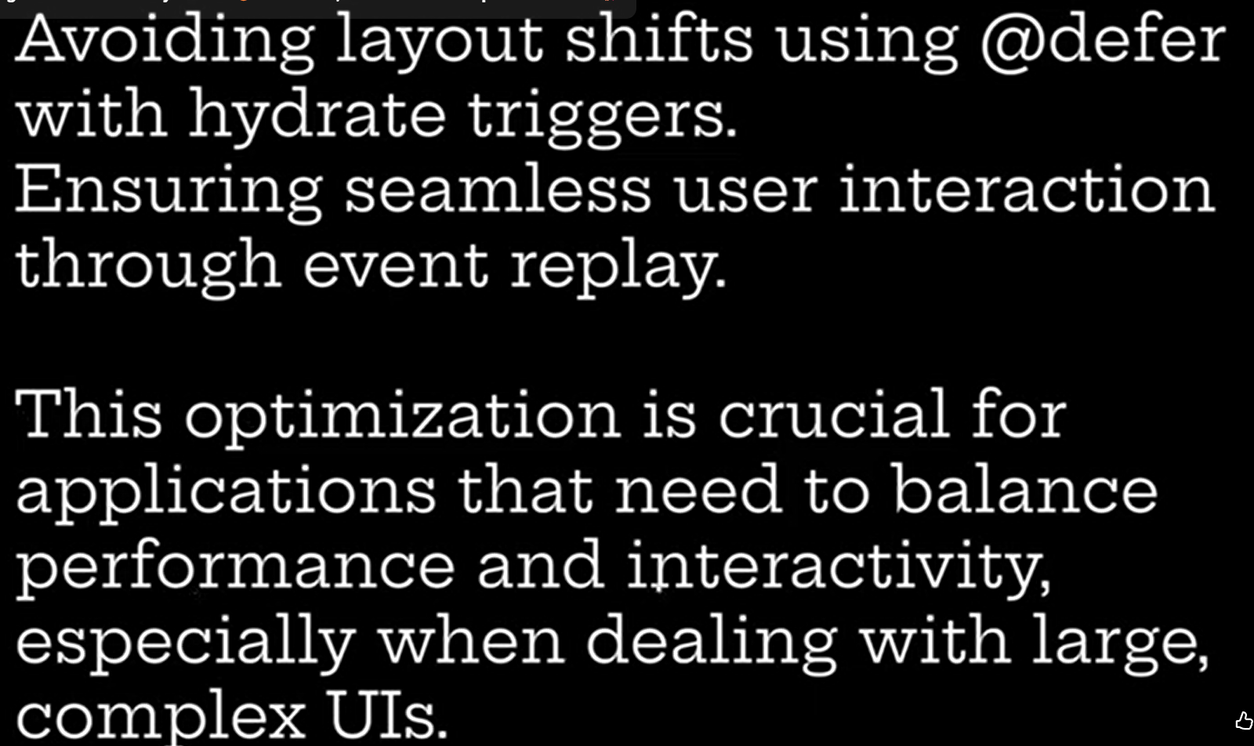  
  
  
  
  
  
  
  
**Controlling hydration of content with triggers - Incremental Hydration —------------------------  
  
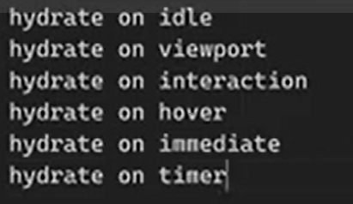  
  
**Enable incremental hydration. By default eventReply was enabled